CFI Projects Monthly Reports for
International
Representatives

Dear CFI International Representative Family,

Thank you for your continued support of the Outreach efforts of Christian Friends of Israel. We continue to strive to encourage those in need and to offer practical assistance during times of struggle. It’s during these times when relationships can be formed which please God and allow us to show Compassion to those who need it the most and have possibly never experienced it before.

During this time of global pandemic, we continue to offer assistance as we are able, and we know each passing day may allow for additional hardships, but we also know the God whom we serve. He is more than able to protect, and provide and heal. We are willing to represent Him to the people of Israel.

Please receive the CFI Outreach electronic updates as a reminder
of the impact each of you have in the lives of so many. We are grateful to represent those of you in the Nations - to those in the Land of Israel.

A friend loves at all times, And a brother is born for adversity.

Proverbs 17:17 (NKJV)

Project Forsake Them Not

“To everything there is a season, a time for every purpose under heaven: A time to be born, and a time to die... A time to weep, and a time to laugh; A time to mourn, and a time to dance... A time to love...” (Ecclesiastes 3)

There are indeed different times and seasons in our lives. Often we don’t have control over the changes. We don’t choose the cause of the mourning, but we can choose to share in the weeping with others. We also can choose to join in the dance with someone who rejoices. We are created for fellowship with one another through which God’s heart could be expressed. I don’t believe God intended loneliness which, like a plaque, spreads rapidly in our days. Today we can and should, choose a time to love.

During the lockdown we received much sad news. We lost dear friends when families lost husbands and wives, mothers and fathers, grandparents and great grandparents. Loss is a seasonal part of life, but it’s never an easy one. When the lockdown was lifted, we had the privilege to visit bereaved families and even to sit Shiva – a period of seven days formal mourning for the dead, beginning immediately after the funeral; a time when individuals discuss their loss and accept the comfort of others. It was a very special time with Evgenia’s family indeed. She was deeply loved, and none of us could believe she was gone forever. The doors of her house and her heart were always open to the needs of others. Many tears were shed that day, but there was comfort in togetherness.

Evgenia was a very bright personality. She lived for others and was proud for her family. She definitely set high standards and left an incredible legacy for those who knew her.
Evgenia was part of a family of six children. Her father was sent to the front line during the war and was killed. She was too small to remember much from the days of being in the ghetto however, a few terrible incidents stood out too sharply to be forgotten. She remembered that her grandmother was sick with dysentery and was passing blood. As a four-year-old she witnessed the Germans dragging her grandmother across the floor and out the door never to be seen again. She also remembered seeing her mother being raped in the kitchen in front of the children. When the war ended the family returned to Chernovtsy to find their home destroyed. They found a small room to rent; it was very crowded with two older brothers, two older sisters, her mother and herself all sharing such a small space. Evgenia remembered tugging on her mother’s skirt saying “Mama, I want to eat, Mama, I want to eat.” Bread was very expensive and food was difficult to obtain.
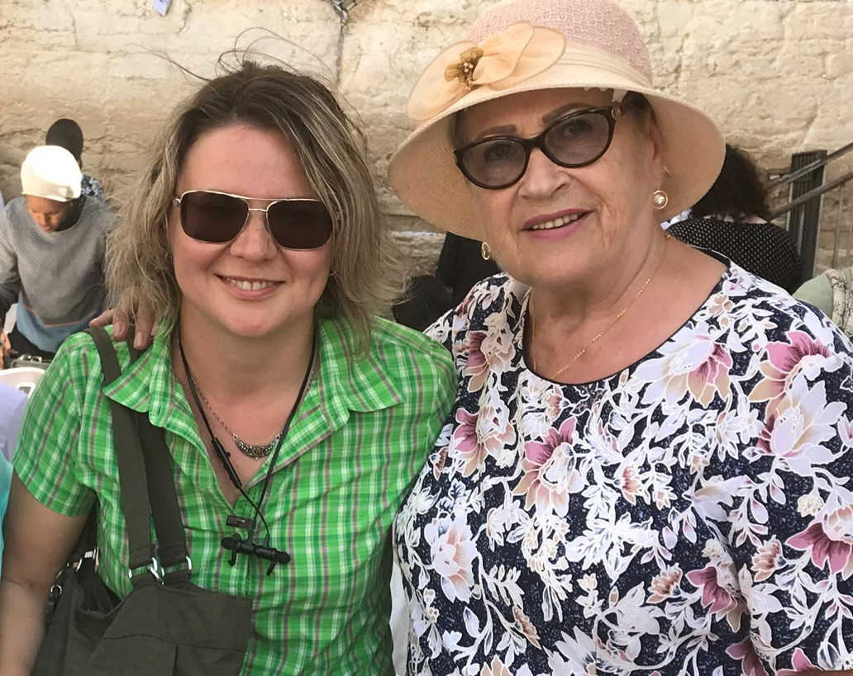
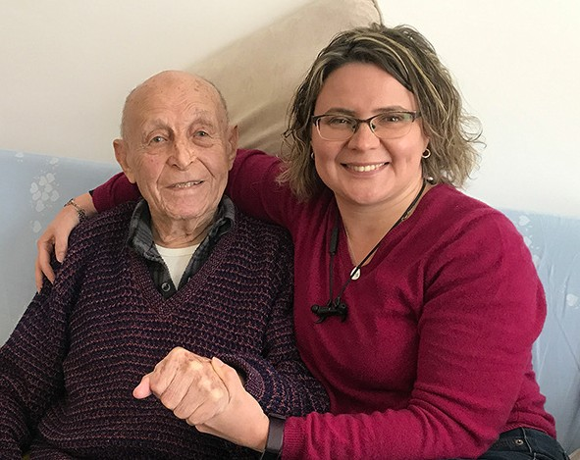

All these shaped Evgenia into the person she was. She knew too well the hardships of life, and she chose to love over everything else. We miss you, Evgenia.

We also were able to celebrate a move to a new apartment with Gedal and Lora. The moving process lasted for over a year, with all the delays of renovations because of COVID and many strains and stresses. Now, finally, our precious friends are able to settle and enjoy their lives next to their children and grand- children. The joy of seeing each other and the realization of final accomplishment seemed to swallow all the worries of the undergone experience. It was just a perfect time for dancing and laughter.
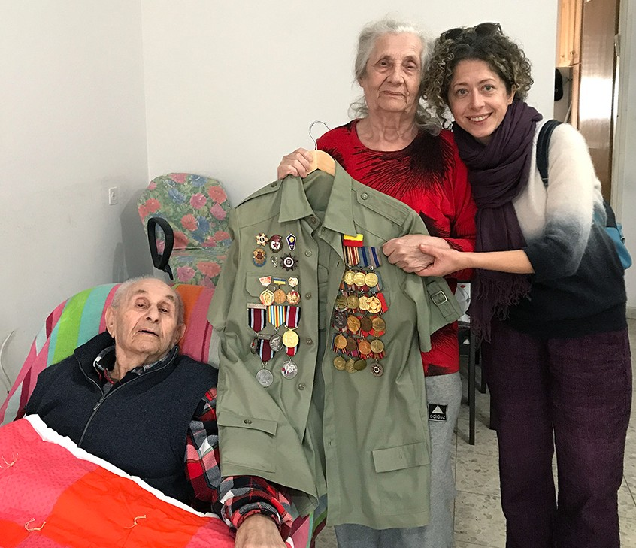
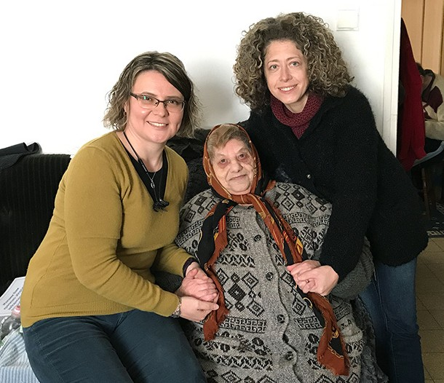

As a team here, we are ever so grateful for this season of reaching out to the dear Holocaust Survivors, which purposes to bring God’s love and comfort into their often-lonely daily routines. Thank you so making it possible for us to mourn with those who mourn, and to rejoice with those who rejoice. Thank you for being faithful in your prayers and support. It is a time to love indeed.

“‘You shall love the Lord your God with all your heart, with all your soul, and with all your mind.’ This is the first and great commandment. And the second is like it: ‘You shall love your neighbor as yourself.’” (Matthew 22:37-39).

Olga Kopilova Project Supervisor

Project Open Gates

Greetings from the CFI distribution center!
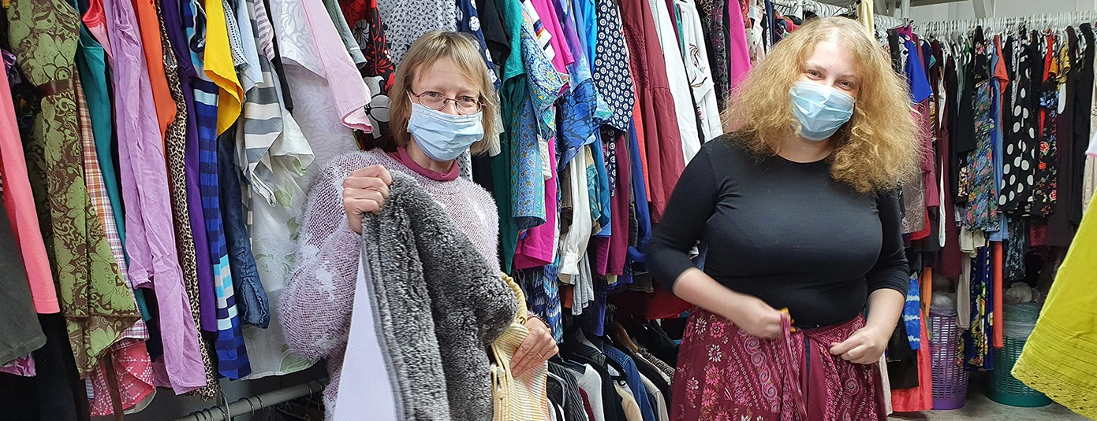

It is a great joy that we have been able to receive and serve people again at our place. A lot of immigrants have made Aliyah during the time of restrictions and quarantines.

Yesterday one couple from South Africa visited us for the first time. They had moved to Israel only 6 weeks ago. They said that it wasn’t easy for them to complete the documents and also to leave everything behind. The fact that their daughter and some other family members already live in the Land makes life easier and more meaningful. The daughter knew about us and brought the parents in. I was glad to see that they found good items for themselves. They promised to come back in a month or two. Their 91 year-old father is still in South-Africa. He is planning to make Aliyah as soon as possible. May the Lord help him to sell his house and do all the paperwork that is needed.

God is bringing back His people using difficult circumstances. In South-Africa there are bad things going on all over. It helps Jewish families to make the decision to move to their real homeland. One of our visitors told us about the political grievances in Belarus. He made Aliyah by himself less than two months ago. Alexander was happy to take clothing and other items that we offered to him. He seemed to be a very talented and educated person. May he find the hope and the future in Israel!

One young man with an orthodox outlook came for a short visit. It is interesting that religious Jews from South-America are much more open to have relationship with Christians than others. This fellow made Aliyah from Brazil three months ago. He speaks quite good Hebrew already. That was our common language yesterday. He got a food voucher with the other items as a first time gift and one good quality pillow. He was very excited to receive the Tanach in Hebrew and Portuguese. He did not want to look at clothing this time, but he may come back later. It is so good to see somebody from the orthodox community smile at you!

Thank you for your prayers and all the support. We are doing this work together! It is so good to tell our clients that they have caring Christian friends in different countries all over the world. That means a lot, especially nowadays!

Project Bridal Salon

Shalom our friends from the nations!

CFI Bridal Salon is open and there have been visitors to our place during the last month. We gave two couples good wedding gowns. Both the grooms and the brides-to-be were blessed by CFI. They were very thankful and even invited me to their wedding ceremony. At the moment you can have 50 people gathered outdoors and 20 indoors here in Israel. So, many weddings are taking place outside. The weather is becoming warm after the winter season and the nature is fresh and blooming. You can have a wonderful wedding hall in a yard or even in a park at the moment. One of the couples is going to have their ceremony at the dung gate in the Old City of Jerusalem.

One girl came to visit us twice. She is originally from Venezuela. As I understood, she made Aliyah by herself some years ago. Now this young lady is getting married. Though she has an average body it was not easy to find the perfect dress for Yael. Her rabbi, who will do the ceremony and bless their marriage, has a very strict opinion about suitable dresses. Unfortunately there are more open and sleeveless dresses in our collection. They don’t work for most of the orthodox weddings; You need sleeves and
a modest neckline there. Sometimes a bolero makes the needed difference. Sometimes our clients add sleeves to the dresses and use lace to make the upper part of the gown less open.

Yael found a suitable and very beautiful dress for herself. She still has a couple of months to make alterations to it with a seamstress. I hope that the rabbi can cooperate with her and with other young women, who want to look beautiful on their wedding day. It is a huge blessing to Yael and many others to have a wedding gown for free. Maybe I should start to make and add sleeves to some of our dresses?
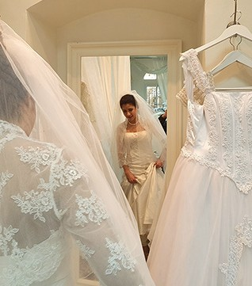
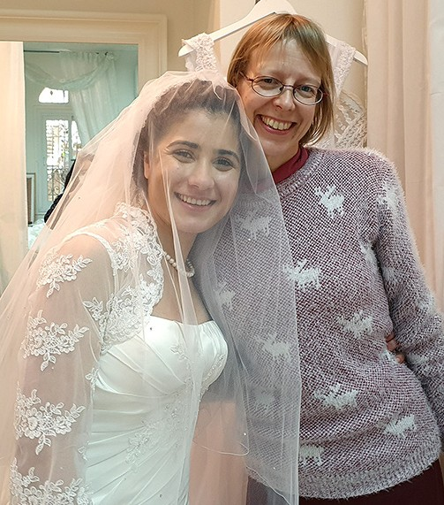

Thank you for being with us! God bless you from Zion!

Project Under His Wings

Shalom Dear Friends of Israel,

“You keep track of all my sorrows. You have collected all my tears in your bottle. ” (Psalm 56:8a)

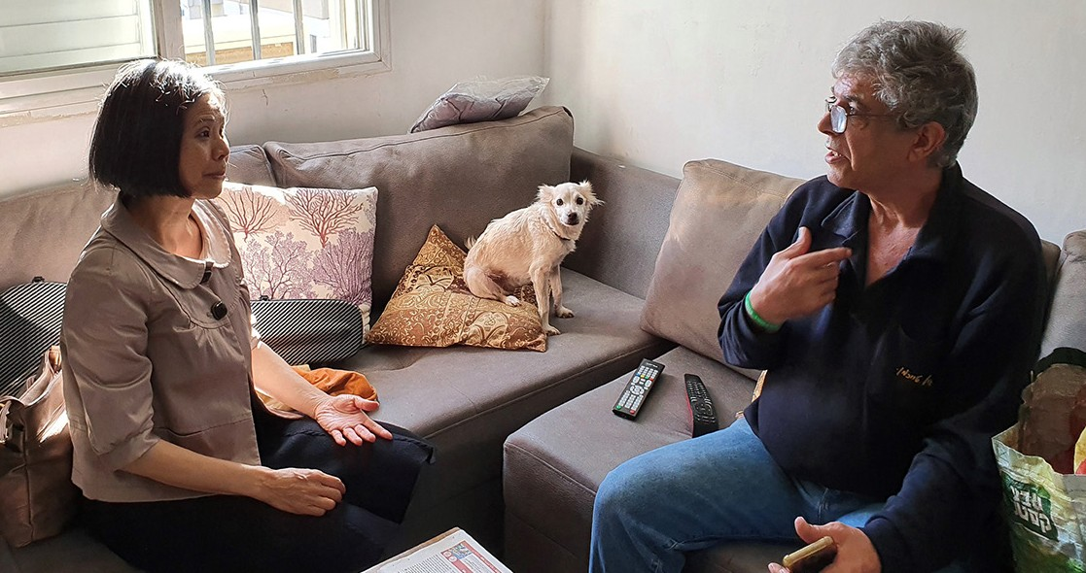
Project Under His Wings had the privilege to visit Noa and her father in Central Israel (her twin brother Asaf couldn’t make it due to treatment). This family has a VERY sad story. Noa and Asaf’s mother is invalid, and their father has not been able to function and has been on medication and ongoing treatment. Their oldest brother Yaniv, who served in the Border Police, was killed during a mission whilst clashing with terrorists; He was the provider for their whole family

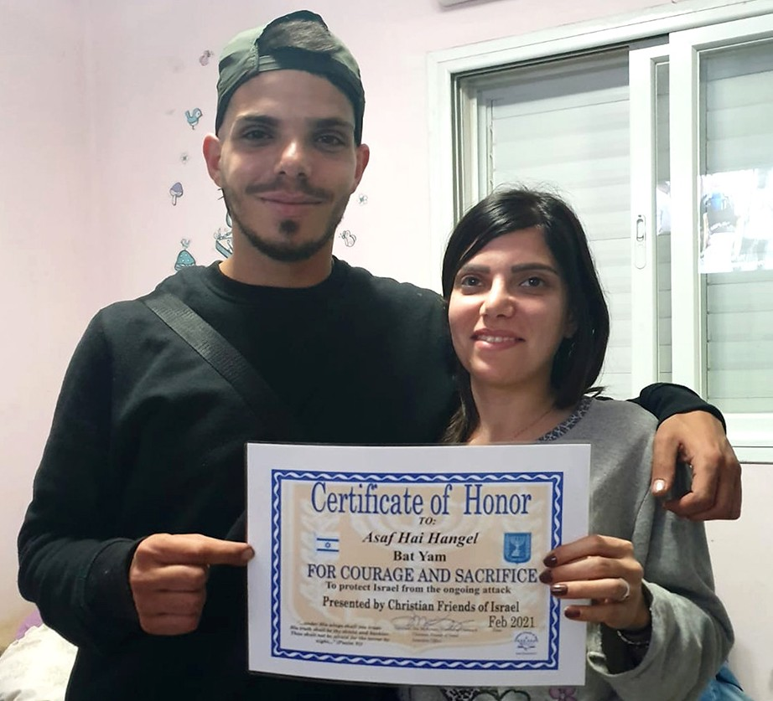
Many years later Yaniv’s younger twin siblings
- Asaf and Noa followed their older brother’s step to serve as border police. During one terror attack in Damascus Gate in Jerusalem in 2017,
several border police were killed and injured, and Asaf was forced to kill 2 terrorists. After that Asaf has been suffering severe post trauma and has been unable to work.

I couldn’t help but thinking about Noa who in her young adulthood has to carry all the responsibilities of their whole family on her shoulders. She said they have been growing up like orphans, as both of their parents have been invalid (Psalm 56:8a). The visit also ministered to their father Ofer.

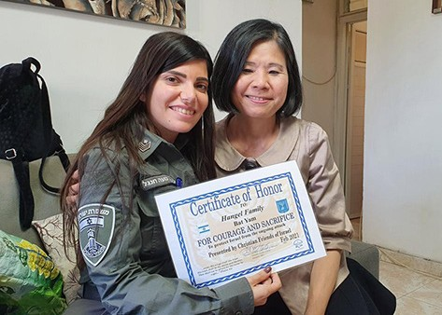
Asaf is now in a Rehab Center that costs lots of money but his post trauma has not improved. I encouraged Noa to look to God, Maker of Heaven and Earth and of men, for help concerning Asaf and all their needs. Let us lift up this precious twin in prayer that God will connect them to the right place that will really be helpful for Asaf and also will lessen the financial burden on Noa.

Thank you, our supporters, for your support of Project UHW. Wishing you Happy Passover, which commences on the eve of 27th March this year.

Project Communities Under Attack

Dear Friends of Israel,

“Comfort, comfort My people, says your God. “ (Isaiah 40: 1)

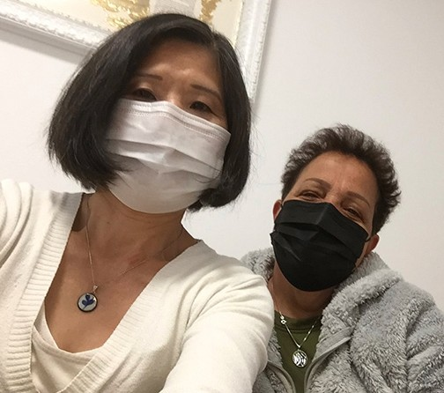
Shalom. Project CUA visited Mazal after the government’s Covid restriction prohibiting visits was lifted. Mazal has cancer and has been receiving therapy for several years. Thankfully the situation of her cancer is stable after a surgery a few years ago and the ongoing therapy, but she is disabled physically to some degree after the surgery.

Mazal is a single Mom, and because of her need her only daughter, who is serving in the army is allowed to go home every day in the evening to help her with housework. The expensive medical treatment has been a huge burden on Mazal. She was very grateful that CUA came alongside her to help, by easing her burden, as well as providing emotional and spiritual support.

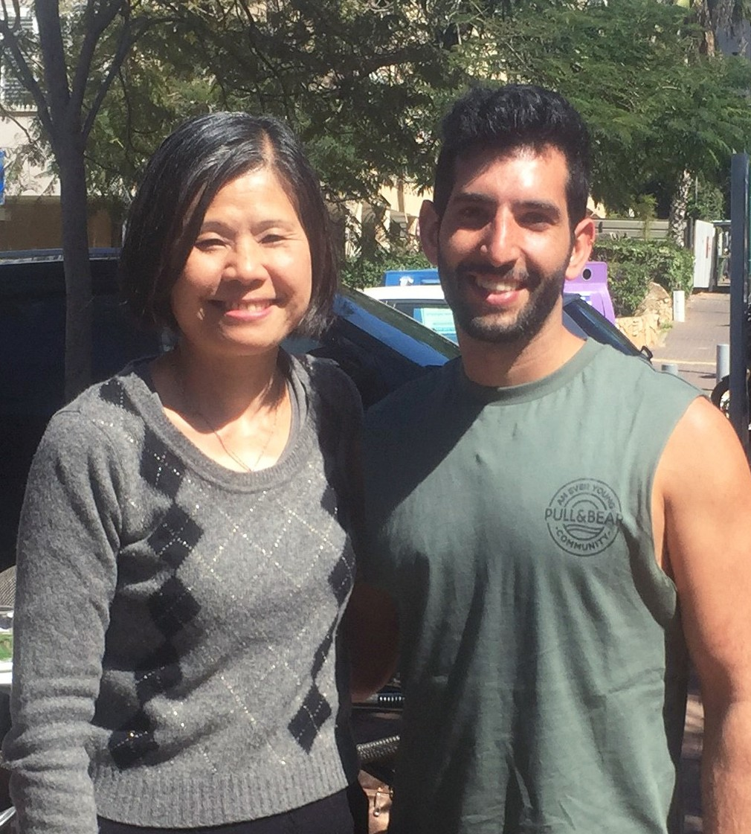
Yohai is another person whom Project CUA visited. Yohai is a University student who has no family support. Fed up by the strict religious practices
of his parents, Yohai broke away from his family and joined the army. He was injured in Operation Protective Edge and also traumatized. The Lord put it in my heart to visit him to see how he was doing, as he has no family support. The visit was in perfect timing and Yohai was deeply touched by the care and concern.

Project CUA also visited one senior Israeli citizen named Moshe and his wife who are religious.
Moshe not only has been struggling with health problems but also post trauma resulting from 4 wars that he fought when he was serving in the Israeli army. Moshe and his wife were greatly comforted during the visit (Isaiah 40:1). Please pray that the visits continue to have an influence on them.

God bless you, supporters of CUA, for your prayers and financial support for this project. May God renew the joy of your salvation as you meditate on the Lamb of God during this Passover season.

Project Wall of Prayer

What is happening at our Wall of Prayer?

“Then Eliashib the high priest arose with his brothers the priests and built the Sheep Gate; ...And next to him the men of Jericho built...Now the sons of Hassenaah built the Fish Gate; ...Next to them the men of Gibeon and of Mizpah, also made repairs for the official seat of the governor...
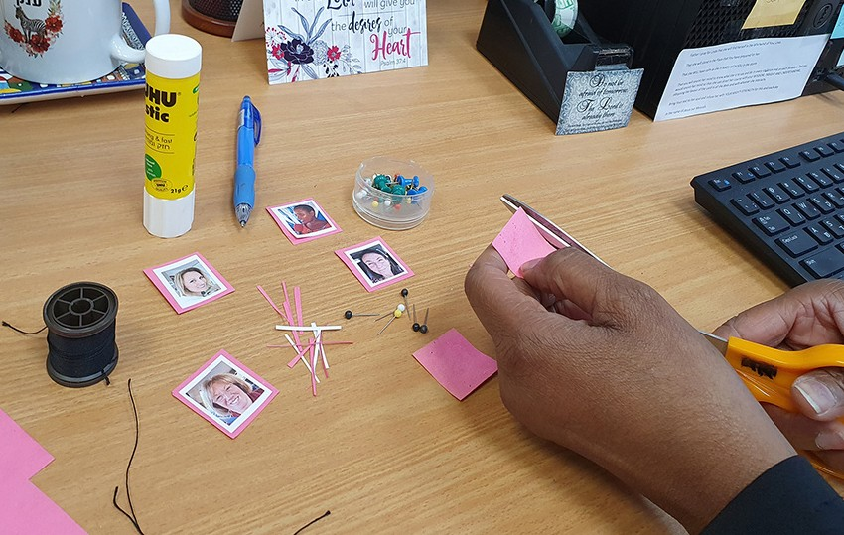
Next to him Uzziel the son of Harhaiah of the goldsmiths made repairs. And next to him Hananiah, one of the perfumers, made repairs, and they restored Jerusalem as far as the Broad Wall.” Nehemiah 3:1-8 NASB

There is much activity at the CFI Wall of Prayer, some visible and much invisible, some external and much internal. As prayer warriors contact us and send their photos for the Israel Watch Prayer map, each week there are scraps of paper, a glue stick, pins, staples, and snippets of thread on the desk and floor while new faces are cut out and attached to the map. As we reply to their messages and put up the pictures, we pray for them while they pray for Israel.
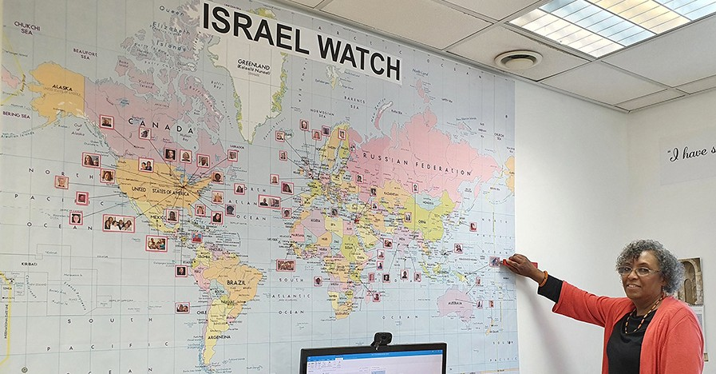

One day an orthodox rabbi came into the office and asked about the map because the faces caught his attention. When I explained that these were people who loved and prayed for Israel. He queried, “Are these all Christians?” I replied, “Yes, and these are only a few of them. There are many more who pray for you. You may have only heard about the ones that feel otherwise, but there are Christians around the world who love Israel,” There was a look of amazement on his face as he said, “So this is what the Wall of Prayer is all about.” He understood.

Just as it was in biblical times when Nehemiah began the rebuilding of Jerusalem’s walls, we are now restoring CFI’s Wall of Prayer as a means of spiritual protection around the land and the people of Israel. Also like Nehemiah’s group of builders, each of our workers has his or her own area to restore. We may not all be in the exact same spot, but we are working together for the common goal of interceding for Israel. Not only are new faces being added to the wall map, but new faces are also appearing at our monthly Zoom prayer meetings. These dedicated people are very passionate about praying for Israel and for our CFI Representatives. Some who were uncomfortable at the beginning are now praying aloud and lifting up their voices to the Lord. Other prayer warriors are coming from countries where Israel is scorned. Our short worship and prayer time serves as live interaction with the Body of Messiah that they may not have otherwise. These prayer warriors look forward to our gatherings where they earnestly intercede for Israel and pray for change in their own nations that stand in opposition to the God of Israel.
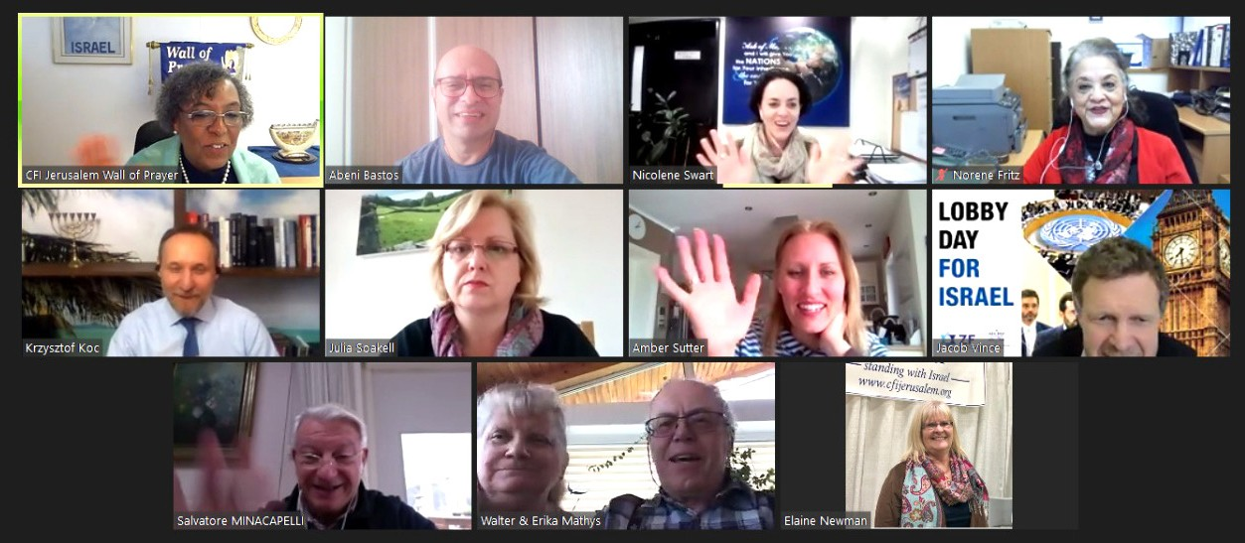

We also saw a new face in the Representative’s prayer meeting. Our new CFI Poland Rep, Krzysztof Koc, was warmly welcomed into the group. Over the months of praying together, there is true camaraderie among this prayer team. With each month, the prayers grow deeper as we allow the Holy Spirit to direct us.

We are thankful for your consecrated service to God and to CFI. Thank you for your gifts that make it possible for us to connect with others both in the land of Israel and throughout the world by way of the internet. May God continue to strengthen you and prosper you as you continue to work for His Glory.

Linda McMurray Project Supervisor

