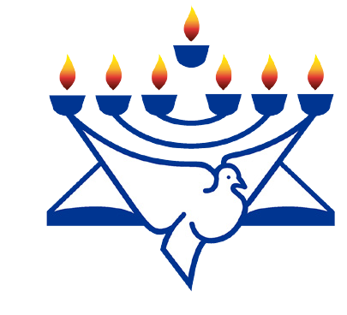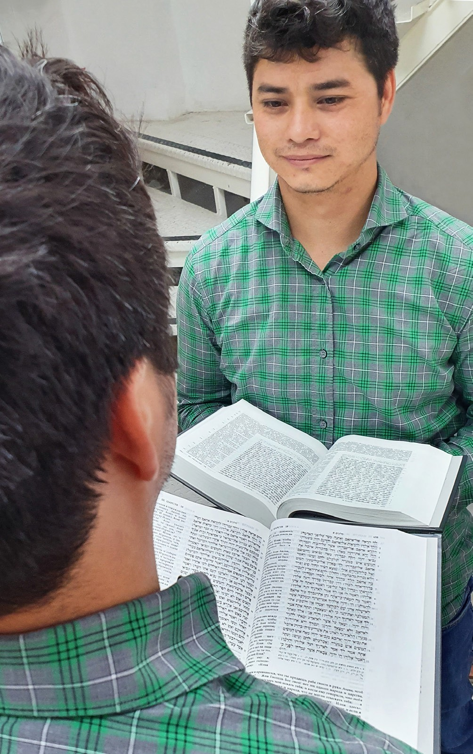
in

Prayer Letter
Watchman’s

Christian Friends of Israel prayer@cfijerusalem.org www.cfijerusalem.org
September 2021 /Jewish Year 5781/5782
LOOKING INTO THE WORD
“But be doers of the word and not hearers only, deceiving yourselves. Because if anyone is a hearer of the word and not a doer, he is like someone looking at his own face in a mirror. For he looks at himself, goes away, and immediately forgets what kind of person he was. But the one who looks intently into the perfect law of freedom and perseveres in it, and is not a forgetful hearer but a doer who works – this person will be blessed in what he does” James 1:22-25 (CSB).

The Hebrew month of Tishri marks a very special sea- son for Jewish people around the world. This year, Tishri begins on Tuesday, September 7. It is the season of the ‘High Holy Days’ which include Rosh Hashanah (Feast of Trumpets), Yom Kippur (Day of Atonement), and Sukkot (Feast of Tabernacles). God instructed Israel to observe these appointed times. As Christians, we also have the opportunity to freely celebrate the feasts that God ordained out of a desire to know His character.

Rosh Hashanah marks the beginning of the Jewish new year. In Numbers 29:1-2, God gave instructions for this feast “...on the first day of the month, you are to have a holy convocation; do not do any kind of ordinary work; it is a day of blowing the shofar for you. Prepare a burnt of- fering to make a fragrant aroma for Adonai…” (CJB ver- sion). Rosh Hashanah is a subdued and contemplative holiday which precedes the “Days of Awe” – 10 days of repentance and renewal that begin at sunset on Rosh Hashanah and close with Yom Kippur, the solemn Day of Atonement. This is a time of deep introspection, during which people examine their own hearts and look intently
into the Word of God comparing how they should live. It is a time of repentance – turning away from sin and aligning with God’s desires. Leviticus 16:29-30 says, “...on the tenth day...you are to deny yourselves... For on this day, atonement will be made for you to purify you; you will be clean before Adonai from all your sins.” (CJB version). In the time of the tabernacle and temple, this was the day the high priest made atonement for the sins of the nation of Israel. Even today, many Jews will refrain from work, fast and/or attend synagogue services on Yom Kippur. As Christians, we believe that God’s appointed times are a beautiful foreshadowing of our Messiah Yeshua who as the sinless Lamb of God made atonement for the sins of the entire world “... because he offered one sacrifice, once and for all, by offering up himself” (Hebrews 7:27 CJB).

Many of Yeshua’s teachings occurred during the biblical feasts. As we look into the scriptures and see God’s holiness, the theme of self-examination and repentance is woven throughout because all mankind need cleansing and forgiveness of sin. Romans 3:23 reminds us that “... all have sinned, and come short of the glory of God” (KJV). Forgiveness of sin is still preceded by repentance. The Apostle John tells us, “If we claim not to have sin, we are deceiving ourselves, and the truth is not in us. If we acknowledge our sins, then, since he [God] is trustworthy and just, he will forgive them and purify us from all wrongdoing” 1 John 1:8-9 (CJB).

During this special season, please join us in praying that Jews and Gentiles alike will be blessed as we gaze into the mirror of the Word of God, spend time in repentance, and become doers of His will.

Praying for Repentance and Revelation
- Praise God for His great love for mankind and His desire to have fellowship with us His mortal creation. “What is man that You are mindful of him, and the son of man that You visit him? For You have made him a little lower than the angels, and You have crowned him with glory and honor” Psalm 8:4-5 NKJV.

- Bless the Lord for His willingness to forgive and cleanse us. “Bless Adonai, my soul, and forget none of his benefits! He forgives all your offenses, he heals all your diseases, he redeems your life from the pit, he surrounds you with grace and compassion” Psalm 103:2-4 CJB.

- Ask God to move upon the hearts of Israel during these High Holy days. May hearts be softened and spiritual eyes opened to understand more of His ways. God made this promise to Israel: “I will sprinkle clean water on you, and you will be clean; I will cleanse you from all your uncleanness… I will give you a new heart and put a new spirit inside you; I will take the stony heart out of your flesh and give you a heart of flesh” Ezekiel 36:25-26 CJB.

- Petition the Lord for continued protection from attacks from Hezbollah in Lebanon and other countries that are hostile to Israel. “You who live in the shelter of Elyon, who spend your nights in the shadow of Shaddai, who say to Adonai, ‘My refuge! My fortress! My God, in whom I trust!’ He will rescue you from the trap of the hunter and from the plague of calamities; he will cover you with his pinions, and under his wings you will find refuge; his truth is a shield and protection” Psalm 91:1-4 CJB.

- Beseech God for unity among believers of various backgrounds both Jewish and non-Jewish. “But now in Messiah Yeshua, you who once were far off have been brought near by the blood of the Messiah. For He is our shalom, the One who made the two into one and broke down the middle wall of separation. Within His flesh He made powerless the hostility… He did this in order to create within Himself one new man from the two groups, making shalom” Ephesians 2:13-15 TLV.

- Rejoice in God’s plan for redemption of Israel and all those who will follow Him. “For God so loved the world that He gave His one and only Son, that whoever believes in Him shall not perish but have eternal life” John 3:16 TLV.

Dear Watchman:
What a pleasure it is to greet you again during these special appointed times with the Lord. I pray you will take advantage of the opportunity to draw closer to the Lord and learn more of Him during these High Holy days. May your time with God be especially significant as He speaks to you.

In His Love,

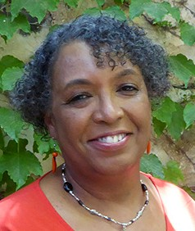
Linda D. McMurray
Wall of Prayer Supervisor

