CFI Projects Monthly Reports for
International
Representatives

Dear CFI International Representative Family,

Thank you for your continued support of the Outreach efforts of Christian Friends of Israel. We continue to strive to encourage those in need and to offer practical assistance during times of struggle. It’s during these times when relationships can be formed which please God and allow us to show Compassion to those who need it the most and have possibly never experienced it before.

During this time of global pandemic, we continue to offer assistance as we are able, and we know each passing day may allow for additional hardships, but we also know the God whom we serve. He is more than able to protect, and provide and heal. We are willing to represent Him to the people of Israel.

Please receive the CFI Outreach electronic updates as a reminder
of the impact each of you have in the lives of so many. We are grateful to represent those of you in the Nations - to those in the Land of Israel.

A friend loves at all times, And a brother is born for adversity.

Proverbs 17:17 (NKJV)

Dear Friends of Israel,

A “lone soldier” is a soldier in the IDF with no family in Israel to support him or her: a new immigrant, a volunteer from abroad, an orphan or an individual from a broken home.

Every day tens of thousands of soldiers are defending the State of Israel and its citizens. These soldiers regularly spend weekends and holidays at home where their parents provide for all of their needs: food, laundry, and even a hug. Challenges for a lone soldier arise when he or she leaves base. While Israeli-born lone soldiers have their families to return home to, lone soldiers are left to fend for themselves while on leave from the army. This can be once a month, or every weekend, depending on where they serve and what part of training they are in. For more than 7,000 lone soldiers, there is no immediate family in Israel to support them. Though highly motivated and proud to serve, when on leave, many of them struggle with basic needs that a family would solve.

CFI and Project David’s Shield have the privilege of supporting many of these brave warriors who have not only chosen to defend the nation of Israel, but to willingly make the decision to leave their home country to defend the Jewish State. It’s a very unique situation, as typically one cannot volunteer for service in another nation’s army. But Israel is unique, in this, and so many ways. A large percentage of lone soldiers actually end up making Aliyah and immigrating to Israel, and many with their families. It’s yet another avenue and opportunity for the prophetic words of God to come to pass as He re-gathers His people.

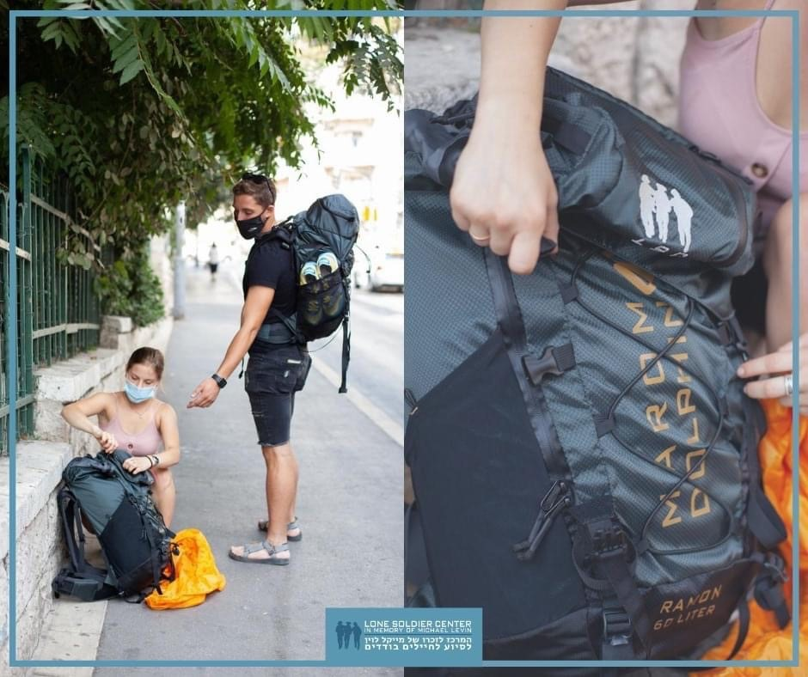
Project David’s Shield recently provided backpacks to a local Lone Soldier Center in Jerusalem as an expression of our thanks to the brave soldiers who have made the decision to serve in the IDF as lone soldiers. We
do this so we can have the opportunity to encourage and tell them that they are doing the right thing. We gifted each soldier with a “challenge coin” which reminds them that there
are those in the Nations who do in fact pray for them and support God’s plan for Israel. Israel has many enemies, and until all of the re-gathering is complete, the path of a lone soldier provides the avenue of such a promise.

Thank you for your continued prayers and support of CFI Jerusalem and Project David’s Shield.

Jim McKenzie Project Coordinator

A friend in need is a friend indeed. There are so many different needs, and different deeds to meet them. There are needs that are obvious, of course and there are so many needs hidden from our eyes, hidden behind the doors of lonely homes, deeply buried in people’s hearts. What a privilege it is for us to enter those doors and to be allowed into those hearts, to attend to those needs. The need for joy; the need for a smile; the need for a kind word; the need for company; the need to be heard; the need to be remembered; the need to be needed.
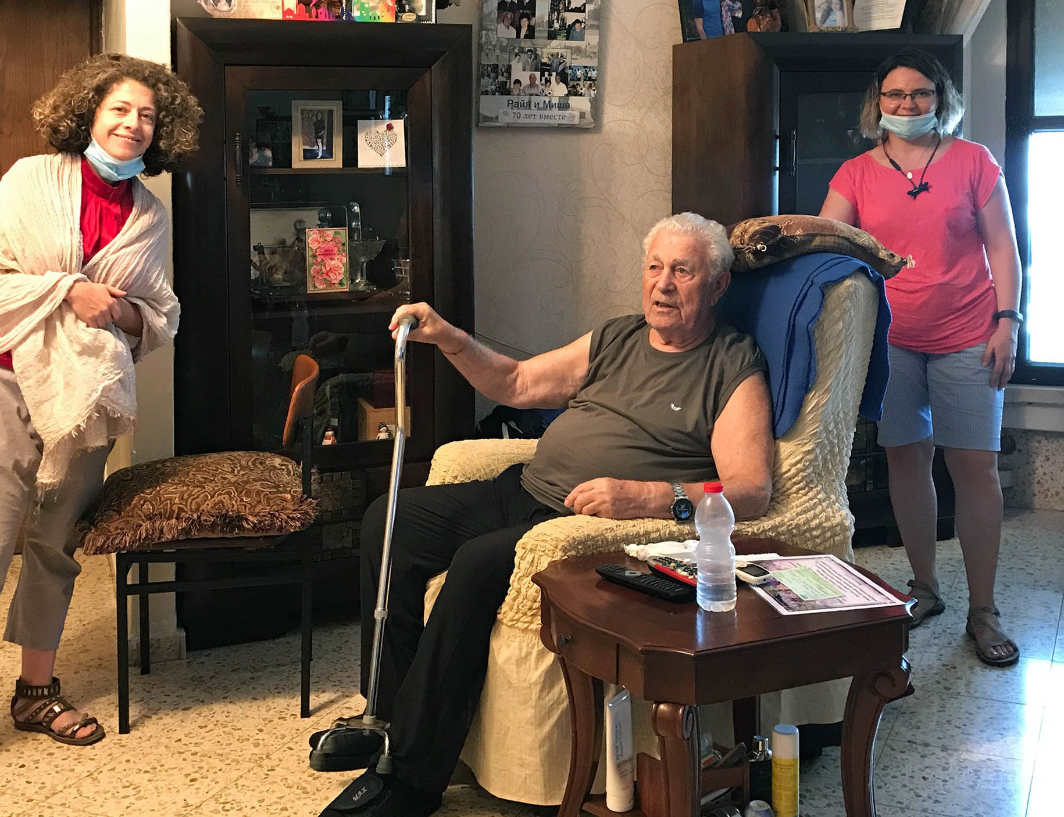

Her entire life, Roanna was used to being the giver, the ‘need-meeter’. She poured herself out as a literature teacher, becoming a role model and impacting the lives of hundreds of students over 45 years. For years she looked after her elderly mother, whom she loved and respected highly. She raised two wonderful sons, often regretting the lack of her total commitment to them. Over 25 years she was wholeheartedly dedicated to her choir, made up of the elderly people, which she established and led for all those years, participating in many competitions around Israel and winning many rewards.
At the age of 68 she was working as a caregiver at Aron’s, also a Holocaust survivor, who then was 80 years old and was very lonely and depressed. They became good friends and soon married. It helped Roanna to give him the care he really needed, and he also looked after her, as she doesn’t have relatives in Israel. Those 15 years together filled Roanna’s life with a sense of purpose, despite all the hardships

of Aron’s health condition. Roanna’s life was a busy one. Aron passed away a couple of years ago. Then, Covid-19 hit hard, banning all the activities and cutting off so much needed fellowship with others. Roanna’s sons live in both Ukraine and America, and it is not known when they will be able to visit their mother again. In the past six months Roanna’s health has deteriorated rapidly, and depression creeped in.
Roanna was left alone with a deep sense of worthlessness growing inside.
There was no limit to Roanna’s joy when we told her we were coming for a visit. Hours of sweet fellowship were filled with laughter and tears, and the time passed by so very fast. But Roanna’s heart was filled with life and new strength. She was “Mama,” and we were daughters for the few hours we were there.
She sobbed while putting on her shoes to see us to the car. “Don’t worry!” she said. “I also cry when my sons are leaving.” She waved us away, with a deep smile and whisper, “I hope to see you soon again.” We pray that Roanna’s need was met that day. We also carried her in our hearts to Jerusalem. We will call soon and come to visit her again.

It is impossible to recount every visit, every text message and phone call we have with the precious Survivors of the Holocaust. We only trust those many hidden needs were met to the fullest.

We also received a letter from our precious friend and would love to share it with you:

“Dear friends,
I want to thank you very much for the wonderful present you gave me, your love and also your warm wishes. I was so surprised to find out there are people around the world who are interested in the life of a 6 year old boy who lived through the war. I know this connection was made possible through Christian Friends of Israel here in the Land and through the hard work and initiatives of dear Olga and Tanya.
I survived because there are kind people in the world, just like you. Now I want to share my story with the next generation here in Israel, but also around the world. Everyone should know of the horrors of t he war and make sure it never happens again. There is certainly no peace in the world as we see now. I am happy to hear about people who want to help other people. That is truly a godly mission.
We wish you all health, success and wellbeing, and that you have much joy. Ya’akov, Pechora (death camp survivor)”

We would like to express our deepest gratitude for helping us to stand beside His precious people, in their times of deepest need of love and comfort during this time of isolation. We are grateful for every smile, the excitement we see on their faces, and the joy we see in their hearts. We are grateful for the ability to bring some sun into their often rainy days. We are grateful to be their friends indeed. THANK YOU!

Some “friends” pretend to be friends, but a true friend sticks closer than a brother” (Proverbs 18:24).

Olga Kopilova Project Coordinator

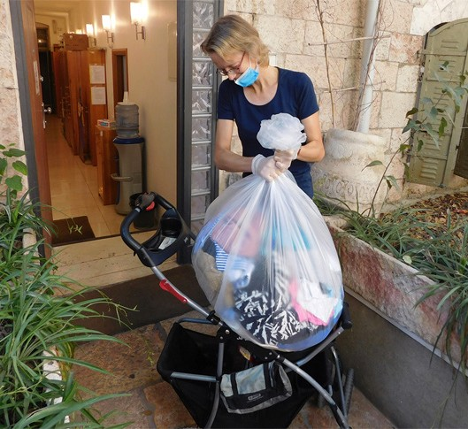
Shalom and blessings from Jerusalem!

Our CFI distribution center is still serving different people. We didn’t get the container this summer, and I start to realize the lack of it more and more every day. Please, pray for God’s provision for us that He can send us clothes to share with new emigrants and other needy individuals. It is a great privilege to help people in this very practical way.

Yesterday there was an Ethiopian single mother choosing clothes for herself and for her four daughters. She has been in our place three times before. Erafu is using this opportunity and taking as many clothes as she can carry every time. She lives outside of Jerusalem. She is really thankful for the help
that Christians are giving her. I tried to find good dresses, that she can wear with gladness, and some new clothes for her younger children. Sometimes it is joyful, even when you offer a person something that she would never use. Erafu and I were laughing at some options that I was suggesting. But many times God gives you understanding about what a person would love to have. Most of the time people like the things I offer them. It gives me great satisfaction.

Last week I served a new emigrant, who is struggling with cancer. She made Aliyah with her family two years ago and quite soon after that they found that she is really sick. Anna told me that in the Ukraine they could not manage to help her, but here in Israel there is a hope for recovering. Let’s pray for Anna and for the whole family. She has two kids. They were sent back to Ukraine for the first period, when Anna was in hospital. She was very weak then. Now the children are again in Israel. The local school is a huge challenge for them, because they don’t know the language yet. Despite the disease Anna has been coming to take clothes for herself and for the family. Her size is changing because of the medication.
We have been a real help for her. Thank you for your support, friends.

Once we got a funny visitor from Haifa. This young man likes fishing. That moment we happened to have an interesting cap in a basket at our DC. I thought that nobody would ever take it, but our fisherman
from Haifa liked it a lot. We got some good pictures and laughed a lot with him. He was happy about this specific fishing cap. I am glad to share this fun moment with you through a couple of pictures. God bless you all!
Tiina Danilevski Project Coordinator
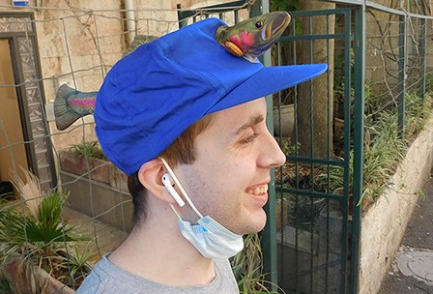
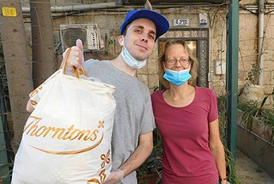

Warm greetings from the CFI Bridal Salon!

This August has been quiet. We have been doing some organizing inside the Bridal Salon together with a couple of our volunteers. It is a needed thing to do once in a while.

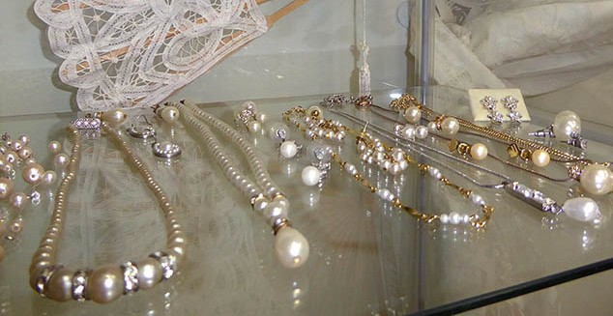
One Israeli family was visiting us one by one last week. They were in need of gowns for their family wedding at the last moment. The mother came to me on Monday. She took the modest evening dress that she had chosen 3 weeks before at her first visit. We found a black scarf to cover the shoulders during the chupah ceremony and pretty black shoes as well. She also took some jewels. The wedding of her step-son was going to be in three days.

Liron asked, if her husband could also come to our place. As the father of the groom he needed a good suit. So, I had an appointment with him on Tuesday. He was not average size. Thank God we found one good option for him for the wedding and one oversize suit for the gathering that they were going to have after wedding. I told him my opinion about the size that was little too big, but he liked the material and the color. We found also a suit for the little brother of the groom.

On Wednesday the sister of the groom came to us in need of a fitting evening dress. Liel is a young and beautiful woman. We looked through all the options that we have. Most of them were too small. Thank God, there was one good dress for her. It just needed some fixing, which I did right away. Liel was very happy and thankful. “You saved me!” she said. We found also a necklace and earrings for her. The wed- ding was the next day. I was glad that the groom already had something to wear for his celebration ☺.

Thank you for your prayers and for every kind of support to this ministry!

May the Lord bless you from Zion!
Tiina Danilevski Project Coordinator
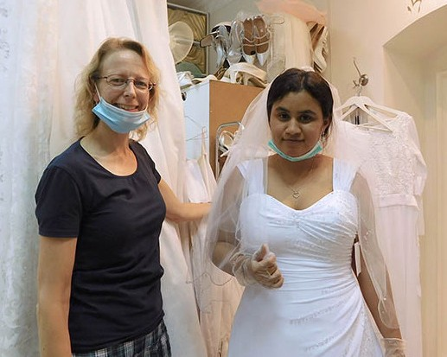

One recent article in the Jerusalem post 19/8/20 stated, “Minister proposes bringing 4,500 Falash Mura to Israel by year’s end.” A call to finish this process by 2021-23!

Christian Friends of Israel’s Hope for the Future outreach has initiated continual, progressive projects to focus genuine care for the previous generation that came into the land of promise, the one highly impacted by the journey from Ethiopia to Israel.

As we await the next generation’s arrival, our anticipation will be increased for more awareness, so that the community may combat depression, despair and any delusions generated from past delayed operations to get them here.

We keep hope alive by empowerment, care, love, and resourcing so as to become friends to the families in any manner and to give them “a hand up” as we can.

In the year 2019, we worked with a family whose young daughter lost the desire to stand for herself.
She refused to attend school, or even leave the home. This summer, we were able to help her, by means of reducing the cost of an emergency dental surgery, by half. I was thrilled to know that she has returned to school and is catching up on core subjects, to see her smile again, knowing the magnitude of our presence has helped to lift her out of a dark place.

We continue to impact families with children. Though we are aware children are more resilient to trauma than adults are, it is still crucial to remember how hardship can shape their hearts and emotions. Not having the necessities of food, shelter, and clothing can result in a lack of confidence in school, more isolation, and increased tendency to despair.

We visited one of our single moms, with five daughters needing help with food. We are also thankful to a group from Asia that showered us with new children’s clothing a few years ago, because with it, I was able to make a lovely care package for the youngest daughter who is entering school for the first time!

To close, let us rejoice in the generation of young professional Ethiopians. We interviewed two amazing women, one just finishing law school and the other a certified pediatric MD. They both gave such insight into the struggles of perseverance and the capabilities they exhibited. We hope to share the video link to that very soon. Blessings to all! Thankful for your prayers and financial support.

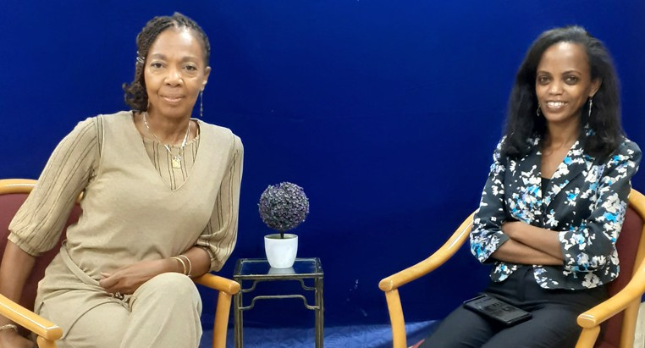
Marcia Brunson Project Coordinator

“For the despairing man there should be kindness from his friend; So that he does not abandon (turn away from) the fear of the Almighty.” (Job 6:14, Amplified)

Previously, First Fruits was able to assist with tree removal for the only cemetery for believers within Jerusalem. These past weeks, we were also able to help Meir, a strong Jewish believer and the attendant at the cemetery with some personal expenses. He is a volunteer who believes God for His day to day care. Because of his duties, he has been adversely affected in his provision, in similar fashion to those who participate in the tour guide industry due to the COVID travel restrictions, as much of his personal financial needs were being addressed by the international visitors to the cemetery.

We were happy to assist this gentleman who was still preparing gravesites for the newly deceased, as he maintains the grounds in the German colony property. Please join us in prayer for him, as he has received a troubling prognosis regarding his eyesight, which could possibly hinder his ability to serve at the cemetery, which is the heart of his ministerial calling.

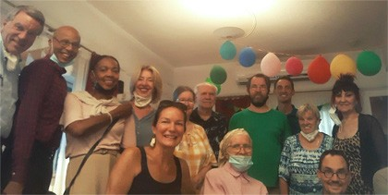
This past month we were also gratified to be in attendance at the birthday party of a longtime prayer supporter of and donor to CFI, Valerie H. Notable guests in attendance included reps from the Jewish Agency and acclaimed CBN correspondent Chris Mitchell. Here is an excerpt of a delightful poem she penned recently:

He is only a prayer away,
wait and listen that His voice is Heard Everyone Is precious in His sight For He has made us and created us
for His pleasure and delight God is ever faithful and ever true.

She has been attentive to the well-being of our founding couple Ray and Sharon and visits the office frequently to encourage me personally in my Outreach capacity and is a living example of that which she has masterfully composed!

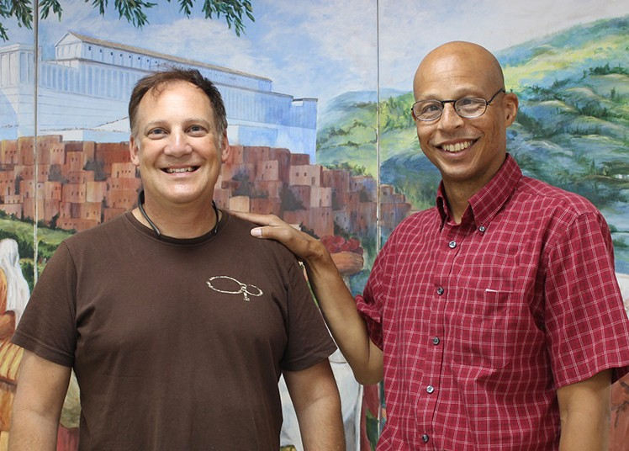
First Fruits was able to procure our 2-wheel dolly and even physically assist some exuberant young believers, Jewish and Gentile in volunteering their time to help an elderly believer and her son move from one condo unit to a larger one in the city near our corporate office. This lady has previously and miraculously recovered from a near death experience and is
an instrumental part of my own personal congregation through prayer and counsel. Her impact on the faith community is palpable and I was delighted to assist! Her son also has an effective witness in the beach culture in Tel Aviv.

There is also a family of four whose father is a minister and psalmist. He was among many in the land downsized out of their regular ministry function due to budgetary constraints imposed by the response to COVID. This father is American and the mother is

Israeli (who is the youngest of 12 siblings…and the only believer so far!) His blended family were obvious candidates for interim support while they transition to other possible congregational roles and determine what is next for them and their precious twin girls in the land during their faith walk!

From supporting volunteers to ministry leaders to widows in the land, it should be clear to you that your efforts, contributions and prayers are helping us remain effective encouragers to those who call Yeshua their Lord! From those who have completed Aliyah to native born, you are making a difference in their success and well-being in His land!

But I have received everything in full and more; I am amply supplied, having received from Epaphroditus the gifts you sent me. They are the fragrant aroma of an offering, an acceptable sacrifice which God welcomes and in which He delights. (Philippians 4:18)

Kim Brunson Project Coordinator

Dear Friend of Israel,

“The LORD is just; He is my Rock, …” (Psalm 92:15a).

Shalom. Recently while visiting a terror victim whose name is Tzuriel, I told him that it is nice to have a name like his that constantly reminds oneself that God is my Rock (Tzuriel, Psalm 92:15a).

Tzuriel has a heart-wrenching story caused by terrorism that made him loath to live after he himself was injured and saw some of his friends were killed by Palestinian terrorists during their army service. After- ward he volunteered to carry out the most dangerous missions, in an attempt to ensure that he himself
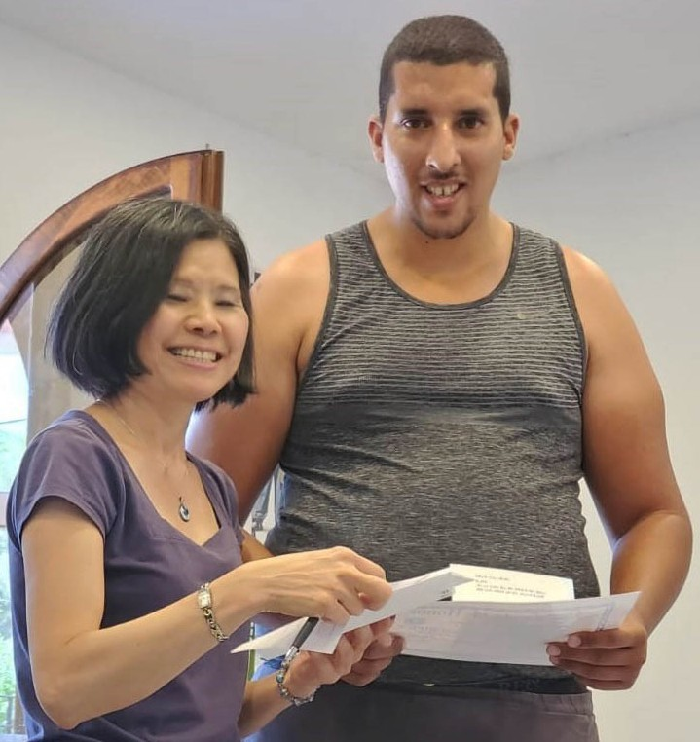
would be killed too. Thankfully God’s plan for him is different from his so Tzuriel was not killed.

However, his post trauma was so severe that he was put in a mental hospital for several years until recently God connected him with one Israeli, who despite himself, was also traumatized during his service in the security forces and has been a tremen- dous help to Tzuriel.

I asked Tzuriel does he still want to die, he said no, now he wants to live and enjoy life. Praise God for giving him this tremendous breakthrough even though he still has long way
to go for total recovery from trauma. Let us lift him up in prayer so that by the help our Rock, the day of his total recovery will come sooner than he expects.

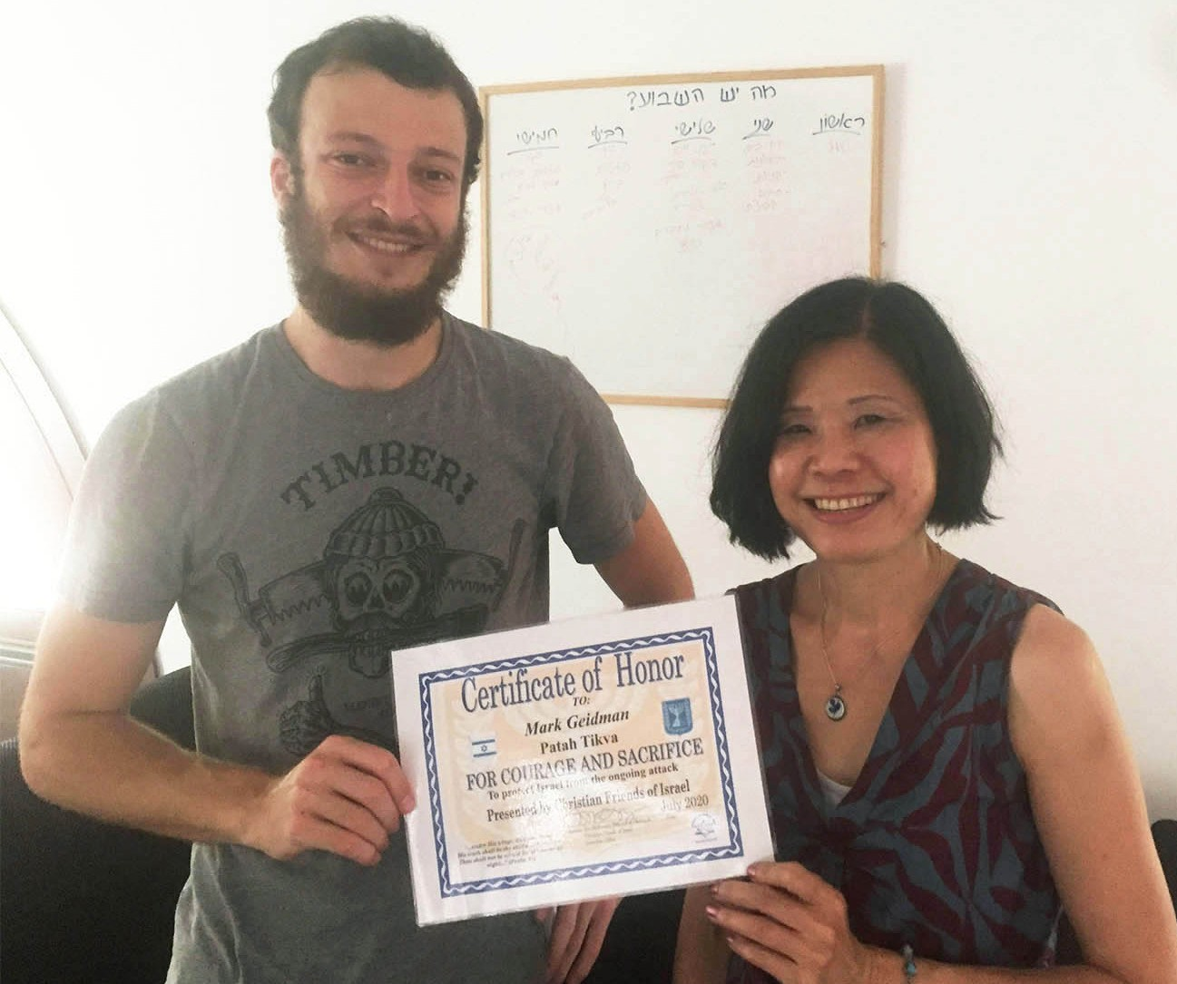
And Mark is another young man who also has been trau- matized but the symptoms manifested after he finished his army service. The Israeli combat warriors have paid a tremendous sacrifice to protect this nation so we can lay down to sleep at night in peace. Mark and many of the former combat soldiers felt abandoned by the Military for the way they were treated, after they are unable to serve because of trauma.

Seeing so many Israelis who were traumatized after their army service, my heart goes out to them, and I wonder how did David’s mighty warriors mentioned in the Bible cope with trauma?

Our visits have brought great comfort, encouragement and love to these traumatized Israeli former warriors; to show them that God cares and recognizes the sacrifice they made and that He wants to bind up their wounds. Thank you so much for enabling Project UHW to do this through your support. May God Himself reward you abundantly for caring for these precious ones suffering post trauma.

Maggie Huang Project Coordinator

Shalom Dear Friend of Israel,

“God is faithful, through whom you were called…” (Luke 1:78)

Praise God that in my recent visit to Luba, who is a rocket attack victim living in Sderot ― a city that has been under constant rocket attack for more than 15 years, God has made His tender mercies known to this precious woman (Luke 1:78).

Like most of the civilians of Sderot, Luba has been traumatized by the constant rocket attacks from Gaza for years, but her trauma is worsened after her recent injuries caused by rocket attack in late August last year, as well as the stress of the huge bank debt also caused by rocket attack.

I sensed a tremendous heaviness hovered over me after sitting down in Luba’s home as she was eager to pour out to me how much she is in need of financial help as well as her trauma. I knew
I needed to turn the tide. I politely told her that money comes and goes and it only can make one happy for a little while. What she really needs is God, to know what He has done for us, and to know Him personally in truth. The Holy Spirit prompted me to lead her to read some Scriptures. Praise God that afterward not only the atmosphere in her house was totally changed so was Luba. I encouraged her to read the Bible daily so her knowledge of God would increase and she would continue to walk with Him.

Also in August Project CUA sponsored the school children of Sderot in a Book Project. We provided them a series of 4 books on the Land of Israel (packed in school backpack). The books will enable the younger generation of Israeli school children to learn about the Land of Israel ― the Land that God promised to give to their Patriarchs as an Eternal Inheritance, so they will learn to love it and cherish it. Thank you for enabling Project CUA to reach out to victims of rocket attacks through your support.

Bless you from CFI Jerusalem.
Maggie Huang Project Coordinator
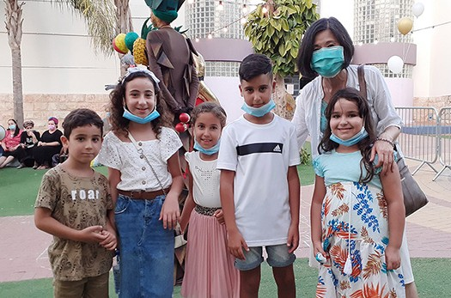
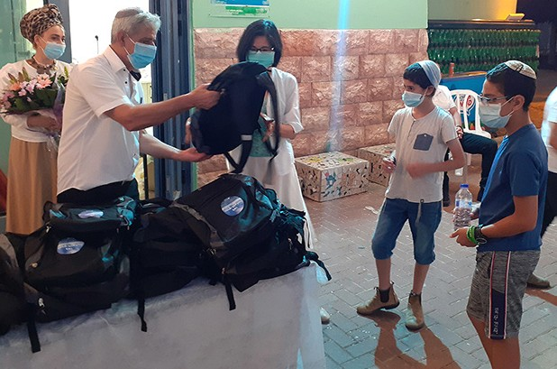

SCARS OR FOOTPRINTS
“Everyone enjoys a fitting reply; it is wonderful to say the right words at the right time!”. (Prov. 15.23)

In the Greek culture one of the customs when burying a deceased is asking the question: did he have passion? Dates are not sculpted on a tombstone, but rather a word that would describe how he would be remembered by all those who knew him.

Of course words harvest actions and what we see around us is the outcome of a specific sowing, not merely produced by external circumstances, but the internal essence, which we feed our inner self with, regardless.

In these moments of CONVID-19 when the whole world is confined to wear masks as a filter in order to communicate, the project Streams of Blessing heard of a wonderful group of teens in Efrat – Judea, who are making a difference in the lives of many. During our visit together with delegates from the local
municipality, we met a couple of young leaders of the community who saw the need to restore and help spiritually and psychologically, the lives of other juvenile victims of abuse, members of divided families and others involved in drugs or alcoholism. They have taken charge of a group of approximately 30-45 high school boys and girls, who receive a warm, safe and caring environment where they can find guidance, interventions, referral services and other appropriate support. This couple of leaders are not professionals, they are students; but a generous heart does not depend on titles or skimp on efforts
to do the right thing.
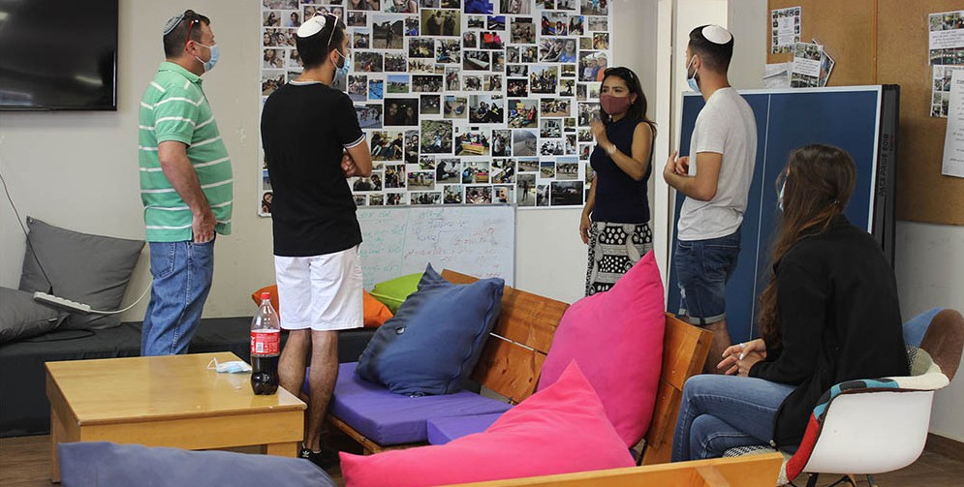

We witnessed the moment when one of the beneficiaries testified about the change he has experienced, including his relationship with his parents. Now he is ready and confident to move on in life to fulfill his duty and serve his country in the IDF. Before ending our conversation, he also with tears in his eyes, told his leader and coordinator: “I will never forget you, you have been a light to my life.”

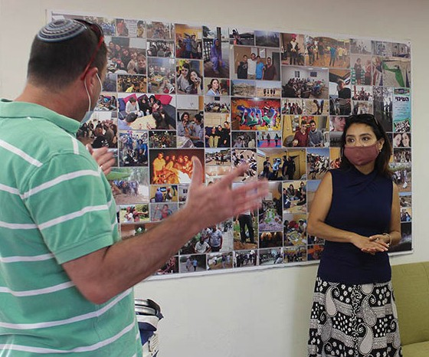
It’s also amazing what is happening in a small caravan. They don’t have all the furniture needed to run their outdoor activ- ities but on the ground, they are cheerfully pouring into what really matters to God for eternity. Christian Friends of Israel in Jerusalem wants to stand in the gap with this passionate small group of people who are determined to face the torrent, and go against the trend. They know they belong to a Land that has fought battles and that exists by faith and conviction of who God is. While many are heading to find safety and comfort, they are travelling opposite direction and are being rescued, equipped and prepared to head to the front lines to snatch and seek the fulfillment of a greater dream.

We are committed to leave people better than we found them, properly. We live in a world where no weapons or war are needed to hurt or even kill the dreams, expectations and desires of someone. We are grateful for each one of you who at distance are praying for the noble service we are providing to the Jewish people as much as we can, but more over we appreciate that your words have turned into actions through your kind donations. May you all be remembered as the invisible hands and feet of God, blessing Israel. “A good man brings good things out of the good stored up in his heart, and an evil man brings evil things out of the evil stored up in his heart. For the mouth speaks what the heart is full of” Luke 6:45.

In Christ and for Israel,

Karen Tohon Project Coordinator

