CFI Projects Monthly Reports for
International
Representatives

Dear CFI International Representative Family,

Thank you for your continued support of the Outreach efforts of Christian Friends of Israel. We continue to strive to encourage those in need and to offer practical assistance during times of struggle. It’s during these times when relationships can be formed which please God and allow us to show Compassion to those who need it the most and have possibly never experienced it before.

During this time of global pandemic, we continue to offer assistance as we are able, and we know each passing day may allow for additional hardships, but we also know the God whom we serve. He is more than able to protect, and provide and heal. We are willing to represent Him to the people of Israel.

Please receive the CFI Outreach electronic updates as a reminder
of the impact each of you have in the lives of so many. We are grateful to represent those of you in the Nations - to those in the Land of Israel.

A friend loves at all times, And a brother is born for adversity.
Proverbs 17:17 (NKJV)

Project Bridal Salon

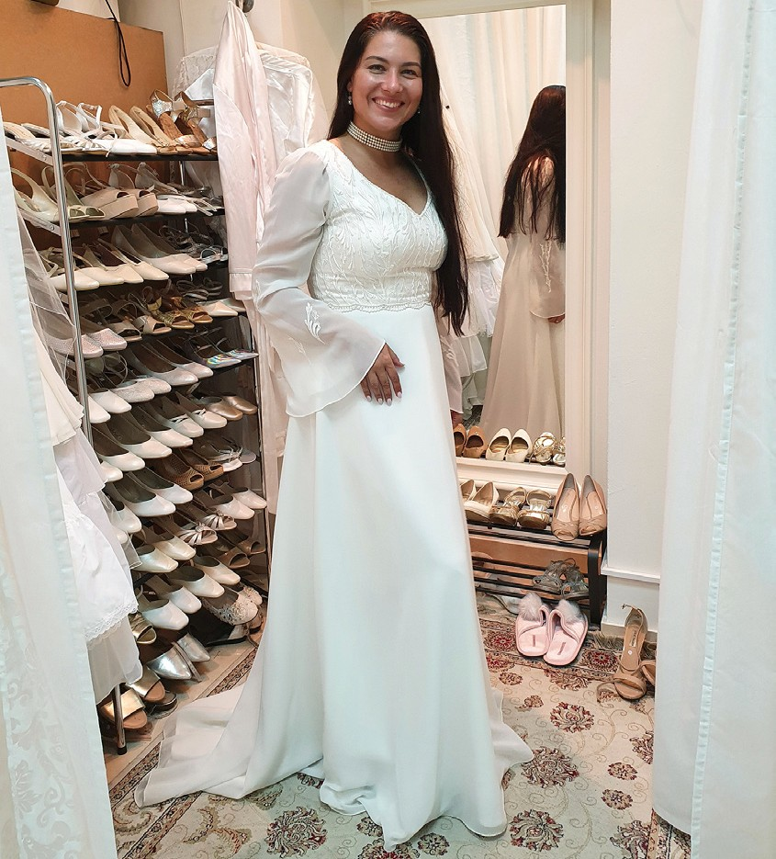
Greetings from CFI- Bridal Salon!

Every week we usually have two or three appointments with brides to be or their relatives. This week for example there was a couple looking for good gowns for the wedding of their close relative. The husband found a suit and the wife found an evening dress and a lace jacket. They were grateful that they did not have to pay a lot of money to get ‘dressed for the coming celebration.’ CFI took care of their outfits.

One young woman came to look for a wedding dress. She was a new immigrant from Germany. She said that it is not easy to be a Jew in Europe anymore. You can’t show openly that you are keeping Jewish traditions there. Many people are against the Jewish nation and religion.

This lady made Aliyah and found the love of her life in Israel. What is very interesting: The fiancé is also a German Jew, who had made Aliyah. They never met each other in Germany. The divine appointment, as she believes, was meant to happen here in Israel. We went through all our dresses with her size and found a couple of good options for our precious client. She will come back, when she knows which dress she wants to wear on her wedding day. The fiancé will also come to look at our suits. I invited them to visit our Open Gates Startup store too. As new immigrants they will get some good gifts from us. “Indeed we really need some household items for our new home.” She said.

One future couple from a messianic congregation will come to choose their wedding gowns next week. They are already excited about the coming appointment. Thank God that we have this opportunity to do good for families of Israel.
“I have been young, and now I am old, yet I have not seen the righteous forsaken or their children begging bread. They are ever giving liberally and lending, and their children become a blessing. Depart from evil and do good; so you shall abide forever. For the Lord loves justice; he will not forsake his faithful ones.” Psalm 37:25-28

A lot of blessings from Jerusalem!
Tiina Danilevski Project Supervisor

Project Under His Wings

Team ‘Under His Wings’ visited a young Jewish man, Tzvi, who made Aliyah from Canada when he was a young boy. Although his parents returned to Canada for a time, Tzvi, came back and eventually his whole family did as well. Despite the hardships of living here, Tzvi, like many others, knew it was where he belonged. We told him that in fact, he was a fulfillment of prophecy… and he told us that we were as well!

Thus says the Lord GOD: “Behold, I will lift up my hand to the nations, and raise my signal to the peoples; and they shall bring your sons in their arms, and your daughters shall be carried on their shoulders.
Isaiah 49:22

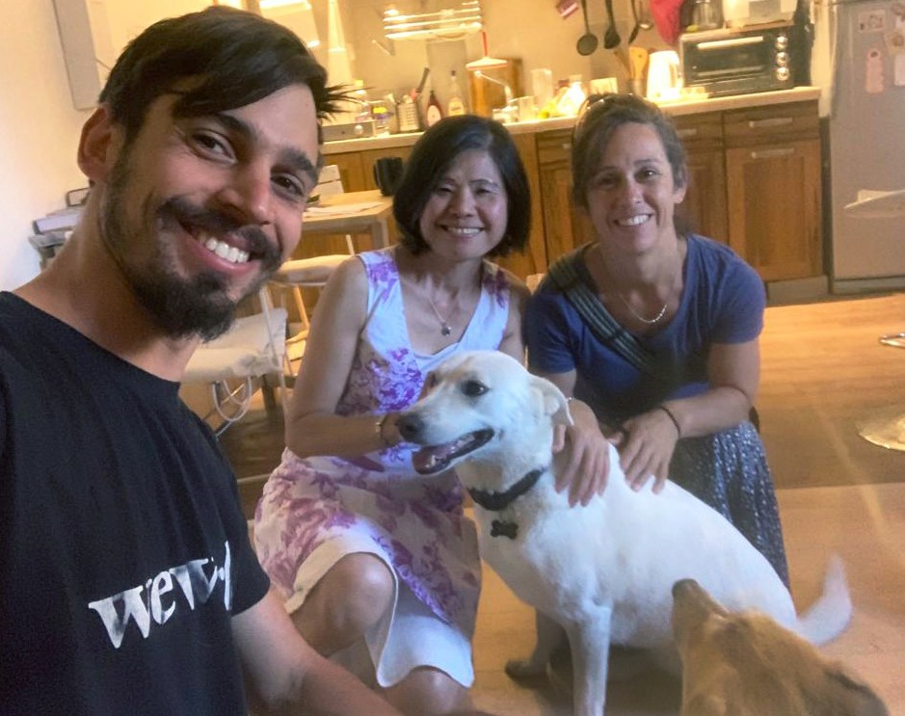
We could only but agree! What a blessing to be in this Land seeing the prophecy of the return of its people fulfilled before our very eyes. While we came to bless Tzvi, we were blessed in return and he graciously told us his story while cooking us delicious omelets! He was such an engaging and gracious host and although sorrow and pain tinged his eyes and face when he spoke
of the trauma that he went through after serving during two wars, seeing friends die on the battlefield, he would always end the sentence with a smile and a word of hope. “Yes things are hard here in Israel, but I want to be the one to help bring about the change…” [paraphrased].

Tzvi received the TANAKH we presented to him with reverence and seemed truly interested in how important, relevant and personal God’s word is to us and seemed surprised to know that the prophets spoke of the end times and events happening in current days!

He explained to us that although he stepped back from the Religious way of his parents, he never stopped seeking God, and indeed, it was because he sought God and questioned the established way of doing things, that he stepped out of that world and ventured into his own quest for knowledge and Truth. Tzvi’s sincerity of heart reminded one team member of Nathaniel when Jesus said to him, “Behold, an Israelite indeed, in whom there is no deceit!” John 1: 47.

Truly we pray and we ask you to pray for his continued healing from PTSD but more so his continued searching and seeking after God and his Truth. Sadly, most Jewish people believe that they must each do “good deeds” or Mitzvot and maybe they will be “good enough” for God, without truly understanding the sin nature and the need for atonement. Many are living a life filled with doubt, fear, and without true healing or true knowledge of The Healer who longs to wipe away their tears and bring them home.

Please pray that in these days leading up to Yom Kippur, the Day of Atonement, many Jewish hearts will seek Truth and will find Him.

Neomi G. Project Supervisor

Project Wall of Prayer

ON THE ROAD AGAIN

“Did you not know that I must be about My Father’s business?” Luke 2:49, KJV.

The Wall Prayer department has been on the move! We are attempting to make the best use of this season by praying onsite wherever God directs us. I feel an urgency to travel now because a time will come when it will not be feasible. Yeshua (Jesus) instructed His disciples to move forward in their assignment by saying, “We must do the work of the One who sent Me, so long as it is day! Night is coming when no one can work” (John 9:4, TLV). Jewish and Gentile prayer warriors from different places accompanied us as we journeyed throughout Israel. We ask the Lord to guide our coming and going so we can pray
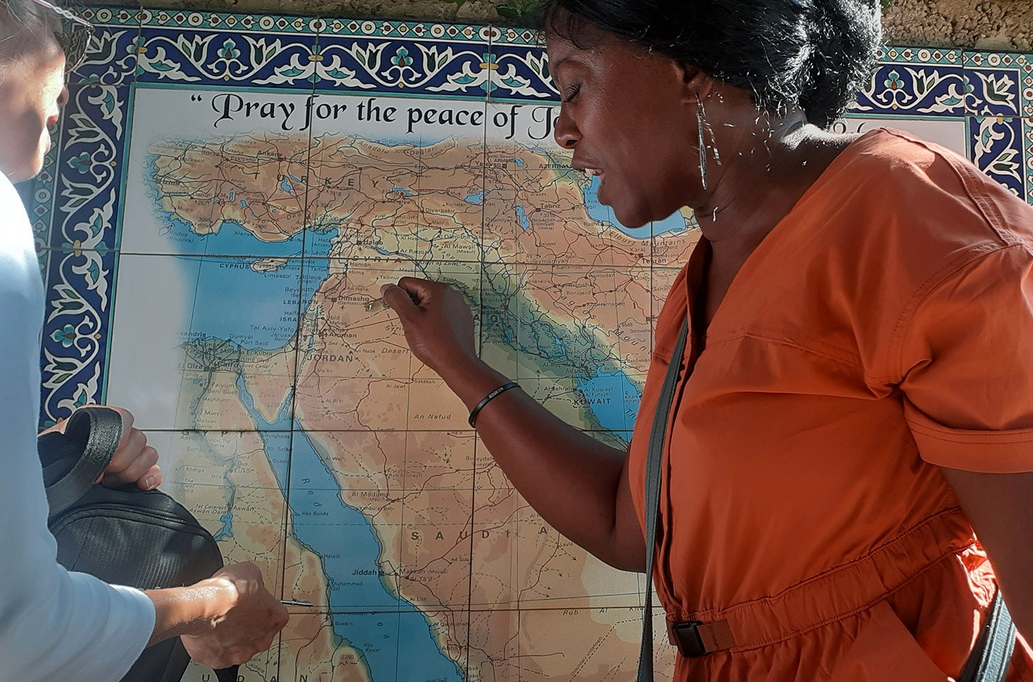
in the locations that He designates. Sometimes we travel by foot, or bus, other times by car, and most recently by train.

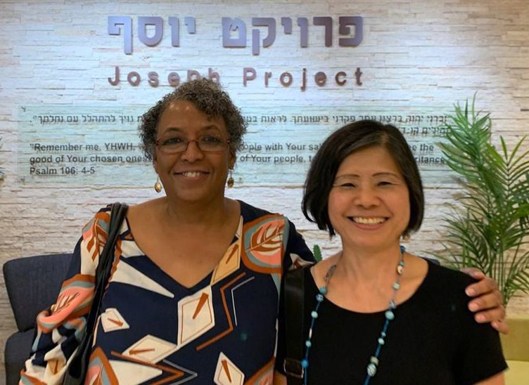
What a powerful prayer time we had when an intercessory team from the U.S. connected with us! Together we offered strategic prayers for Israel and the nations using ceramic maps of the continents at the Jerusalem Prayer Center.

Our next prayer visit was in Beit Shemesh at the Joseph Project, Israel’s largest importer and distributor of humanitarian aid. This organization partners with Christians and Jews to serve the
needy. We prayed for our brothers and sisters at the Joseph Project as they work in their God-given assignment and for those they assist in Israel and abroad.

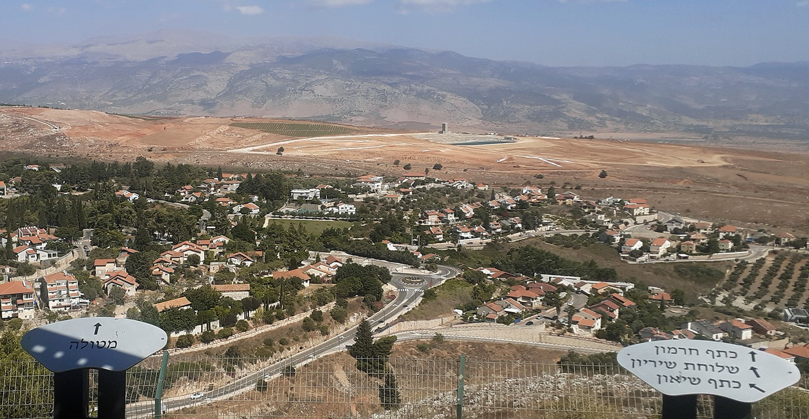
On an extended visit, we took the train north to Nahariya, where we connected with another team member. Our assignment was to drive to some of the northernmost cities of Israel: Metulla, Rosh Hanikra, Kiryat Shmona, and Ein Yacov. We believe the Lord directed us to intercede in these towns because
of their location near the Mediterranean Sea and the

Lebanon border. One of the benefits of praying on site is that you often see things you would not have known to pray for had you not been there. I believe that is one of the reasons God has allowed us to “pray onsite with insight” during this season.
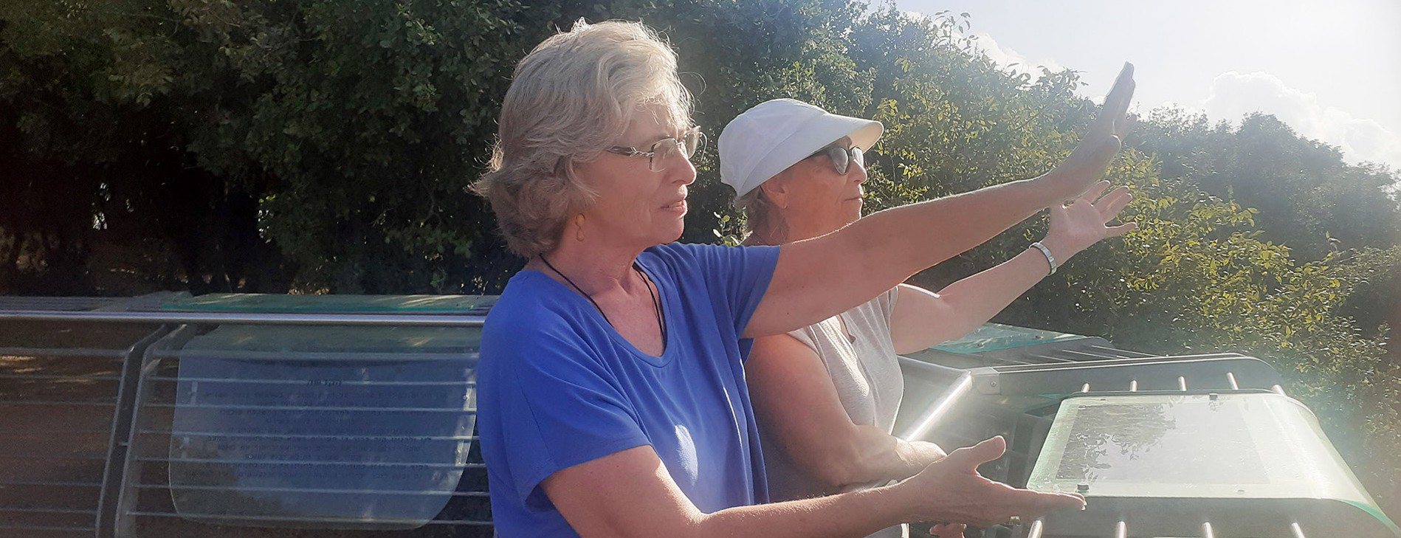

For two days, we prayed while walking the streets and ascending to observation points overlooking Israel, the Mediterranean, and the Lebanon mountains. As we approached soldiers guarding Israel’s borders, we told them we appreciated their service and prayed for them continually. They seemed pleased that someone stopped to thank them for their service. We spoke blessings over businesses, residences, and people everywhere we went. You cannot measure the effectiveness of prayer because intercession often hinders trouble that would have happened had you not prayed.

This month’s visits culminated with a prayer gathering of Arabs, Jews, and Christians who believe in Yeshua. We met in the sanctuary of Kehilat HaCarmel in Haifa. In these meetings, we hear what the Lord is saying to the Body
of Yeshua. The worship, intercession, and fellowship with other believers is always uplifting. No matter how far we have to travel, we return with a sense of determination and strength to carry out our assignment. We must be about our Father’s business.

Thank you for your faithful prayers and support, which allows us to make these prayer visits. God has promised you a reward. “Indeed, whoever gives you even a cup of water to drink because you come in the name of the Messiah – yes! I tell you that he will certainly not lose his reward” (Mark 9:41, CJB).
If you would like our monthly newsletter with prayer points for Israel, please contact us at prayer@cfijerusalem.org. Shalom!
Linda McMurray Project Supervisor

Project Forsake Them Not

“Then again, the one having the likeness of a man touched me and strengthened me.” Daniel 10:18

Oh how we all need His touch, all God’s creation longs for this Divine touch that makes a change. The touch that brings to life, gives strength, opens eyes, heals, sets free, cleans and inspires.
As humans, we realize it especially when we go through the time of desperation, loneliness and pain, physical or emotional.
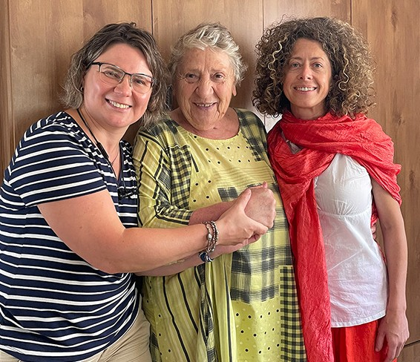
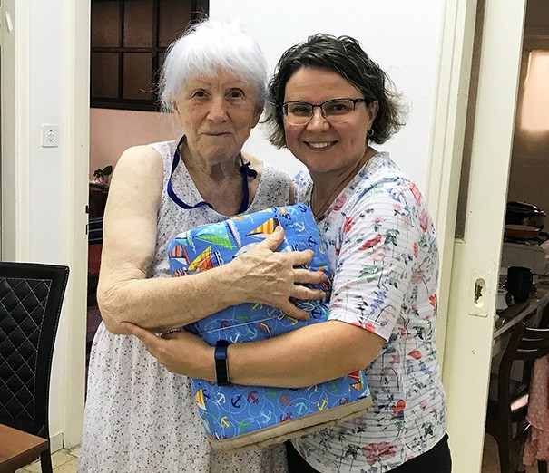

This time when we entered Adelia’s room, she did not meet us with a smile, but started to share about the pain of her loss. Her beloved husband passed away this year. Tears often come to her eyes and she is honest to say that there is no meaning of life for her anymore. We spent a good two hours together with Adelia then her daughter Lena joined us on the visit. Both Adelia and Lena admitted that the time we spent together made such a difference and lifted the heaviness from Adelia’s heart. It was difficult to say good-bye and let Adelia out of our hugging arms, where she feels so comfortable and comforted.

We got to know Boris from his friend, who is also a survivor that we visited. Then at the end of the visit, he told us: “I have a friend who is so lonely; his children moved to Canada. It would be so wonderful if you could visit him too, it would be so good for him!” Finally, we arrived at Boris’s house. There he and his wife shared their story. From first sight, we became so close and developed a mutual trust.

Lena is 82, still active and independent. Now she hosts her daughter from Ukraine, who ran from the war leaving her husband and son behind. They face a lot of uncertainties and have many questions to the Almighty. There are many stories from the past and from the present, which they told us. In such cases, it is always a privilege when we can share a scripture from the Tanach, or say a prayer.

A week after this visit we got a phone call to the office from Emma, Lena’s friend. She was telling us that she is survivor too and wonders why we never visited her. Her friend Lena was touched by the visit so very much that she could not stop talking about it with her friends. We had to assure Emma that soon we would visit her as well.

Those are just few small touches of our big God from this month, which we share with you.

Constantly we keep thanking and praying to God for those who make this work possible by supporting us with prayers or gifts. We are grateful to Him for giving us strength to be your feet and your hands which could touch lives. Together with you, we are praising our Lord, who is the source of all good things and who is faithful in time of need to stretch His loving hands, giving His divine hug!
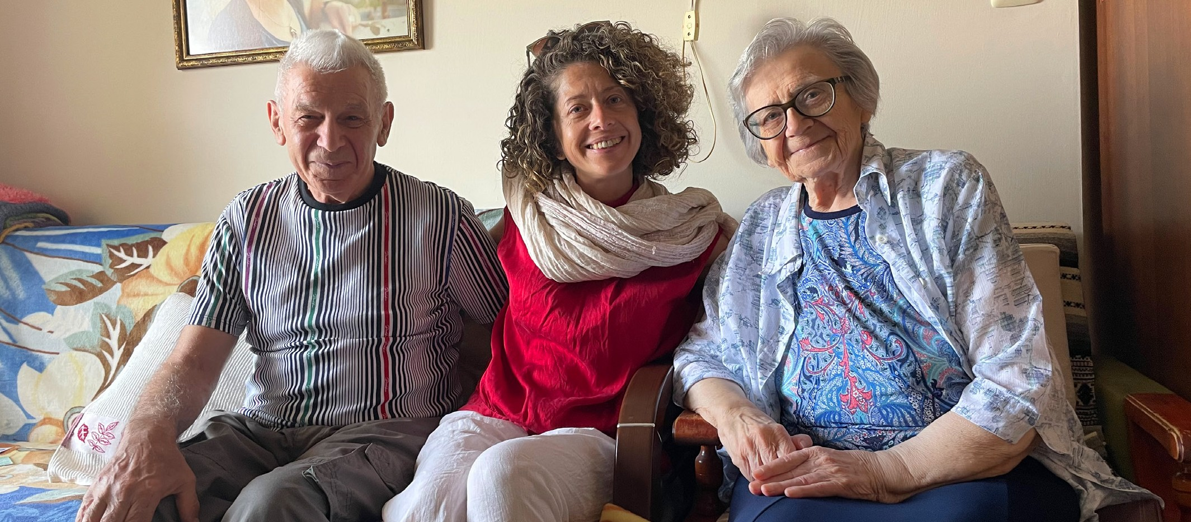

“The Lord builds up Jerusalem; He gathers together the outcasts of Israel. He heals the brokenhearted and binds up their wounds.” Psalm 147:2-3

Olga Kopilova Project Supervisor

Project Open Gates

Shalom from Jerusalem!

This month has been quiet compared to the previous ones. Fewer people are coming, but we served at least a couple of new immigrants from different countries every day. They contact us by phone or e-mail, and we give them an appointment. Some of them just come to our door and ring the doorbell.

The majority of our visitors are still from Ukraine. Some have just arrived in Israel; some moved to Israel half a year ago, when the war began, but they did not know about us earlier. Every week we meet new immigrants from Russia too. They have left their property and made Aliyah because of the political situa- tion. We have never heard any arguing between the new Olim from these two countries at war. They are in the same boat here in their Promised Land.

We have also received quite a lot of new immigrants from
Argentina. These young people seek a better life in Israel, as things become worse in their previous homeland. Some of them are young families with religious backgrounds. Others are students in the language school. They all are very grateful for our help.

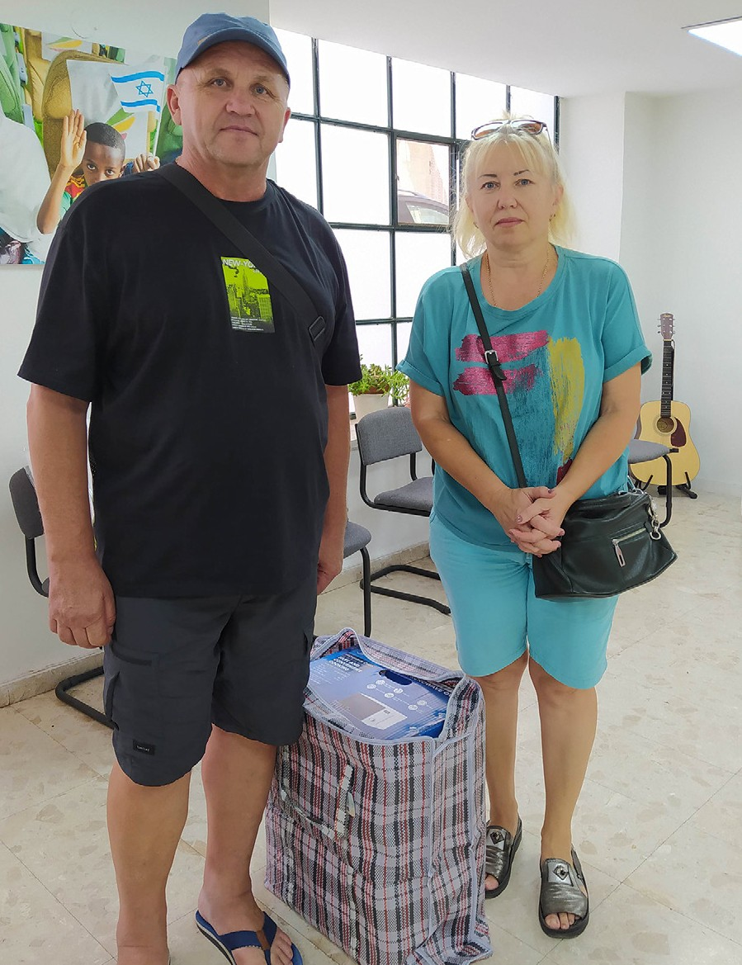
Ivan and Lubov came to our place a week ago. We talked a bit, and I discovered they are from Mariupol, Ukraine. I processed them and welcomed them into the Store. They chose a microwave as their main gift. I did not notice anything special until I asked Ivan to sign the needed paper. He asked his wife to sign it for him since his right hand was injured from a bombing in their previous home city. His hand, arm, and leg were hurt. Ivan and Lubov escaped Mariupol through Russia. A costly operation was performed on his arm while they were there.
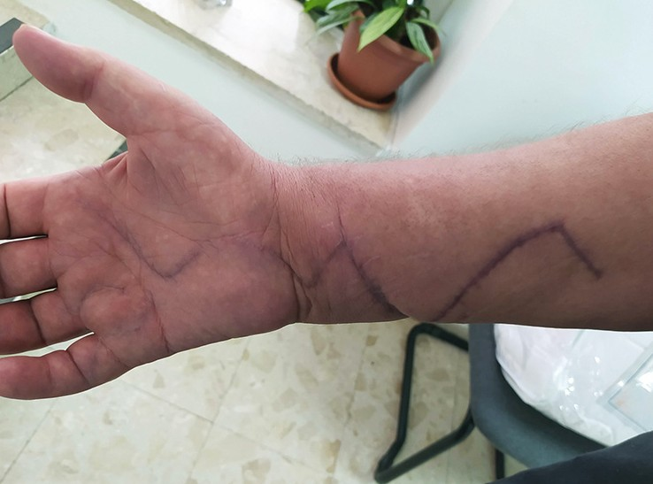
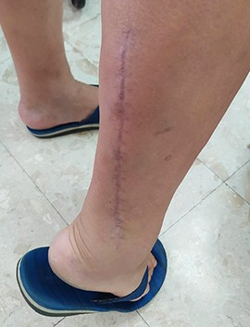

Now they live in Beersheva. Ivan has had appointments with different doctors, but none of them have helped him yet. He needs a good specialist.
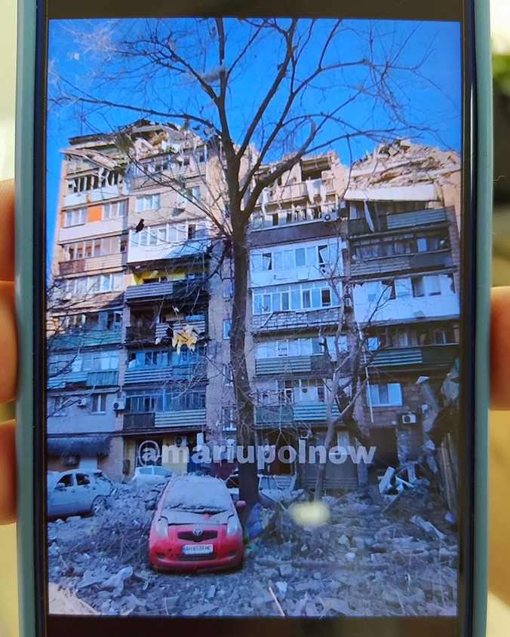
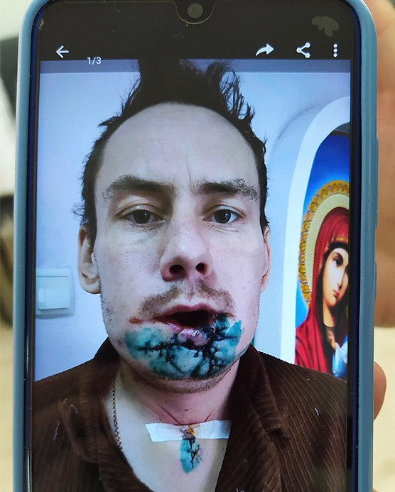

Lubov told us in tears about her nephew, who was wounded even worse. He is still in Ukraine even though he could come to Israel.

Please, pray for these two men! May the Lord touch their hearts and bodies. May they come to know the God of Israel.

“Come, let us return to the Lord; for it is he who has torn, and he will heal us; he has struck down, and he will bind us up. After two days, he will revive us; on the third day, he will raise us up, that we may live before him. Let us know, let us press on to know the Lord; his appearing is as sure as the dawn; he will come to us like the showers, like the spring rains that water the earth” (Hosea 6:1-3).

Thank you for being with us in this ministry!

Tiina Danilevski Project Supervisor

