CFI News Insights
Christian Friends of Israel
feedback@cfijerusalem.org
www.cfijerusalem.org

December 25, 2021 /Jewish Year 5782

Jewish Housing or Shared Airport
Dilemma of Construction at Atarot

There is an area of contention between not only the Israeli and Arab local communities within Jerusalem concerning building plans but also between national and international ideologies that have differing opinions about the path forward to eliminate hostility within the city and what the makeup or definition of this city, God’s city, should ultimately be. Atarot originally operated as a moshav prior to WWI, then again during the 20’s and 30’s before the British Empire expropriated the land to establish an airport for Jerusalem. The settlement area was evacuated and remained in Jordanian hands until the 6-day war in 1967. An industrial area was developed there, but an airport ceased to function as a casualty of the 2nd intifada in 2000.
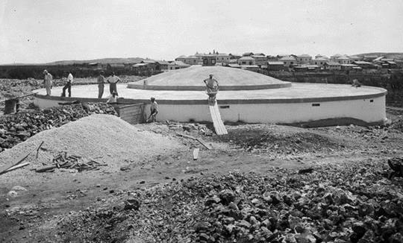
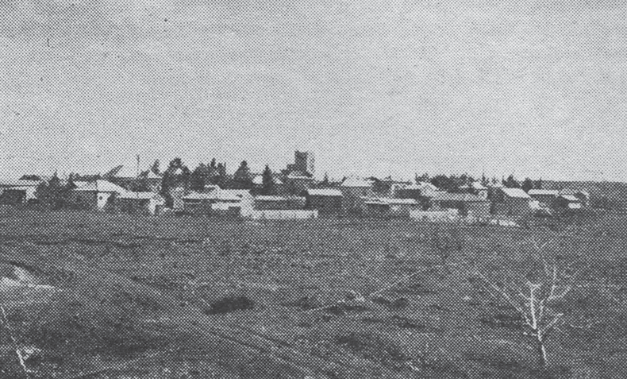
Atarot construction of water tank 1928 (Wikipedia) The Atarot moshav in 1944 (CC BY-SA 3.0, Wikipedia)

With recent housing availability strains in Jerusalem, the municipality has sought to establish 9000 housing units, mainly meant for the Haredi community adjacent to the ground where the non-functioning airport now sits. Establishing a neighborhood here reinforces the identity of Jerusalem as an undivided metropolis, indeed capital, under sovereign Jewish control. This narrative does not resonate well within the Palestinian leadership, nor the left leaning voices within Israel and outside. Building housing here is interpreted as provocative by definition and alternatives should be explored, this group contends. One such alternative that has been floated is the re-establishing of service and modifying the airport to accommodate not only the Jewish population, but also the Arab population, whose international travel options are currently limited to special permission for use of Ben Gurion or transport through the West Bank into Jordan and out from Amman.
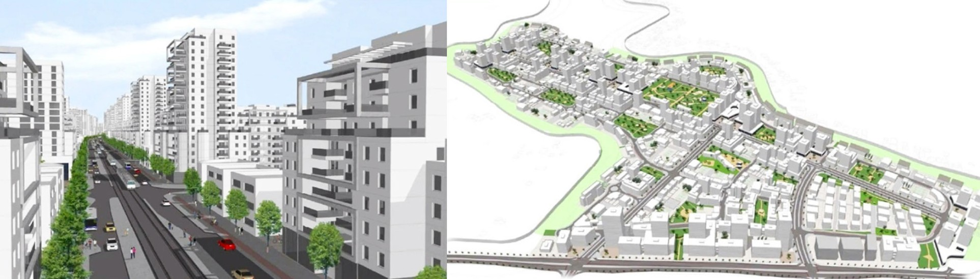
The project, would see the construction of 9,000 housing units - designated for ultra-Orthodox Jews - in the Atarot community on an abandoned airport (YouTube)

“Now the king sent word and called for Shimei and said to him, ‘Build yourself a house in Jerusalem and live there. Do not go from there to any other place’” 1 Kings 2:36 (AMP).

With Atarot, as with the ongoing conflict in the Judea/Samaria region between the Jewish and Arab populations, about who retains the land and the right to determine its proper use, as believers in the earth, we know that the root of these disputes here are not ideological at all. They are theological. If your theological understanding leads you to believe in the veracity of Tanahk (Old Testament) and the Deity that is portrayed within its pages, then establishing the residence of a Jewish person within Israel could not be considered provocative in and of itself. If you currently adhere to the teachings that promote the existence of, or allegiance to a different Deity…or no Deity at all, you might come to a different conclusion based on worldly or idolatrous concepts of fairness or equity. Those of us who have aligned with YHVH, the God of Israel have more than a hint about the destiny of land and those who will ultimately possess the entirety of the borders promised to Abraham, and can’t go wrong praying in agreement with God about that destiny. Especially with respect to Jerusalem, its eternal capital. As we agree, we reap spiritual and natural benefits from being grafted into Israel’s covenant by faith in the Messiah Yeshua/Jesus (Romans 11:17), both in this life, and the one promised throughout eternity.
Reporting from Jerusalem,
Kim S. Brunson

