February 25, 2022 /Jewish Year 5782

Eruptions and Tremors
Creation groans eagerly for redemption

“For nation will rise up against nation, and kingdom against kingdom; there will be earthquakes in various places; there will be famines. These things are the beginning of the birth pangs [the intolerable anguish and suffering” Mark 13:8 (AMP).

“He looks at the earth, and it trembles; He touches the mountains, and they smoke” Psalm 104:32 (AMP).
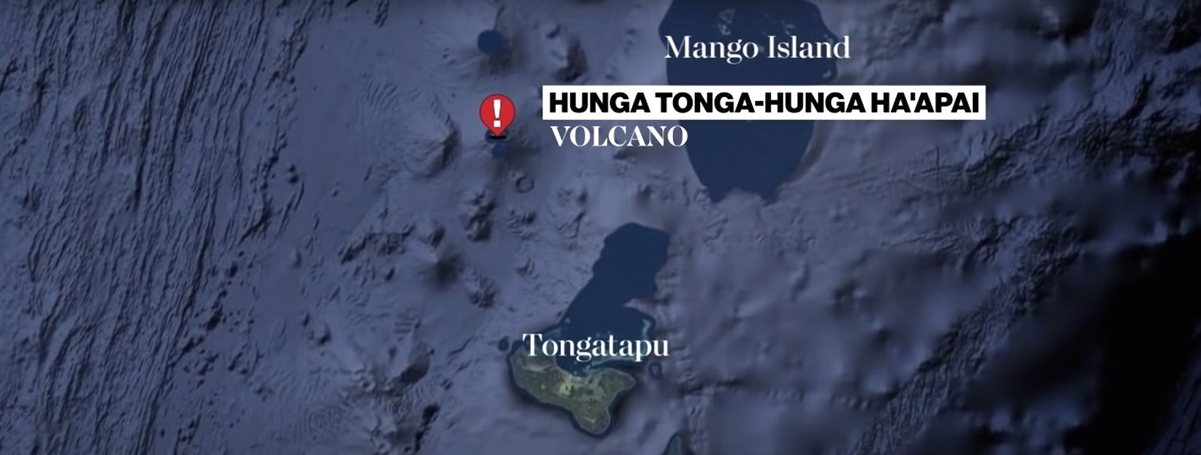

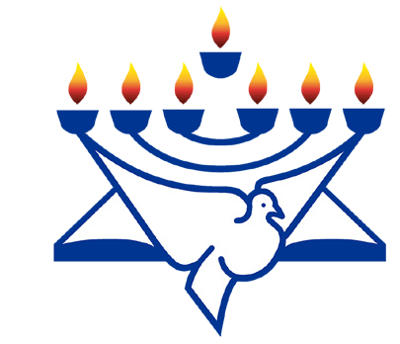
CFI News Insights
Christian Friends of Israel
feedback@cfijerusalem.org
www.cfijerusalem.org
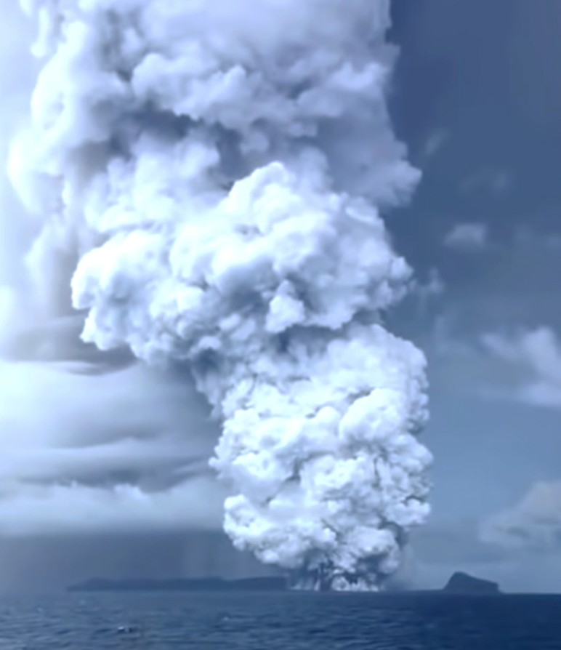
The most powerful eruption ever recorded
(YouTube)
In mid-January 2022, a significant event took place in the south Pacific in Tonga: the earth witnessed the largest volcanic eruption in over 30 years. This sparked a tsunami that affected a large area of the Pacific and caused unusually high tides all the way to the west coast of the Western Hemisphere. From the epicenter all the way to Peru in South America, this event caused some loss of life, major beach erosion, property damage and reminds us on planet earth how volatile nature can be on any given day, in any given place. This event took place in what is known within the scientific community as the “Ring of Fire.” According to Wikipedia, this area is a volcanic belt that surrounds the Pacific Ocean from three sides.. Strong earthquakes also occur more frequently along this ring. These sometimes trigger the tsunamis typical of the Pacific.” With the Ring of Fire now becoming so active, (many believe) those living on the west coast of North America should particularly be on alert. Scientists have been warning us that “the Big One” is way overdue, and at some point time will have run out and it will finally be here. This is something alluded to by scripture, but heretofore has not affected major INDUSTRIAL populations during the modern era.

Here in the northern part of Israel, the nation and some of its neighbors experienced not 1, but 2 earthquakes within a ½ day of one another, which has been unprecedented in populated areas, until recently. About 10 days prior, there had also been a quake off the coast of Cyprus in the Mediterranean which was about twice as strong as the tremors felt in Nazareth and Tiberius. The earth itself both here and abroad seems to be crying out for a rejuvenation or re-boot, much like the population is longing for spiritual renewal and restoration, individually and on a wide scale.

“Behold, the LORD lays waste to the earth, devastates it, twists and distorts its face and scatters its inhabitants. The earth will be completely laid waste and utterly pillaged, for the LORD has spoken this word. The earth dries up and crumbles away, the world dries out and crumbles away, the exalted of the people of the earth fade away” Isaiah 24:1, 3-4 (AMP).

As believers, we should be as cognizant of the atmospheric and tectonic trends in the earth as much as we are about the geopolitical twists and turns of our political systems. Not to walk in fear or anxiety, but as another tool in our kit to bring attention to how awesome and sovereign the God OF ISRAEL is and perhaps how close to the restoration of all things we might be. We are convinced that the Most High God is giving us ample warning to make certain that we have proper relationship with Him, ourselves, our brethren and His land and to act accordingly.

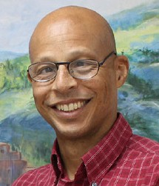
Reporting from Jerusalem,
Kim S. Brunson

