CFI Projects Monthly Reports for
International
Representatives

Dear CFI International Representative Family,

Thank you for your continued support of the Outreach efforts of Christian Friends of Israel. We continue to strive to encourage those in need and to offer practical assistance during times of struggle. It’s during these times when relationships can be formed which please God and allow us to show Compassion to those who need it the most and have possibly never experienced it before.

During this time of global pandemic, we continue to offer assistance as we are able, and we know each passing day may allow for additional hardships, but we also know the God whom we serve. He is more than able to protect, and provide and heal. We are willing to represent Him to the people of Israel.

Please receive the CFI Outreach electronic updates as a reminder
of the impact each of you have in the lives of so many. We are grateful to represent those of you in the Nations - to those in the Land of Israel.

A friend loves at all times, And a brother is born for adversity.

Proverbs 17:17 (NKJV)

Project Open Gates

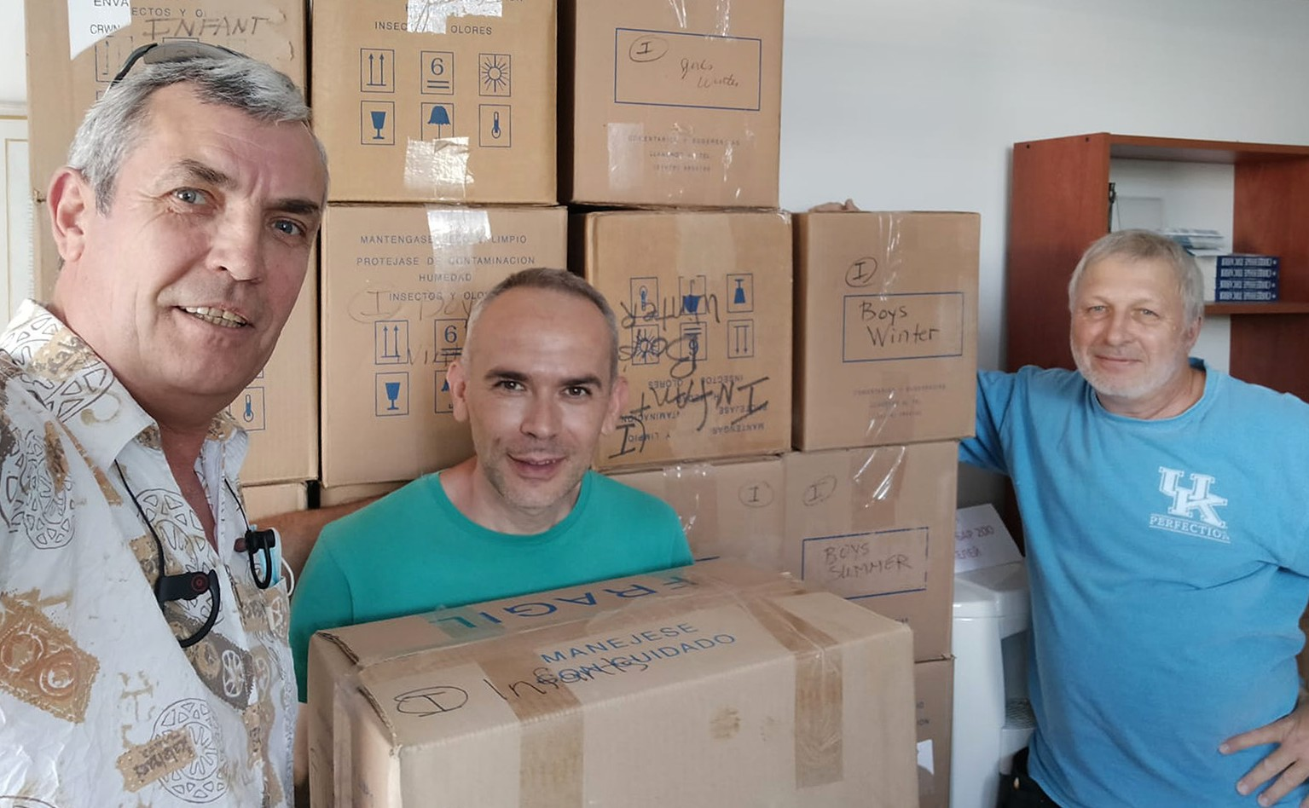
Shalom our friends!

This month has been very busy. We are giving most of our clothing to other ministries who are helping people in Jerusalem and in other cities of Israel. Things are changing fast in the project of Open Gates.
People have still been coming to take clothes during the morning hours. There have been new immigrants, pensioners and other people who have been blessed at our place with good quality items.

Here are some words from them:

Hello! Once again I want to say ‘THANK YOU’ for your activity of charity, which really helps and supports people who are in need. I wish your organization strength and long existence!

Oksana Primak

Dear friends! I can’t put into words the gratefulness that is filling my heart. I understand very well, how many people are involved in packing and sending these items and how much warmness and love has been put into this process! Every time when I wear a gown or some other thing given by CFI, I remember and think about you with thankfulness. May you all be in good health! May God protect you and help you in your activities. With a huge respect and appreciation,

Tatyana Stepanova
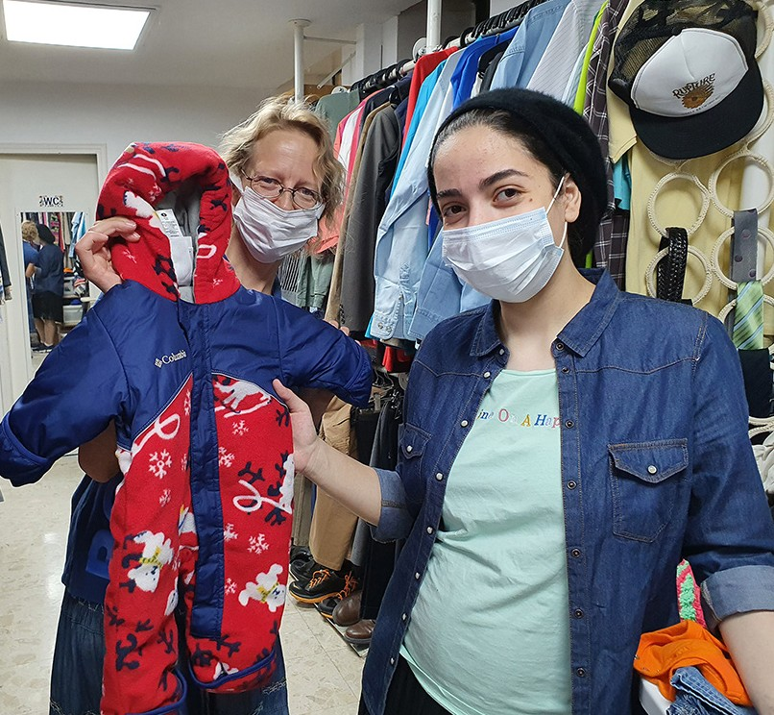

Please, pray that the Lord will guide us all during this time of change. Thank you for being with us.
Tiina Danilevski Project Supervisor

Project Under His Wings

Shalom Dear Friends of Israel,

“The LORD is my shepherd; …He restores my soul” (Psalm 23:1a & 3a).

During my visit to Elad and Noam who are traumatized former IDF soldiers, it was heart wrenching to see how post trauma has cost them what is most precious to them.

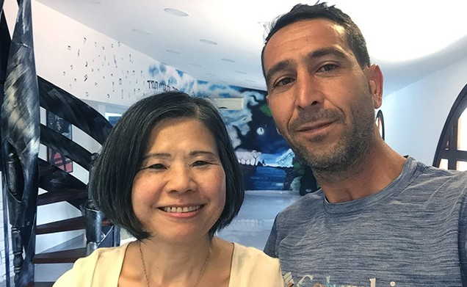
Elad is from Beer Sheva (Beersheba) in Southern Israel. When he was doing his compulsory military service, he was stationed in Gaza (before the Gaza Disengagement). He saw terror related and horrible scenes all the time and also encountered several life-threatening situations.

After his army service, Elad completed his higher education, had a job and even got married and had
2 children. Then symptoms of his post trauma started to come to the surface. He said his ex-wife was the
first person to recognize that he had post trauma but she was unable to cope with this. He was in tears, saying his trauma has also affected his children. To prevent causing them further suffering, Elad and his wife divorced and he could not see his children.

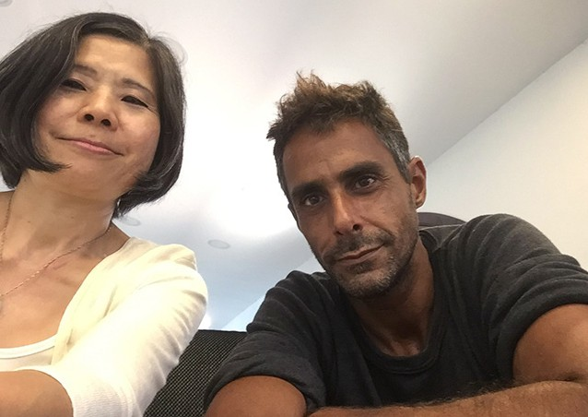
Noam is from Holon in Central Israel. He served as a commander in the Elite Egoz combat Unit. He performed dozens of activities and operations to counter the enemies of Israel. His friends said their relationship with Noam was terminated for a number of years after their military service. Finally they discovered that he had been hospitalized in a psychiatric ward for 11 years. In a search for him, he was found homeless dumped on the streets of Holon. They collected him and transferred him to a Trauma Rehab Center for rehabilitation. Noam has suffered acute combat reactions and his condition is severe.

Many Israelis serving in combat units have suffered post trauma, but sadly they were not given the proper treatment they need. The visits brought encouragement and great comfort to Elad and Noam, knowing that they are not alone and we are praying for them.

Please pray for their mental, psychological, and spiritual health. That through reading the Jewish Bible for comfort in their suffering they also could have an encounter with the Prince of Peace and the Good Shepherd who alone can restore their souls (Psalm 23:1a & 3a).

Dear supporters, thank you so much for being such a great support to Project UHW, it means so much to Elad, Noam and so many other traumatized terror survivors. Bless you from CFI Jerusalem.

Project Communities Under Attack

Dear Friends of Israel,

“…enriching you in every way to all generosity, which produces through us thanksgiving to God” (2 Corinthians 9:11).

Shalom from CFI Jerusalem. In this past month, continuing our outreach to Israelis affected by the recent barrage of rocket attacks in May, Project CUA came alongside some of the civilians of Kibbutz Nahal Oz situated only 800 meters away from Gaza borders. The Israeli civilians experienced many miracles and saw God’s hand of protection in the midst of the severe rocket fire that caused devastation. For that we give thanks to God.

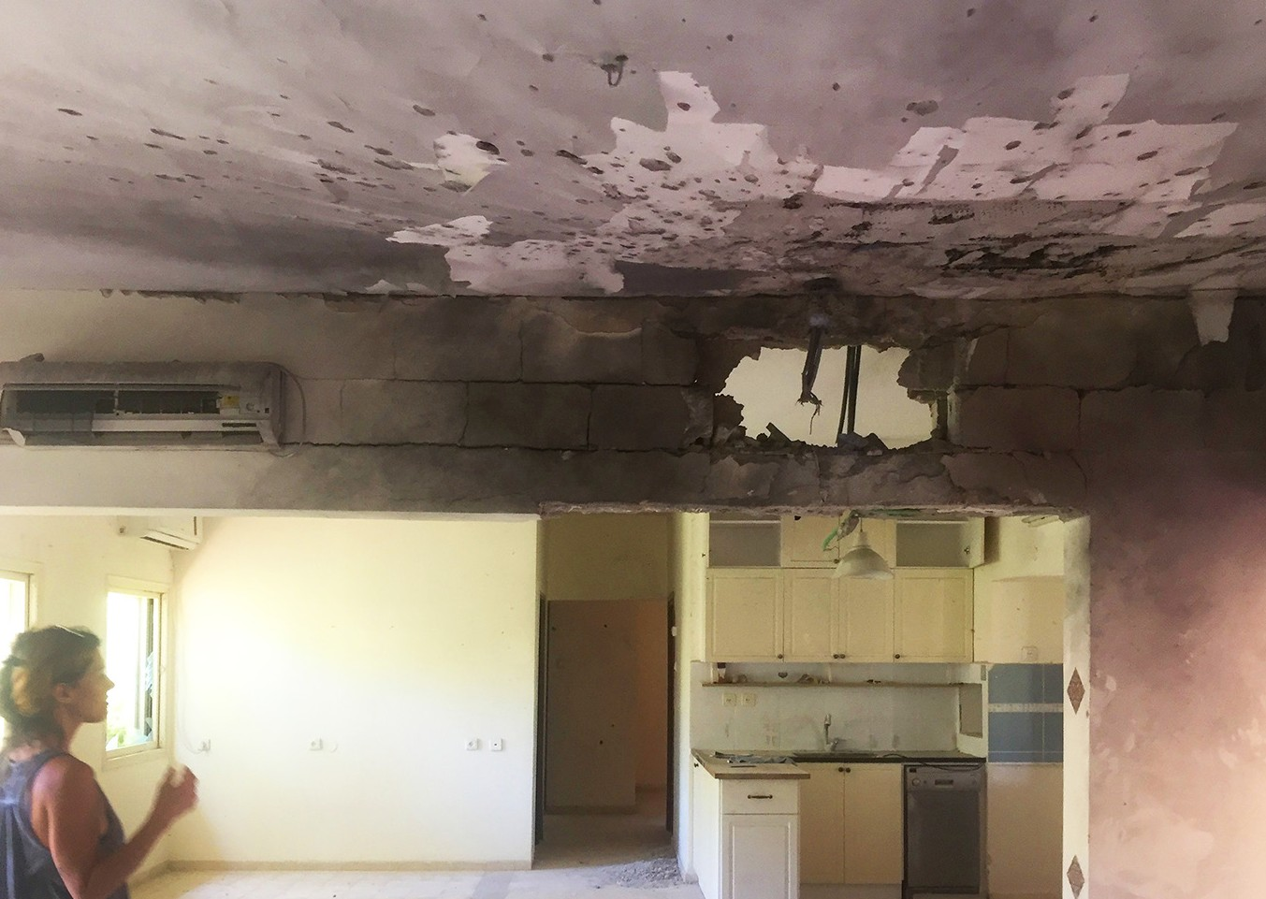
Ella is a single mom who has 2 small children aged 10 and 11. Their home suffered a direct hit by a rocket, but thank God that Ella and her two boys evacuated to her brother’s home near Beer Sheva (Beersheba) so they were not injured when it happened. The explosion of projectiles penetrated every room, causing huge damage to the entire house, making
it unlivable. Currently Ella and her sons are staying in another house temporarily within this Kibbutz. Their house needs to be torn down and rebuilt, and nobody knows how long will it take to go through all the bureaucratic procedures for rebuilding.

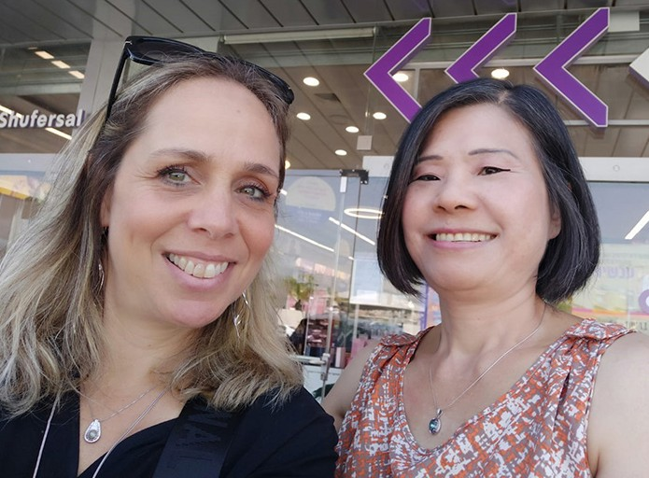
Rotem is also a single mom who has 3 children. She experienced an answer to prayer, which built her faith in God. During these recent intensive rocket attacks, Rotem and her children did not go to another place for refuge but remained in their home. During the 10 days of barrage, all the houses surrounding her home were hit or affected by rocket fire, but their home was protected by God. The current attacks have worsened the trauma of her youngest son who has been severely traumatized since he was four years old and sadly the trauma has affected his studies in school as well as every aspect of his life.

The visits were very encouraging and uplifting to both Ella and Rotem. Thank you so much for your generous financial support, which enables Project CUA to reach out to Israeli civilians affected by this recent barrage of rocket attacks from Gaza, and it resulted in thanksgiving to God. (2 Corinthians 9:11).

May The Lord bless you for your generosity.

Project Wall of Prayer

PRAYING WITH PEOPLE IN ISRAEL

“For You formed my innermost parts; You knit me [together] in my mother’s womb… Your eyes have seen my unformed substance; and in Your book were all written the days that were appointed for me, when as yet there was not one of them [even taking shape]. How precious also are Your thoughts to me, O God! How vast is the sum of them!” Psalm 139:13, 16-17 AMP.

July was an eventful month for the Wall of Prayer Department. There is never a shortage of prayer needs in this world – only a shortage of those who will pray. This month we had an opportunity to pray in a new arena. The most memorable time of intercession was with my friend, Annie, and a prayer team of believers that meet at an Israeli Pro-Life center. The organization assists and encourages women in crisis pregnancies to help them choose life for their children. Annie is a grief counselor at this facility.
She provides support for women who are post-abortive, or have had stillbirths and/or miscarriages. The community prayer group meets weekly at the center to pray for the clients. Counselors, from this network of centers throughout Israel, send their prayer requests to the team each week. The outstanding feature of this prayer time was that the counselors did not combine their prayer requests into one group, but sent individual requests about each girl or woman’s situation. They maintained the client’s privacy by referring to them with a single initial. As we prayed aloud for each mother individually, I was impacted by the thought that God sees us as individuals and addresses our specific needs like a loving father. His care and attention to His children starts before conception and continues forever. We gladly lift our prayers to Him.
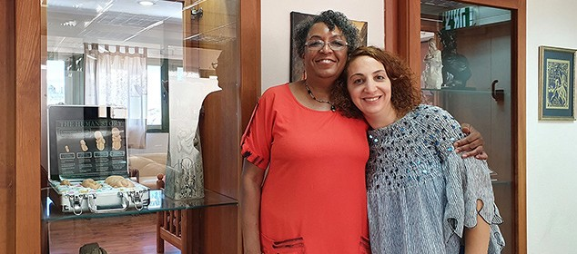
Visiting Annie at the Pro-Life Center

What an honor it is to pray alongside Israeli believers for other Israelis! We are pleased to be the hands, feet and arms of Yeshua extending the love of God to others. Thank you for partnering with us. Your support of this ministry is vital. God has promised to bless us all whether we are called to serve Him at home or abroad. “But David said…For as is the share of the one who goes down into the battle, so shall be the share of the one who stays by the baggage; they shall share alike” 1 Samuel 30:23-24 NASB.

Linda McMurray Project Supervisor

Project First Fruits

“Then Ezra blessed the LORD, the great God. And all the people answered, ‘Amen, Amen!’ while lifting up their hands; and they knelt down and worshiped the LORD with their faces toward the ground” Nehemiah 8:6 (AMP).

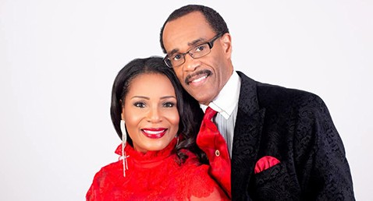
In July, we were able to focus on establishing some ministerial relationships that should prove fruitful.
We were able to connect CFI with Glenn and Ruth Plummers of the COGIC denomination in USA who are now residing in the land to educate Jews regarding the African American community and also to help the African American faith community in the USA move away from anti-Semitic tendencies being fuelled by media propaganda.

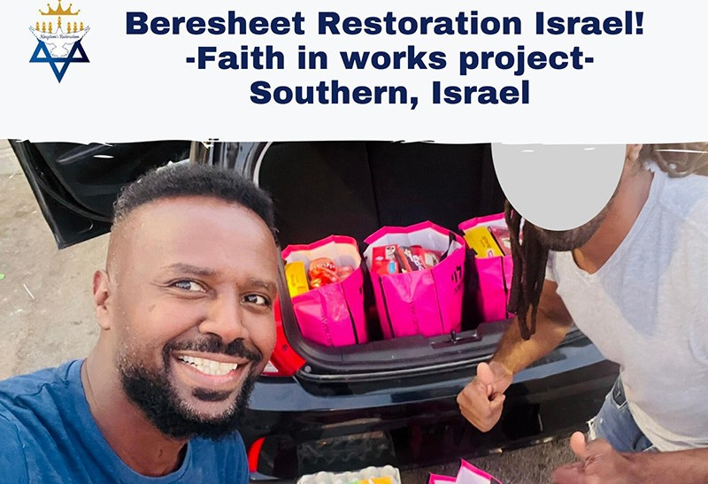
Prior to that interaction, Marcia (the Hope for the Future super- visor) was also able to fellowship with Beresheet Restoration, a new congregation consisting mostly of Hebrew speaking and young Ethiopians. Pastor David Safafa left the legal profession and his governmental career to minister to this generation.
Baptisms are on the rise as they are affecting the secular community, which they have a heart for.

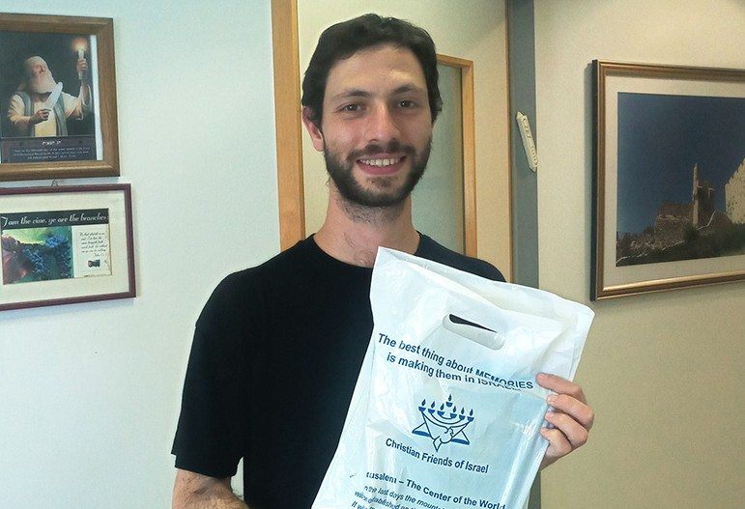
We also invited new olim Matias
from Argentina into our office and gifted him with the Word of God. We were not aware that it was his birthday week when we did so!

I visited Good Shepherd Baptist Church in Nazareth led by Afif and Mimi Saba. Over a meal with the family, Michael Nasrallah (evangelist and our Arab translator for First Fruits)

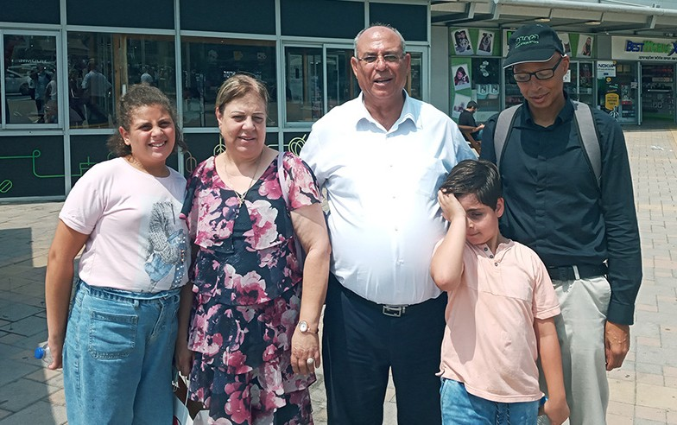
and I were able to share the history and purpose of CFI. The Sabas were not aware of the scope of things
we are committed to do in the land as servants of the Most High. We look forward to interacting with them regarding their ministry and assisting them in the support of their flock and for those within it that might have needs. This would include those who they desire to train up in leadership within their own churches and also churches they are planting throughout the land.

Following our meal with the Sabas, we travelled to the home of the Abdallah family of Kfar Kanna. (This is the biblical town of Cana, where Yeshua performed the “wine from water” miracle at the wedding John Chapter 2). Nabil is a tour guide and businessman who has been buffeted by COVID economically. He also battles diabetes and a heart condition, which has been aggravated by some of his financial worries. He and his wife have one daughter in school in Italy, and four other children at home. Your generous support for food vouchers from the nations has provided for the household and we are able to consider assisting Mrs. Abdallah with ‘bus driver training’ in order for her to secure her next place in the workforce for the family’s benefit, while Nabil waits for tourism to Israel to resume. We prayed for Nabil, who says that he had immediate relief from pain he had from a fall prior to our visit and also via phone with the daughter in Milan, striving to be the best student while separated from her family. As this man shared the integrity of his heart for his family, it was obvious to us that the Father will restore this believer’s promi- nence and good fortune, for His own glory! We are pleased to play a part in that restoration. As I am sure you are also.
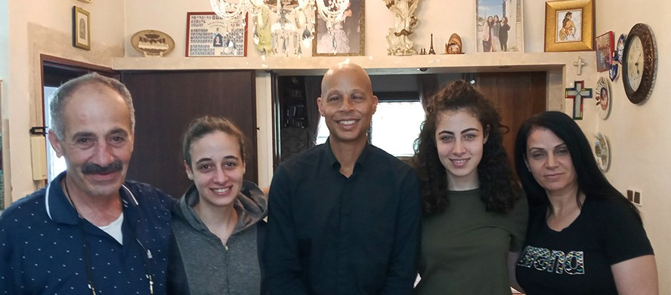

For this is the message which you [believers] have heard from the beginning [of your relationship with Christ], that we should [unselfishly] love and seek the best for one another 1 John 3:11 (AMP).

Kim Brunson Project Supervisor

Project Hope For The Future

Empowerment uppercut for today

When I was contemplating this article title, I wanted to stay on point with the topic and see it from the present era. While volunteering in Israel, I have discovered that the most precious part of our society are the dear females who make the difference in many lives in their roles as mothers, grandmothers and daughters. Carrying the weight to care for others is a blessing. To be able to see the tables turn for the better, to help women to engage and become empowered to seek careers, and for them to see their daughters become knowledgeable about technical degrees. What incredible times we live in! A boxer
sparring in a ring gives us the visual manifestation to think about a true knockout! What is truly necessary to identify how to become a winner is to identify areas in our lives that may be turning points to change and produce the empowerment to succeed. The female gender in the society’s career sector must be influenced to see a road to success as a reality.

“For I know the plans I have for you declares the Lord, plans for welfare and not for evil, to give you a future and a hope” Jeremiah 29:11 (ESV).

Our dear clients with Hope for the Future have jobs showing an uptick in the incredible move toward young girls and women moving out of traditional topic interests such as home economics and beauty careers, to promulgate gender parity in future job indicators for technology skills.

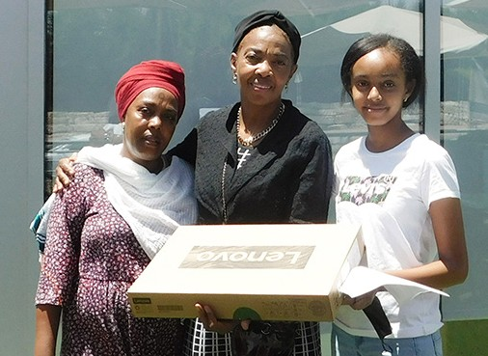
Hanna, a mother from a very religious family in a city outside of Jerusalem, needed to look ahead for her daughter’s future. We addressed her needs with help for the children with their school tuition fees when we initially met her – (she is the only working adult in the home). Hanna wanted her children to have a computer to do their homework and take classes online because of COVID issues. We were so blessed to find an excellent computer for only 1,670nis! It was not fitted with Microsoft but we got great news: the Ministry of Education will download this program for free because the purchase was for school-age children! Wonderful!

Taking quantum jabs at the economic gaps while facing the gender gaps in our work is not a simple task. Hope for the Future would like to be a resource for empowerment and advancement, as a link for Ethiopian women and men to the possible careers that require technological literacy.
We have to switch purposely into the jobs of tomorrow
Our client in Beni Brak, Esmuti finally feels a sense of integrity, after recovering from a bout of low
self-esteem. She is using her talents to work in the medical field, which required some additional educa- tional skills. We may not possess the level of funding to help each and every individual right away, but it should make us all proud of the hard work put in to serve this community, maintaining relationships and staying relevant. I see their eyes and vision have been dramatically shifted to see the prize for themselves, thanks to you and Father God!
Marcia Brunson Project Coordinator

