CFI News Insights
Christian Friends of Israel
feedback@cfijerusalem.org
www.cfijerusalem.org

January 10, 2022 /Jewish Year 5782

Righteous Gentiles
The Place of Nations’ in Israel’s destiny

“But you, O mountains of Israel, will put out your branches and bear your fruit to My people Israel; for they will soon come [home]. For, behold, I am for you, and I will turn to you [in favor], and you shall be cultivated and sown” Ezekiel 36:8-9 (AMP).

Throughout scripture and history, Gentiles have been involved in the fate of Jewry, the existence of Israel and its ability to thrive as a nation-state in multiple ways. Many Christians helped finance and arrange logistics to help Jews in the Aliyah process, whether it was immediately following World War II, Israel’s multiple conflicts with her Arab and/or Muslim-majority neighbors, or the influx of immigrants that came as a result of the fall of the Soviet Empire. Besides this and repeated tourist and pilgrimage support from foreigners into Israel, is the dynamic of many international citizens coming here to work, live and volunteer alongside the citizenry based on biblical instruction or receiving an impression of a directive from Creator God. Christian Friends of Israel was among the pioneer non-profit organizations in the land established to fulfill a role here that would qualify under such a description. We have come alongside, Holocaust, Cold War, and Ethiopian emigres, new brides, national military and local security authorities, individuals and communities victimized by terror, believers in Yeshua/Jesus or just those who have great or dire need in the land.
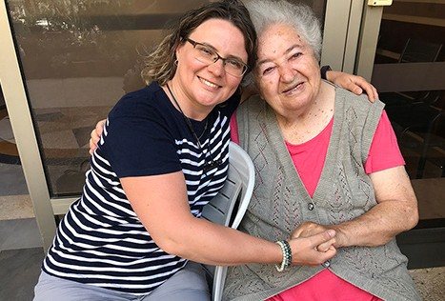
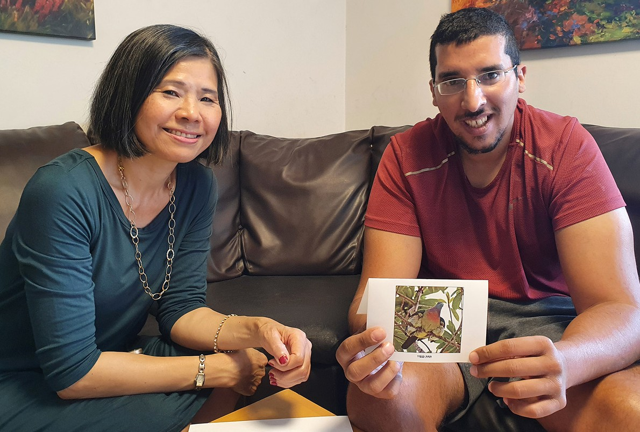

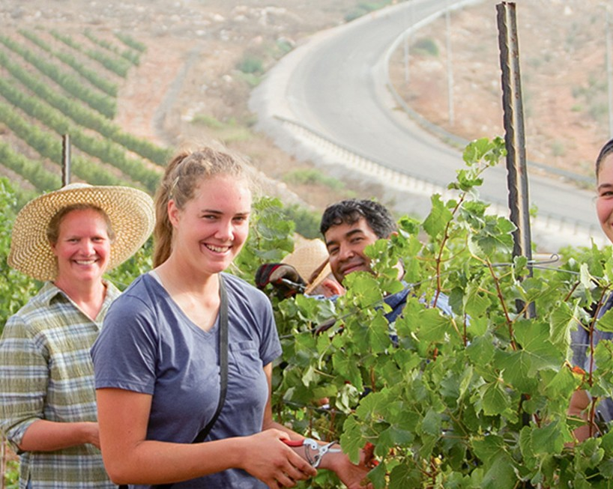
There are other groups motivated to be among those who might be considered righteous Gentles in the land. HaYovel provides a vehicle and platform for international volunteers to be a part of restoring the forestry and plant life, particularly in Judea and Samaria, which is scripturally in the biblical heartland of the nation. Appropriately, this service oriented ministry is based on the the area which Mark Twain described as desolate wasteland when he visited the region at the turn of the 20th century and encompasses the region where 85% of accounts recorded in Tanahk (Old Testament) and the Brit Hadashah (New Testament) occurred.

“Again you will plant vineyards On the mountains of Samaria; The planters will plant And enjoy the [abundant] fruit [in peace]” Jeremiah 31:5 (Amp).
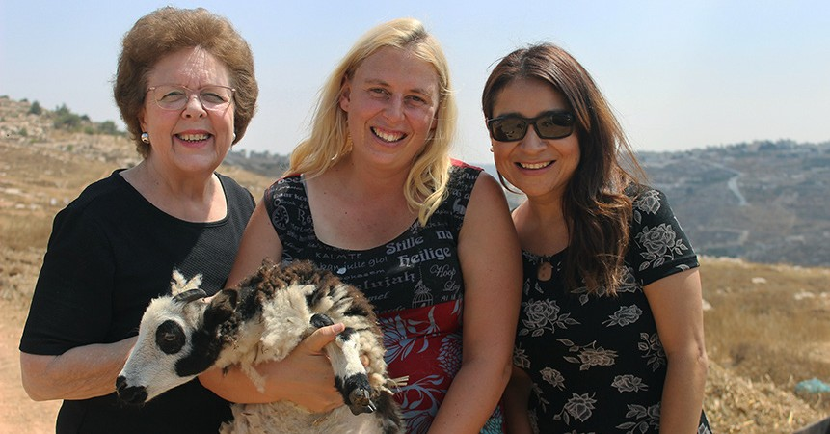

“Strangers will stand and feed your flocks, and foreigners will be your farmers and your vinedressers” Isaiah 61:5 (AMP).

There has been a natural or perhaps supernatural phenomenon occurring in the land of Israel since the ’67 war: Many biblical plants thought extinct or no longer indigenous to Israel and the Middle East have re-emerged in the land. Some with medicinal qualities that have even been alluded to in scripture and some simply that have breath taking beauty indicating that a sovereign Ruler of nature might be pinpointing the direction of His favour at this time in history upon not only the people of His land, but the land of His people. Is it possible that a component of God’s prophetic plan for the restoration of the land be directly tied to the faith and obedience of an international Gentile population that affirms the deity of the God of Israel as depicted in the scriptures that are shared by Jew and Gentile alike? I certainly hope that is the case, as it is the motivation for myself, my wife and many of my other colleagues that volunteer in the land or that participate in a ministry of some kind or another. We encourage you to determine your own piece or part in the unfolding of the destiny of Israel, whether it is where you are currently or if you determine that you should join with CFI, HaYovel or others like us right here in this place at time to be determined in the future.

Reporting from Jerusalem,
Kim S. Brunson

