CFI Projects Monthly Reports for
International
Representatives

Dear CFI International Representative Family,

Thank you for your continued support of the Outreach efforts of Christian Friends of Israel. We continue to strive to encourage those in need and to offer practical assistance during times of struggle. It’s during these times when relationships can be formed which please God and allow us to show Compassion to those who need it the most and have possibly never experienced it before.

During this time of global pandemic, we continue to offer assistance as we are able, and we know each passing day may allow for additional hardships, but we also know the God whom we serve. He is more than able to protect, and provide and heal. We are willing to represent Him to the people of Israel.

Please receive the CFI Outreach electronic updates as a reminder
of the impact each of you have in the lives of so many. We are grateful to represent those of you in the Nations - to those in the Land of Israel.

A friend loves at all times, And a brother is born for adversity.
Proverbs 17:17 (NKJV)

Project Under His Wings

Dear Friends of Israel,

“The Lord is near to the brokenhearted and … the crushed in spirit” (Psalm 34:18).

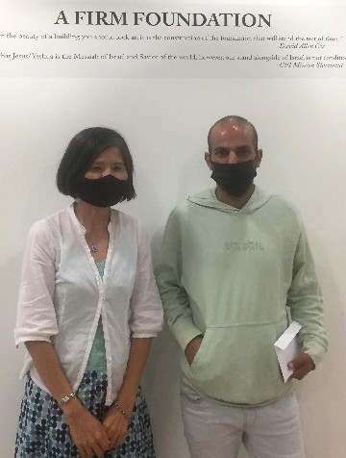
Recently Project UHW had the privilege to visit one terror survivor named Uriel who has a special story. He was raised in an Ultra-Orthodox home but his family disowned him when he decided to join the army.

Serving in the army as a lone soldier, Uriel completed his military service however he was attacked by terrorists during his military service. He was wounded not only physically but his teeth were severely damaged, which for many years have not been treated, as he did not have money for dental work and he has not have family support. Thankfully with the financial support from our supporters, Project UHW helped him with part of the dental payment.

Giselle is another terror survivor who does not have family support. She made Aliyah to Israel alone, as all of her family were killed in an earthquake (she was the only survivor). Not only going through the severe
trauma of losing all her family, Giselle also was stricken by a terror attack while in Israel which has deepened her trauma.

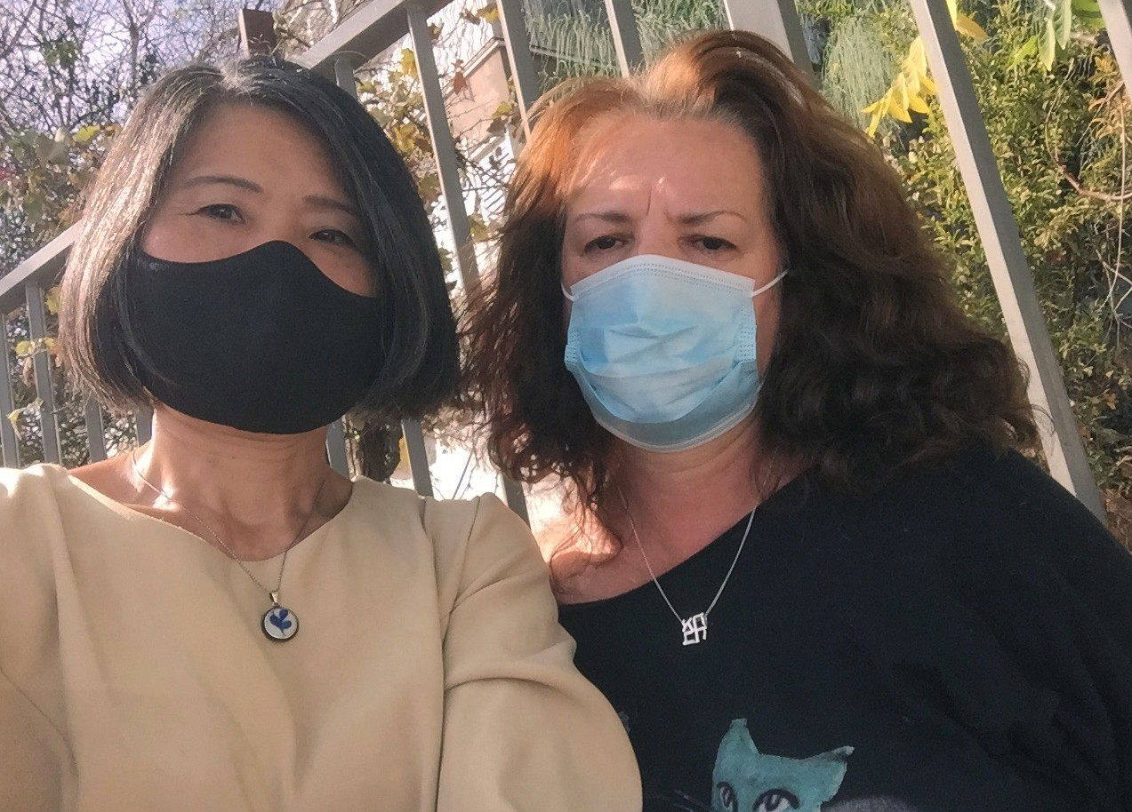
Despite the ordeal, Giselle strives to move for- ward, working as a tour guide, despite all that she went through. However the tourist industry has been the one hit the most severely by Covid; for almost two years now tourists have been prevented from coming to Israel, so that that Giselle has been out of job and therefore has seen no income. We had a deep discussion on Scriptures and faith in God during the visit, and Giselle was deeply moved by the love, care, encouragement and help she received from CFI and our supporters via Project UHW (Psalm 34:18). She asked me to convey her thankfulness to all of you for your support.

Thank you for allowing Project UHW to comfort and touch lives of the suffering terror survivors on your behalf. Bless you from CFI Jerusalem.

Maggie Huang Project Supervisor

Project Communities Under Attack

Dear Friends of Israel,

“When the cares of my heart are many, your consolations cheer my soul” (Psalm 94:19).

Shalom. Continuing the outreach to fire victims, Project CUA reached out to more Israeli civilians affect- ed by the suspected arson in forest close to Jerusalem in mid of August.

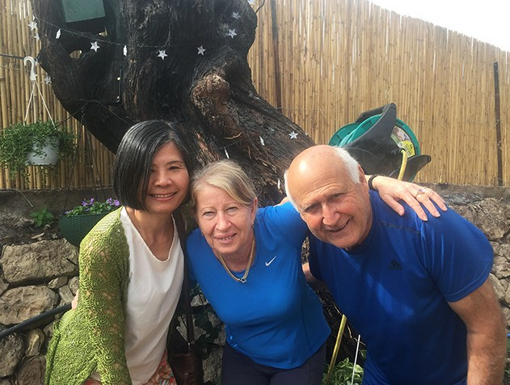
Special relationships were formed between CFI and Israeli civilians whom Project CUA visited. Sara and Shmuel, a couple in their early 70s. Both of them made Aliyah from Poland with their parents when Shmuel was
3 and Sara was 1. They have known each other since childhood and have lived in this neighbourhood all their lives, even after they got married.

The fire caused much damage to their property and several areas of their garden. A large part of the roof of
their machinery room was burned by this fire which also damaged several places within the machinery room, especially their heating system that
provides heat to their entire house in winter. It cost a large sum of money to repair it but the insurance company only gave them a very small amount of financial compensation.

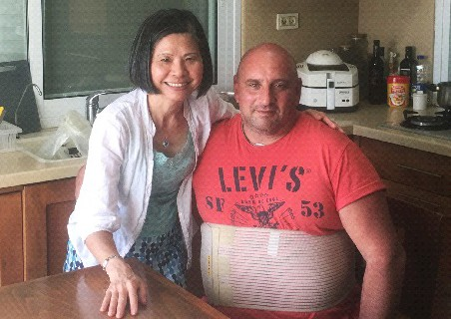
We also visited Moshe who is disabled. Moshe and his wife had a catering business but the facilities were totally destroyed by this fire. They do not have money to repair the damage as the insurance company wouldn’t compensate them. Several of Moshe’s siblings moved to the US, but he didn’t as he is a Zionist. Praise God!

Their hearts were uplifted as well as deeply touched as we ministered to them through scriptures, songs of worship, prayer and love in action through practical help for their rebuilding (Psalm 94:19).

Thank you for making these visits possible. God bless you.

Maggie Huang Project Supervisor

Project Wall of Prayer

A Time to Give Birth

“For everything, there is a season and a time for every activity under heaven: a time to give birth and a time to die, ...a time to tear down and a time to build up; a time to weep and a time to laugh” Ecclesiastes 3:1-4 TLV.

King Solomon, a seeker of wisdom, wrote about life’s different seasons in Ecclesiastes chapter 3. As he searched for the meaning of human existence, Solomon concluded that God has a purpose and timing for everything in our lives.

I witnessed the birth of a long-awaited dream of my Israeli friend, Hanah Wagner, a believer who loves the Lord. A native of Columbia, she and her family lived in the United States, where she completed cosmetology schooling in 1987. Since that time, Hanah has used her skills to bless others by enhancing their natural beauty. She embraced her Jewish background and enjoyed worshipping with other Believers. In 2004, Hanah and her husband attended an Aliyah conference that encouraged Jewish people to return “home” to Israel. During that phase of their lives, God began speaking to them about making aliyah (immigrating to Israel). It was not an easy decision for them, but three years later, they uprooted their five children and moved to Israel.

Moving to Israel meant starting over again, beginning another season in a new culture with a new language. Upon arrival in the Holy Land in 2007, Hanah and her family lived in an absorption center, a temporary housing and training facility. They began learning Hebrew, getting to know Israel, and forming social networks; Hanah also gave birth to her sixth child. She admitted that adapting to her new home was an arduous process. However, this was also when God gave her the dream of owning a full-service beauty salon. She described it as being pregnant with that idea; it was a long-term pregnancy. For 14 years, she carried this dream, but it still had not become a reality.

Living in the land, some of Hanah’s children became adults and had children of their own; she was now a grandmother of 7. Hanah drove to various homes, providing
a door-to-door beauty service to her growing clientele. Several CFI Jerusalem staff became her customers. Because of setbacks and disappointments, sometimes
Hanah doubted if the idea implanted in her mind would ever come to fruition. She thought she was too old to give birth to her dream, but her family encouraged her and came alongside her. They served as birthing coaches and midwives to help Hanah bring forth her
long-awaited vision!

Healthy births are happy occasions, and this birth was no different. To the delight of Hanah’s family and friends, Alma Wellness and Beauty was born on November 15, 2021. Alma is a Hebrew word that means “a young maiden,” as found in Isaiah 7:14; in Spanish, Alma means “soul”. Hanah’s goal is to uplift the souls of those who enter her shop. While she was moving furniture into her new beauty salon, potential customers and staff from surrounding hotels enthusiastically asked about her availability. During the celebration of this beautiful 2-story shop, we gathered to rejoice with Hanah and to hear her story.
Helpers are prepared to assist with her already full schedule. After the ribbon-cutting ceremony, the
well-wishers poured blessings and prayers over Hanah and Alma Wellness and Beauty. The Spirit of the Lord was tangible in that shop.

Romans 12:15 instructs us to “Rejoice with those who rejoice.” We are delighted when God blesses His people. It is a pleasure to encourage Israelis like Hanah with our heartfelt prayers and finances. Friends, it is your love, prayers, and generosity that make these opportunities possible. God has promised to bless you for blessing His Chosen People.

Linda McMurray Project Supervisor

Project Forsake Them Not

“Behold, how good and how pleasant it is for brethren to dwell together in unity! It is like the dew of Hermon, descending upon the mountains of Zion; for there the Lord commanded the blessing - Life forevermore” (Psalm 133:1, 3).

“The dew of Hermon and the dew that descended upon the mountains of Zion, to which the psalmist referred, differs entirely from the ordinary dew of other countries and is a phenomenon peculiar to Israel and the East. It is a soft mist that comes from the Mediterranean during the summer, when the heat is greatest, and the country is burnt up with the terrible sunshine. It is attracted by the inland heights, and condensed in copious moisture upon their sides, and creeps down upon the plains, reviving and refreshing every green thing.” (H. Macmillan, D. D.)

What a beautiful picture of what ‘heart filled fellowship’ brings into our lives, and how much it is needed for our wearied hearts. We have a great privilege to witness how our visits enlighten Holocaust Survivor’s days and bring comfort and refreshment into their lonely routines.

It was so pleasant to finally visit all of our friends in the northern town of Karmiel. We spent four days there, making two trips and seeing, once again, how necessary that attention and fellowship is for the elderly people. Things, as usual, didn’t go according to our original plan, but in all the changes it was so comforting to see how the Lord arranged our steps.

Klara’s memory is fading and she often doesn’t remember what she had for breakfast, or even if she had one. She still lives alone in a hostel for elderly people under the strict supervision of her daughter. “Where have you been all this time? I missed you!” Klara exclaimed when she opened her door and saw me. Our fellowship was full of joy and laughter despite all the challenges Klara faces today.
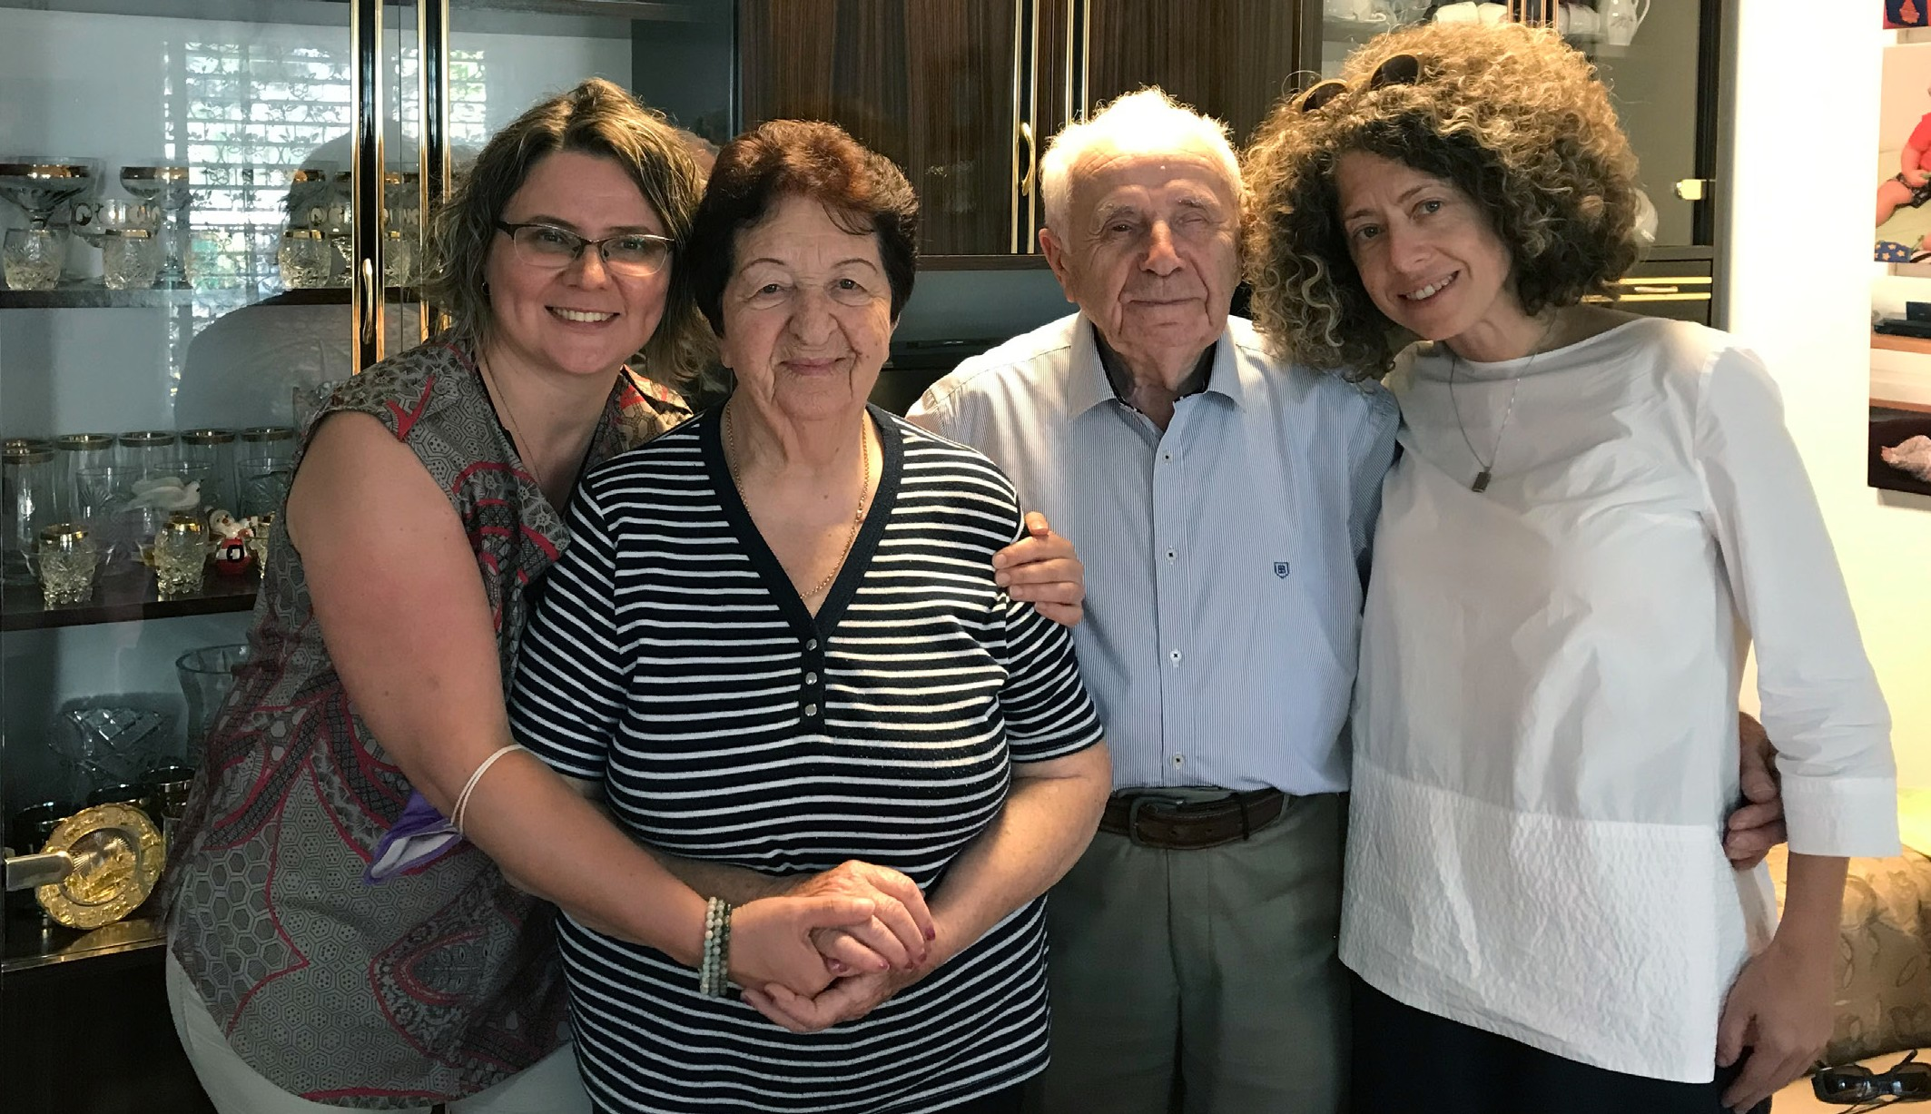

Elizaveta wasn’t home when Tanya came to visit her. It was very unusual as we knew how much she was looking forward seeing us. After finding out she had a doctor’s appointment, we decided to come back later. Oh, how glad we were that we did! It was already late when we finally arrived to Elizaveta’s house. She lives with her daughter’s family and it was a privilege for us to meet them. We also learned that Elizaveta forgot she had an appointment and almost refused to go. There was no limit to her joy when we finally met! We shared news, read Psalms together, spoke of the Goodness and Faithfulness of our Heavenly Father. Elizaveta’s daughter was also deeply moved and encouraged by our visit. She sincerely asked us to carry on the good work we are doing when she walked us to the car. Our hearts were overwhelmed with gratitude.

We called Lev’s daughter to confirm our visit and found out he was in the hospital. We prayed and asked the Lord for healing and opportunity to see him again. A few days later, as we travelled to our destination, we called Lev again and what a miracle – he was back home and invited us to come. We wanted to be sure our visit wouldn’t be too much for him and said we will just come in for a few minutes. Lev’s coun- tenance changed when he saw us, it felt like someone removed a grey blanket from his shoulders. He brightened up and was able to chat, telling us all his news and challenges. He said he suddenly felt so much better and stronger and even his daughter was surprised by such a wonderful change. It was like dew descending upon Lev’s heart and bringing life and peace.

In October we were able to reach out to 48 people, making many trips around Israel. This wouldn’t be possible without you. How good and how pleasant indeed is the fellowship with good friends and family, how much comfort and refreshment it brings to our souls.

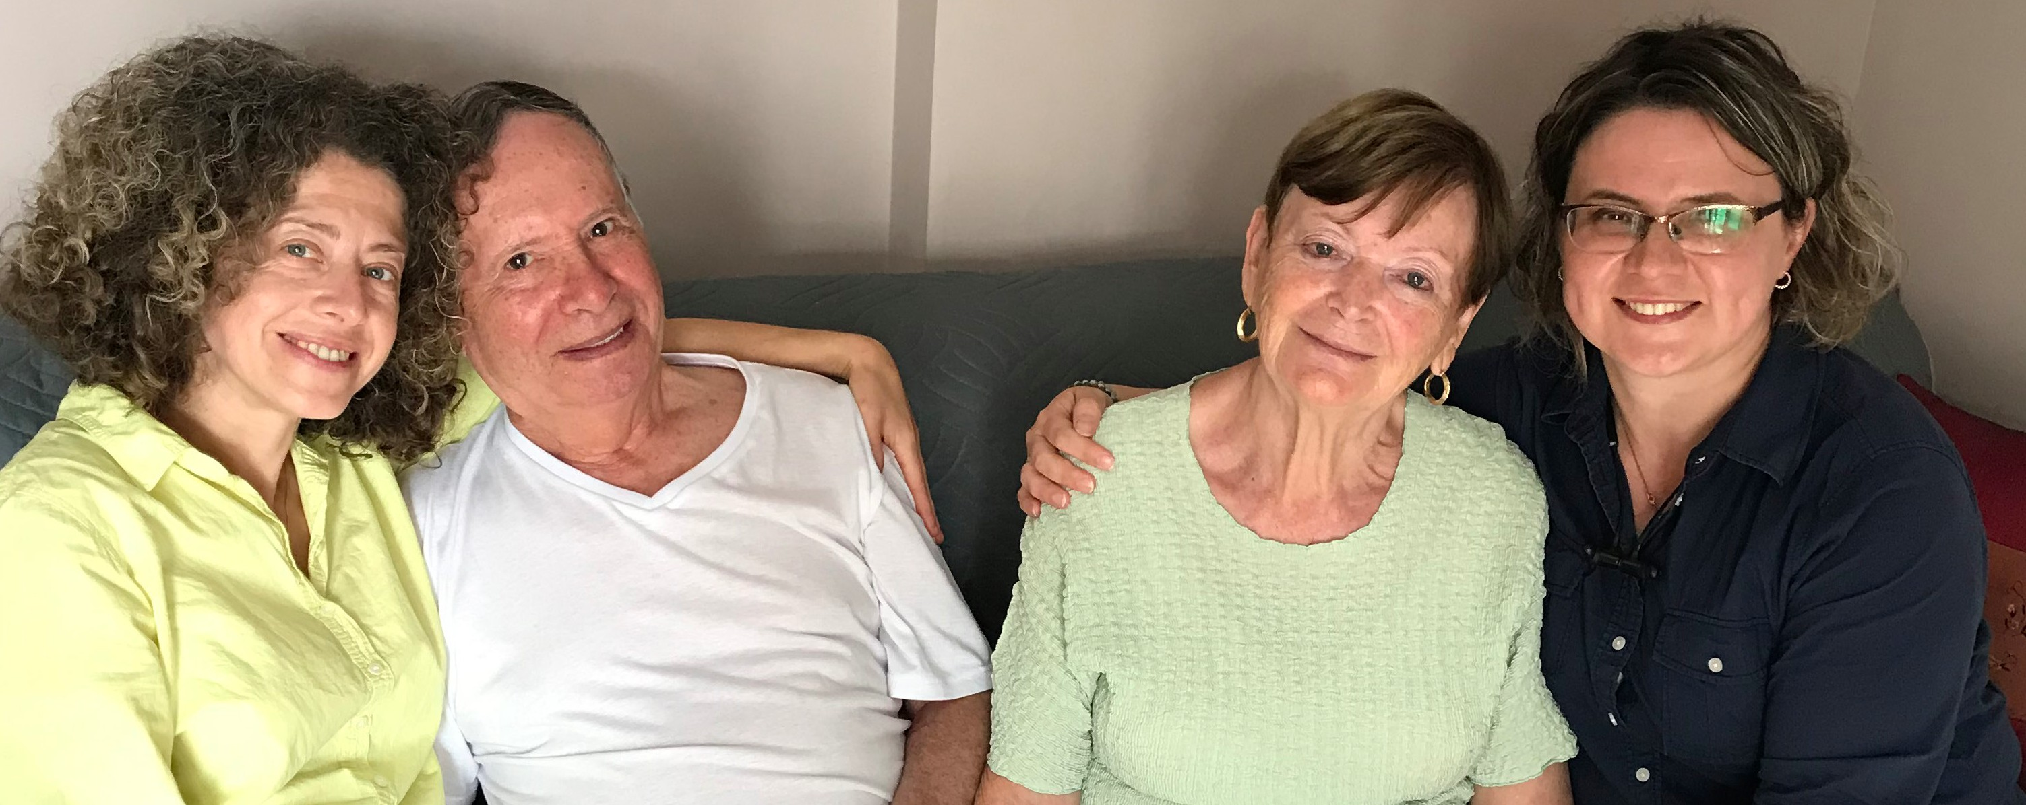

Thank you so very much for your faithful support and prayers in such a time as this. May we all continue to stand in unity, to see the wonderful work of restoration our Lord is doing and to accept it with grateful hearts.

”The Lord shall preserve you from all evil; He shall preserve your soul. The Lord shall preserve your going out and your coming in from this time forth, and even forevermore” Psalm 121:7-8.

Olga Kopilova Project Supervisor

Project Open Gates

Shalom from Jerusalem!

After a long break the project “Open Gates” is serving Jewish friends who have recently made Aliyah. We are open two days a week. People can come to us by appointment as individuals/families or with an organized group from an absorption center.

Our “Getting Started” Store contains different household items. Every item has a price on them. We give a client a certain amount of “money” that he can spend in our Store. The larger the family is the bigger is the amount. It seems to be a good system for so far. Our visitors have been happy to get brand new, good quality items for their homes. We have oil radiators, toaster ovens, slow cookers, kettles, irons, blenders microwaves and some other electric devices ready to be taken and to be used by new immi- grants. Also bedding sets, blankets, curtains, pillows and towels are a good help for somebody.

This is really a new beginning. Please, pray that the Lord will be glorified through our project again and again. Pray that the needed finances will always come in time and the project will be a real blessing for many Jewish people. May the Lord continue to guide us and use us for His glory. We also need new volunteers to come and help to fulfil the vision of the new “Getting Started” Store. Thank you for your prayers!
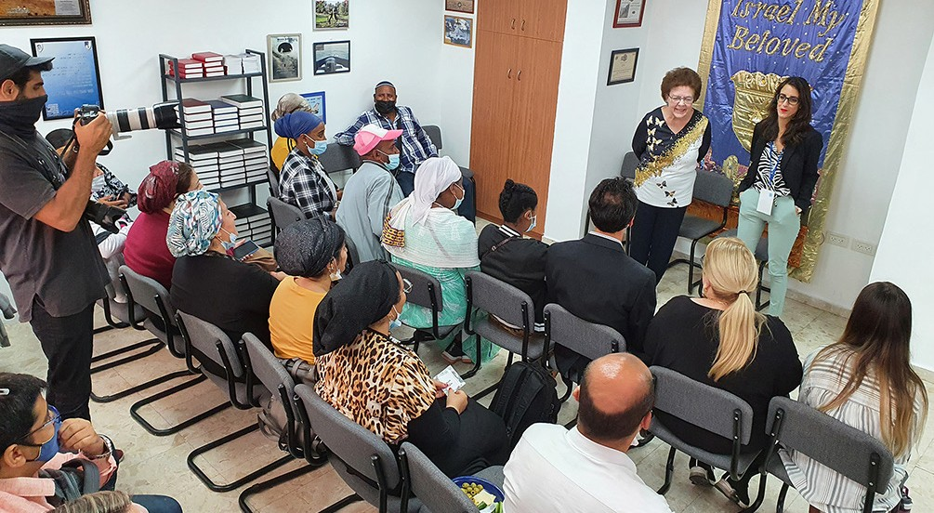

After our Opening, which took place last month, we have had just a few appointments. The first ones who came in were a mother and her two daughters from Venezuela. They got an oil radiator to make the coming winter easier. They also chose a nice pot set for cooking, fleece blankets and a towel. We gave them some extra items too. They were very happy and thankful. The next visitors were new immigrants from Peru: parents with three children. They also chose an oil radiator plus an ironing board and a pan. We gave them knitted blankets, which we recently got from UK, as an extra gift.

Every family gets also a candle holder set, a candle box and a challah cover from CFI. It has been our tradition for years already.

Two couples that came to us this week had made Aliyah only a month ago. They were really in need of everything for their households. Our gift was not so big, but it made the visitors smile. They understood that there are Christians, who think and care about them.
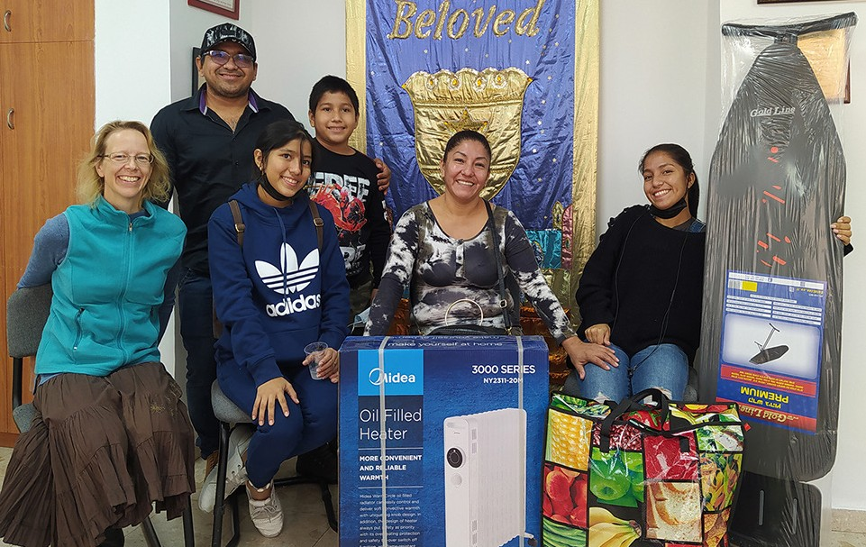

Thank you for being with us in this unique project.

“He remembered for their sake His covenant, and relented according to the abundance of His steadfast love. He caused them to be pitied by all those who held them captive. Save us, o Lord our God, and gather us from among the nations, that we may give thanks to Thy Holy Name and glory in Thy praise. Blessed be the Lord, the God of Israel from everlasting to everlasting! And the all the people say, ‘Amen! Praise the Lord!’” (Psalm 106: 45-48 RSV).

Tiina Danilevski Project Supervisor

Project Hope For The Future

Shalom from Jerusalem!

Hope for the Future outreach continues to impact and strive to undo some of the negative narratives regarding Christians for the sake of our Ethiopian brothers and sisters. This is done with heart-felt special attention surrounding the beautiful religious community of Ethiopian Jews that came to the country of Israel back in the ‘80s and 90’s.

Such honor is felt for thousands of hearts that gave tears, sweat, and blood exhibiting true tenacity to arrive here from Ethiopia. My heart is overwhelmed when I experience the community’s full expression of love for Israel to reach the land, especially Jerusalem. It took unimaginable hardship for them to get here. Christian Friends of Israel has worked over the years to establish a relationship with Ethiopian leaders and families in the land. Following many years of serving the needy and helping with the assimi-
lation process, we are grateful. It is our pleasure that Hope for the Future and the Hope Resource Center will catapult us into a new phase of service.

Our hope is that we will reach out in this next era by continuing an ongoing assessment of community needs. The Center will facilitate the enrichment of families through more productive means equaling tangible outcomes. This generation creates long-term opportunities to catch up to the rest of Israeli society via start-up businesses, technology, and confidence in job creation and finding gainful employment.

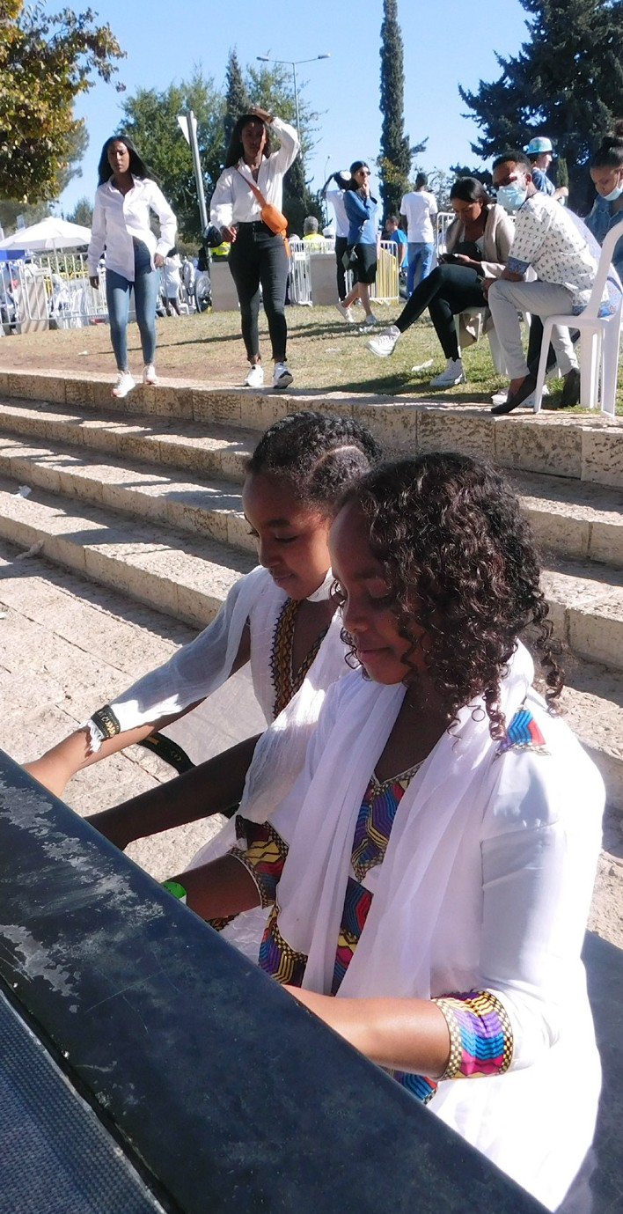
November 3, 2021, commemorated the Ethiopian holiday Sigd with and the annual festival took place with no postponement because of COVID. Last year, the event did not take place – this year, it was more significant than the years previous! Ethiopians have always stood on their oral history which, continues to strengthen them as a community, Sigd was officially acknowledged in Israel in 2008, when it was enacted into law as a national holiday.

The Sigd festival allows the closeness of the community to gather in high places to pray and fast, then feast. While in Ethiopia, the prayers were for coming to Jerusalem now; the focus is to cry out for Unity and Justice and to be seen. “There is no full integration without recognition.”

I was impressed with the vendors that maintained business during the pandemic. Families had reunited from around Israel to gather at the Promenade Park. The Hope for the Future project helped supply a few families with food vouchers for this fantastic celebration. By giving to four families in Kiryat Gat and 20 families in Beni Brak, we joined the efforts to make this festival of community reformation a success. Our impact helps heal the years of trauma experienced by this group of Jews, even after migrating to Israel. As God calls us friends, we will always consider the Ethiopians our brothers and Sisters. And a brother loves at all times!

Marcia Brunson Project Coordinator

Project First Fruits

“Taking Root downward, Bearing Fruit Upward”

“This shall be the sign [of these things] to you [Hezekiah]: you are to eat this year what grows of itself, and in the second year that which springs from the same, and in the third year you are to sow and harvest, and plant vineyards and eat their fruit The surviving remnant of the house of Judah will again take root downward and bear fruit upward. For out of Jerusalem will come a remnant and from Mount Zion a band of survivors. The zeal of the LORD of hosts will do this” (Isaiah 37:30-32 AMP).

Upon my return to my project duties from a visit with family, I was immediately engaged in making certain that the assistance that our CFI partners around the world generously provide is sown into believers here that will put it to proper application. Our featured recipients this article have one thing in common besides their faith in Messiah: the assistance that they have received from us has been two-fold. Because of this, we expect that each of these individuals will project the benefits of serving a living and benevolent God, as they conduct their daily lives.

Yuri is an essential member of his worship team in Haifa as a musician and as a sound engineer for this particular body of believers that has impact not only in Israel, but also in the international faith community. After a year and ½ delay related to COVID, CFI is assisting him with advance certification in his capacity as sound technician so he might be able to properly maintain and adjust the updated sound and other equipment that the congregation has been able to acquire. Beyond his gift as a guitar player, this Ukrainian émigré’s daughter is a violin player with a skill set far beyond her young age. We are delighted to encourage this creative family to thrive in God’s land!

“Instead of your [former] shame you will have a double portion; And instead of humiliation your people will shout for joy over their portion. Therefore, in their land they will possess double [what they had forfeited]; Everlasting joy will be theirs” Isaiah 61:7(AMP).

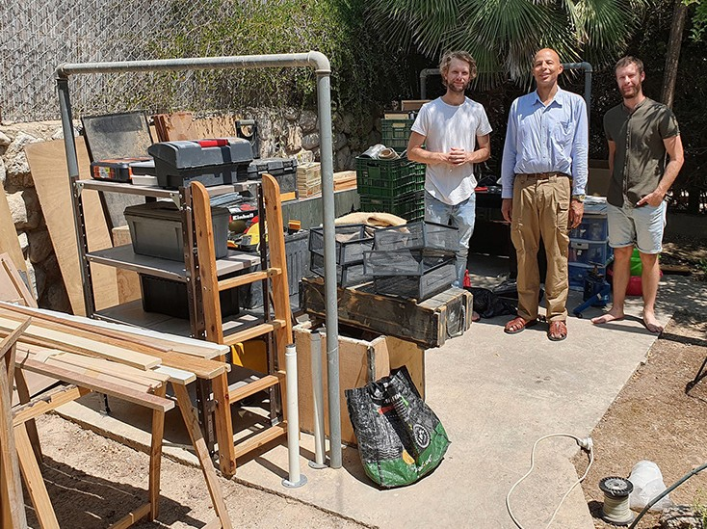
JJ Orde, his British siblings and other housemates are young entrepreneurs in the land who have blessed many through, first, a Jerusalem restaurant and now a Beersheba area catering service. We use them frequently to feed our office staff. This is only one vocational operation that takes place within this home connected with international ministry. CFI has helped John acquire specialty tool items for his woodwork business and we were happy to contract him to help provide us with furniture items necessary to help us launch the Hope

Resource Center which will enhance Hope for the Future’s project ability to serve the Ethiopian Jewish community. We will also sow into his brother Ben’s media ministry activities by obtaining a camera in this new year.

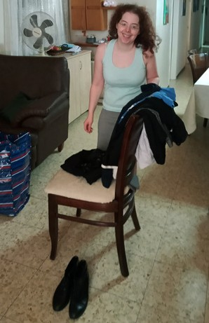
Galia is of Polish descent who we are sponsoring through graphic arts school to allow for a major change in the trajectory of her life. She lives with her mother, a widow in Ramat Gan and they have endured the trauma of terrorist rocket attack in the past, along with being ostracized by non-believing family members regarding their faith. We were able to provide some clothing and shoes to help Galia feel more comfortable about her appearance within a student population near Tel Aviv, that tends to scrutinize young ladies. We thank God that Galia’s external presentation will now more closely reflect the innermost beauty that the Creator has placed within her to realize His destiny her as His child!

“It was with this confidence that I planned at first to visit you, so that you might receive twice a token of grace” 2 Corinthians 1:15 (AMP).

So to those of you in the nations: Recognize what your prayers and support are doing to impact Israelis, especially these who share your faith!

Thank you from that land has set apart for His own Name!

Kim Brunson Project Supervisor

Project Bridal Salon

Greetings from CFI Bridal Salon!

This month has been quiet. There are still a lot of people who don’t know that we exist. The CFI Media Team has already created a facebook page for us, which we can use in social media. We are also planning to contact different congregations and remind them that we still serve future families with beautiful wedding gowns. After all the lockdowns and times of corona restrictions many ministries have changed their way of helping and serving people. Our Bridal Salon is still here. We just need to remind leaders of local congregations about it.

Please, pray that the Project will be used by God in the way He wants. Pray that new groups of people here in Israel would hear about us. It is a great help to a future family to get their wedding gowns without any cost. More individuals should know about this.
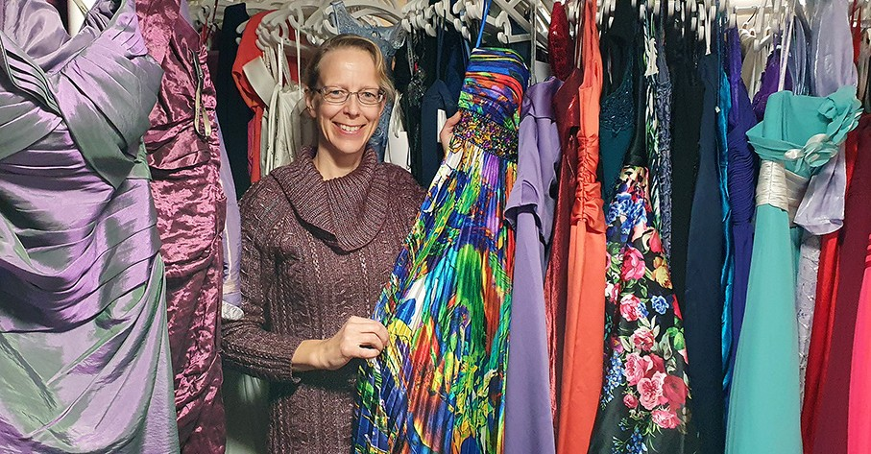

Our evening dresses and shoes are also a big blessing for many families. Last week we had a sister of a bride choosing a dress for the coming celebration. She was looking for a certain colour and she needed a very specific size for herself. We found a beautiful blue dress with a dark blue fur bolero. The wedding will be in December, and it can be cold, both inside and outside a building then. Sometimes they make the Jewish chupa ceremony outdoors even in winter. So, we need fur jackets and boleros here in Israel :) Our young client and her mother were happy. They both got shoes as well. Next day I got a special message of thanks from them. It is always so gratifying to hear that people have been blessed in our place.

Thank you for being with us. May the Lord bless you all!

“So then, as we have opportunity, let us do good to all men, and especially to those who are of the household of faith” (Galatians 6:10 RSV).
Tiina Danilevski Project Supervisor

