CFI Projects Monthly Reports for
International
Representatives

Dear CFI International Representative Family,

Thank you for your continued support of the Outreach efforts of Christian Friends of Israel. We continue to strive to encourage those in need and to offer practical assistance during times of struggle. It’s during these times when relationships can be formed which please God and allow us to show Compassion to those who need it the most and have possibly never experienced it before.

During this time of global pandemic, we continue to offer assistance as we are able, and we know each passing day may allow for additional hardships, but we also know the God whom we serve. He is more than able to protect, and provide and heal. We are willing to represent Him to the people of Israel.

Please receive the CFI Outreach electronic updates as a reminder
of the impact each of you have in the lives of so many. We are grateful to represent those of you in the Nations - to those in the Land of Israel.

A friend loves at all times, And a brother is born for adversity.

Proverbs 17:17 (NKJV)

Project Open Gates

Dear friends and supporters! Shalom from hot Jerusalem!

I have been able to work about two weeks now after the corona quarantine. People are calling us every day. I can already make appointments with one individual at a time. So, they come in one by one. This week has been quite busy. Every morning there are clients waiting for us to open the door to them. We are using masks and plastic gloves inside the building. Everybody has found nice things for themselves and also for the family members.

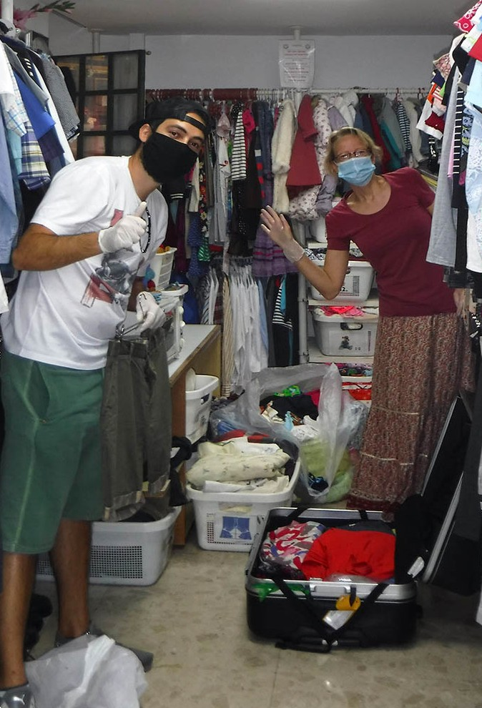
Because of the quarantine many people in Israel have big challenges with their finances. Our clients have difficulties even without this corona thing. I am happy that we can give them good quality clothes and some other items, too. Thank you for being the team behind us. Thank you from many individuals that have been served at our distribution center during this year. This is a special time and a special opportunity to support Israelis who are coming to us. Please, pray that they could see the One, who put His life and love into our hearts. Pray that we could be the lighthouse that our Lord has called us to be.

Maybe you are interested to know, there are Jewish people, who have made Aliyah during the corona lock down period. Yesterday I got a phone call from a family, which moved into the Land at the beginning of May.
Yes, God is bringing His nation to Israel in spite of quarantine instructions. “For I will take you from the nations, and gather you from all the countries, and bring you to your own land.” (Ezekiel 36:24)

These people were ready to spend the first weeks in the promised Land in isolation. Now the situation has eased. Soon I can meet these brave new emigrants and ask them, how it was. Every Aliyah-story is different. I hope there will be interesting stories in the next reports that I will write.

Be blessed in the name of Yeshua, our Lord! Be blessed from Zion!

Project Bridal Salon

Shalom friends!

Our CFI Bridal Salon was in quarantine almost two months. Now we are able to serve future brides and grooms one at a time, without any relatives or friends that usually come with them to help to make the best choice. There have already been phone calls. Some clients are already on their way.

One girl came to have a look. She did not find the dress she was looking for, but she promised to come back. We have beautiful veils, headpieces, jewels and shoes that she wants to choose after she has found her dress.

One girl contacted us just after the lock down began in the beginning of April. She needed something white to wear, because her wedding was going to be in couple of days. I did not know what to do. I really wanted to help her. I was ready to go to the Bridal salon by myself and get a dress for her. Fortunately
I didn’t have to do it at that critical moment. The bride-to-be called me back and said that her friend had given her a dress. I wished her happy wedding and God’s blessings.

The Corona instructions have changed many wedding plans all over the world. I can imagine that espe- cially for some young girls it has been almost a tragedy. In Israel you could have a wedding ceremony even during the worst lock down period, but only with a couple of witnesses keeping a distance of two meters from each other. The bride and the groom could be closer to each other, of course. It has been a real test and a place of humility for future families.

Some of the couples are having their wedding in two parts now. First there is the ceremony with a few people and after the period of the restrictions they will do the celebration with all family members and friends. Nobody knows yet, when those celebrations will take place…

Let us pray that The God of Israel will bless every new family that has been born during this unusual time of many limitations. Maybe for some young people this situation has been even a blessing. They have saved a lot of money by having only small weddings this spring.

Thank you for supporting our project “Bridal Salon” with your prayers and donations. We will keep going. God bless you!

Project Hope For The Future

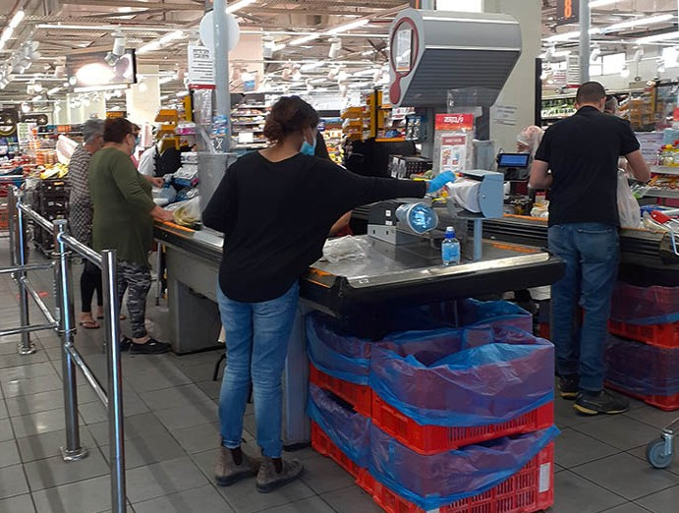
Our position at Christian Friends of Israel may involve wearing multiple hats throughout the month. We are paving the way for those that have experienced turmoil growing up in Ethiopia involving very super sensitive information and confidential secrets. Nevertheless, we proceed cautiously in the best path to walk with our clients. To hear the pain and see the scars in the eyes of women, can truly tear at your heart. These visits may require more time, patience, and unconditional love to help the client see their way to move on or grow past episodes that have scarred them in many ways throughout the years.

In all honesty, I think individuals that have experienced the loss of trust or love from their natural parents is the worst pain to experience.

I am thanking God that by pursing assistance for the client intentionally, I was able to see the purpose behind a financial request and become the friend in time of need. I got positioned to put on a different hat as a listener, and to encourage them with the wonderful words of the Torah. We are always looking to empower those with low self-esteem and for those unable to function emotionally to shine forth hope and positivity in the midst of the sting from past abuses.

One of my clients had an incredibly unique situation this spring during a time being home alone during the shutdown months. I was extremely concerned about her. What I was able to provide her, I could not put a price on it. This month, I spent four hours on the phone with her and one evening we were able
to meet and walk (with our masks on, of course). She needed food vouchers and thank God I retained them. We provided her with 500nis of food vouchers and I even accompanied her to the grocery store to suggest healthy foods to buy.

Our last stop was at an outdoor library where she found old novels with positive content in it to read.
I was so thankful that she had made an appointment to see a specialist to help her process her areas of pain. For such a time as this…I did what I knew to do! I received a text last night from the client that touched my heart:

“Hi Marcia! How are you? So I started therapy finally Thanks for all your help During the Corona time!”

So thankful to all our Reps for faith in what we do here at CFI! We already see fruit from all our efforts and the multiple hats we wear.

Marcia Brunson Project Coordinator

Project Forsake Them Not

“These things I have spoken to you, that in Me you may have peace. In the world you will have tribulation; but be of good cheer, I have overcome the world.” (Luke 16:33)

In this fast changing world, with all its uncertainty, there is still the One who is Certain, the One who never changes, the One whom we can trust – the Lord God Almighty, Our Heavenly Father, the Rock of our salvation. He is the One who carried us through the month of April, with its many events and celebrations, all only observed from enclosed spaces of our apartments, separated from others in body, nevertheless united in the spirit.

Being unable to go out on the visits, we still connected with many Holocaust Survivors through phone calls and video chats, text messages and emails. Many sent us their greetings and pictures of their families, whom they are missing so much during the total lockdown of these past 7 weeks. Every day we were calling our precious friends on their birthdays to tell them we remember and to wish them good health and to, often, read them a psalm. What joyful moments those were! But there were also very sad and painful days when we learned that some of our dear ones just recently passed away. We can’t wait for the quarantine to be lifted so that we could see Holocaust Survivors face to face again.

It is impossible to give you an account of every phone call we made, as those are many, but we would still love to share with you few.
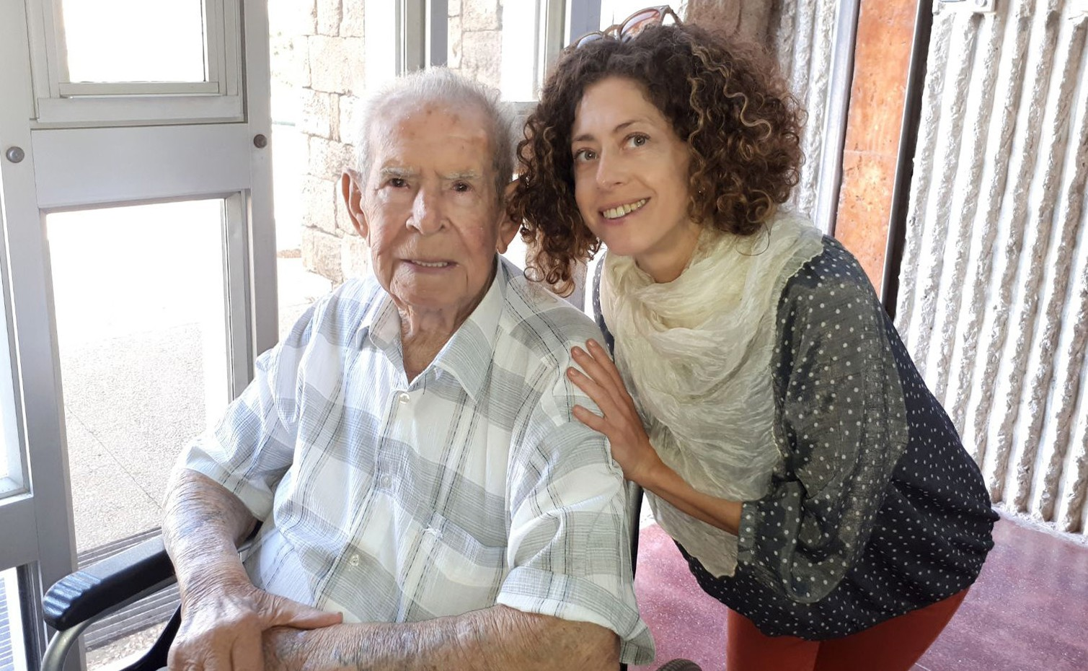
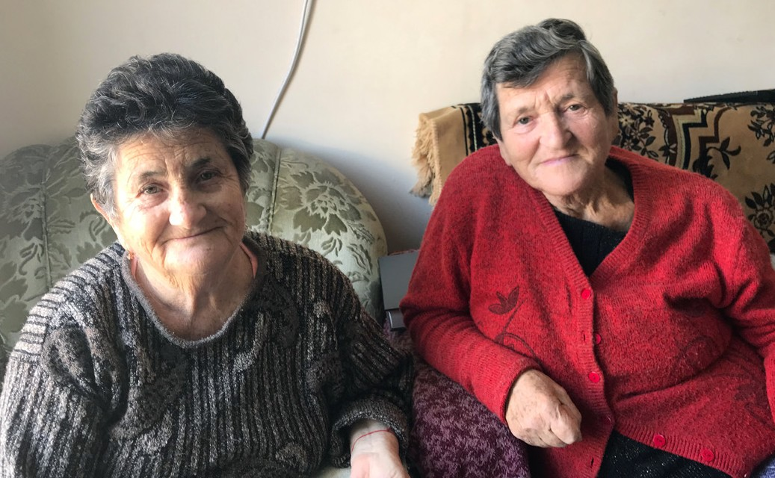

I was nervous to call Grigory’s son on 1st of April, Grigory’s 90th birthday. Just 3 weeks prior he had returned from the hospital where he was taken, to be treated for a recent stroke. I wasn’t sure if Grigory could speak at all. Yakov, his son, was surprised to hear my voice, and very happy to pass the phone so that Grigory could hear my greeting. I sensed that he was so proud to pass the pone to his dad. Grigory’s voice was alert and strong and I was thrilled to greet him on his birthday and to congratulate him on another victorious year in his long and full life.

Anna lives in Kiryat Ata and suffers from depression. She spends long days alone in apartment with her cat. She was so touched to get our phone call and so pleased to talk with someone. There were too many questions on her mind about what is going on in this current worldwide crisis. She expressed the fears that were on her heart. She, like the rest of us, has never experienced anything like this in her life!
It was so important for her to have someone who would listen to her concerns and then bring her some words of encouragement and comfort. She couldn’t hold back her tears during our conversation, and we were so pleased to offer her hope and company, even through a simple phone call.

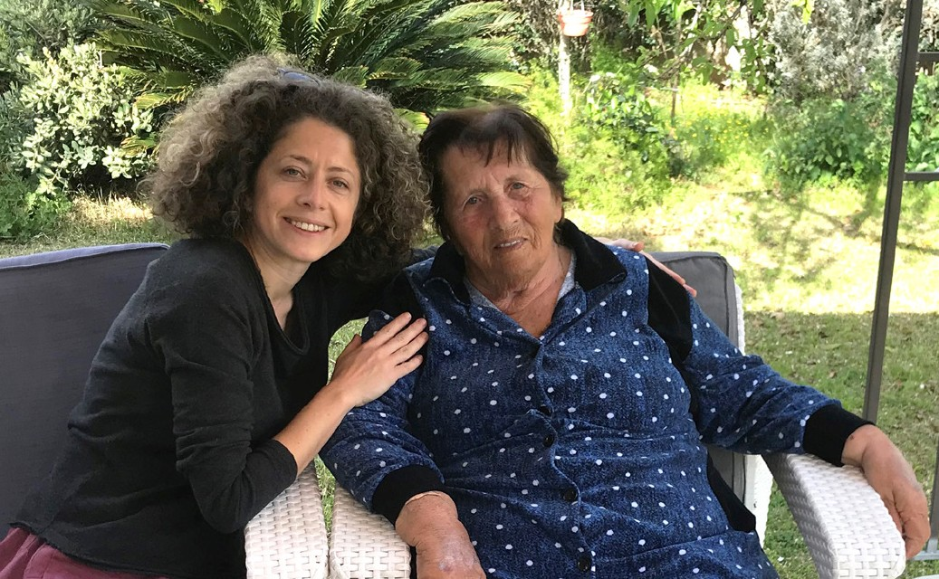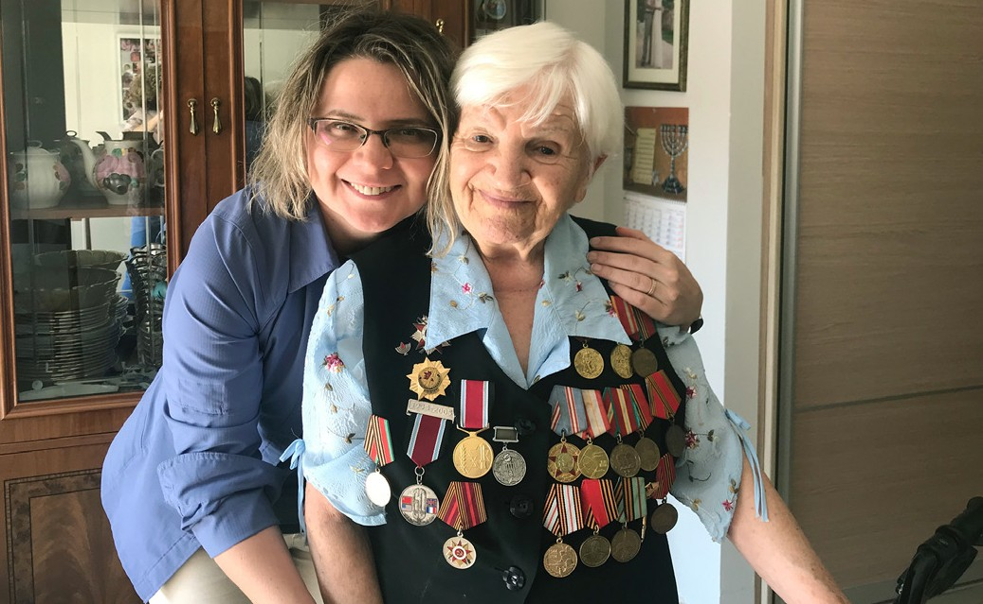

Evgenia from Ashdod was so despairing in her anxiety because of her heart surgery being postponed, as nobody wanted to operate on her in the current situation, and also for a total lack of medical attention. For the past few months her only nourishment was through the tubes, which caused inflammation of the nostrils and dried her digestive system, so now she also needs another surgery on her digestive system. How grateful Evgenia was to receive our call in such a desperate condition, though it was hard to recog- nise her voice, as she was so weak even to speak! What a privilege it was to pray with her and to bring comfort in assurance that all our days are in God’s hands – He sees everything! Evgenia said she is missing us greatly and wants to see us as soon the isolation is over.

Berta from Gedera lives in a luxurious retirement apartment and only a caregiver is allowed to come in and help with her daily needs. At 93 Berta is still very bright minded and pretty independent. The only Survivor of her entire family and a rare survivor of the Minsk Ghetto, she is also a war veteran and a brave warrior of a partisan unit of Belarus resistance. She immediately recognised our voice and was so pleased and happy to hear from us! She told us all her news, expressed her strong opinion on new
regulations, but most of all she expressed her deep gratitude and appreciation for our care and attention towards her. Even in these challenging days, Berta remains strong and optimistic.
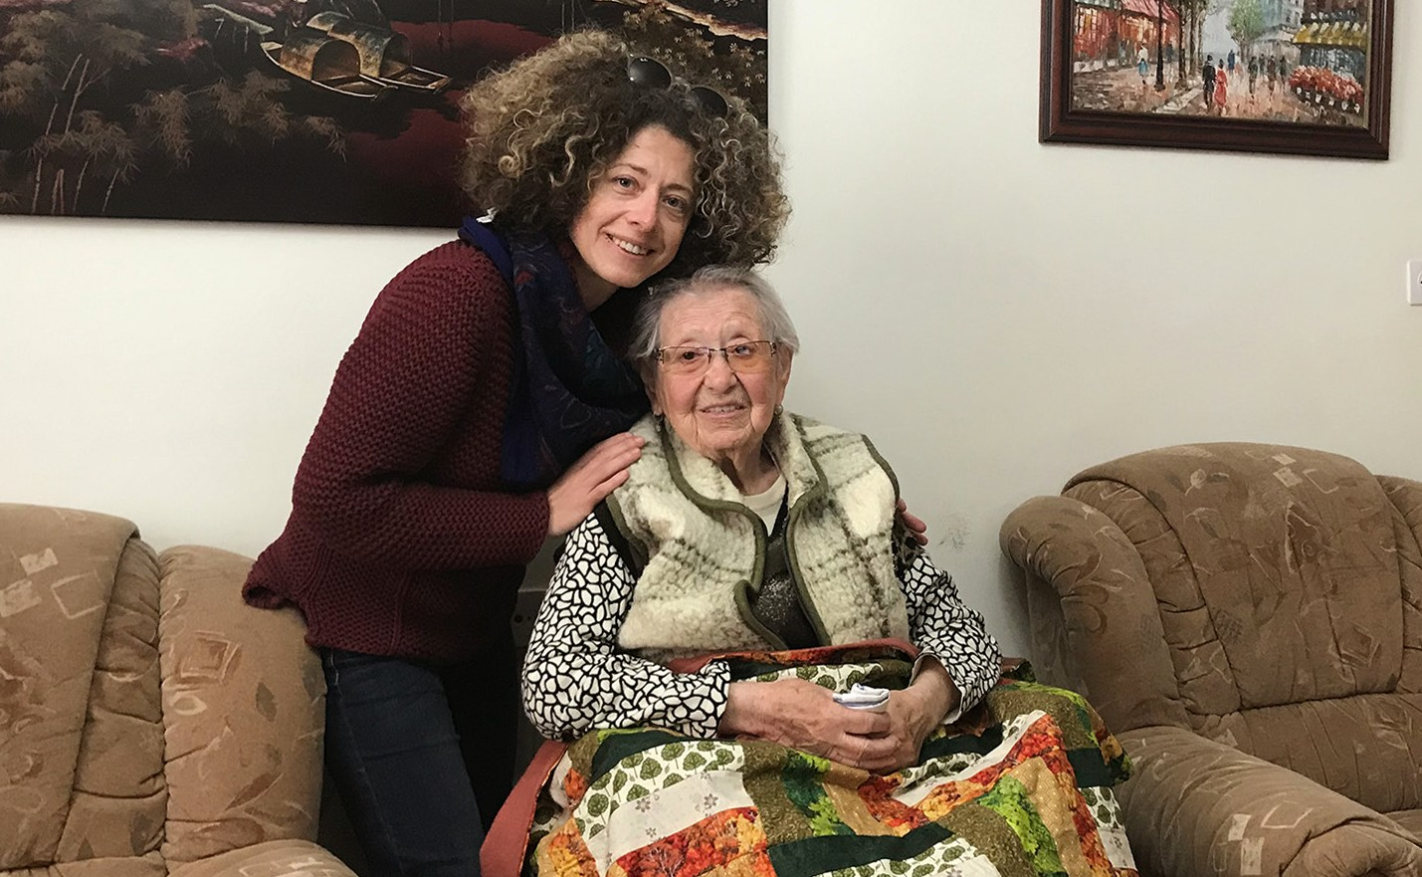
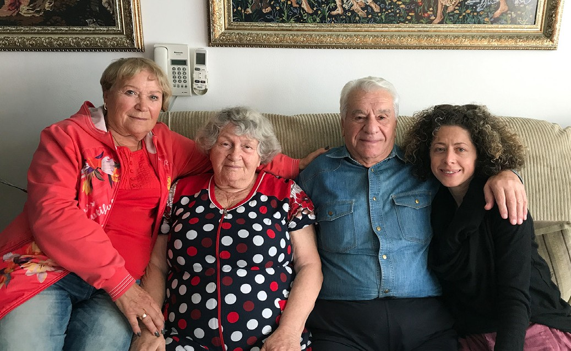

Thank you, as always, for your continued love, prayers and support. We realise that these times are trying for everyone, and we so appreciate your constant efforts in helping us forsake not our precious survivors.

Olga Kopilova Project Coordinator

Project David’s Shield

…The purpose of the IDF is to preserve the State of Israel, to protect its independence, and to foil attempts by its enemies to disrupt the normal life within it. The soldiers of the IDF are
obligated to fight and devote every effort, even at the risk of their own lives, to protect the State of Israel, its citizens and residents… (IDF Mission Statement)

As it is with the mission of the Israel Defense Forces, who stand undeterred to fulfill its mission to protect the State of Israel, the necessary adjustments are apparent in Israel’s way of life and the brave soldiers and defenders of Israel continue to fulfill its mission in unique and important ways. Their mission is in fact
- unwavering…
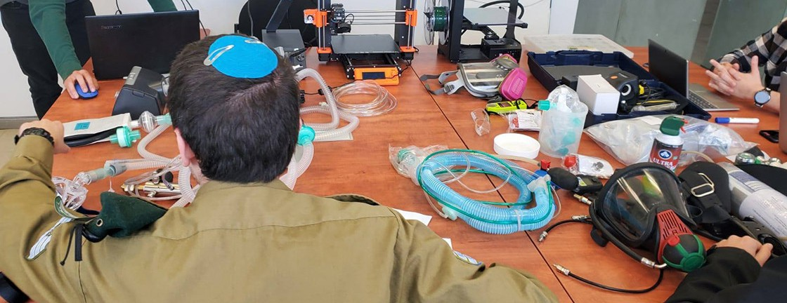
IDF medical C19

The global outbreak of COVID-19 has left many people in a heightened state of vulnerability. The IDF took part in a nationwide food distribution operation to assist Israel’s elderly and other at-risk population. The IDF Technological Intelligence Unit assisted the Ministry of Health and Magen David Adom to find innovative solutions to the medical challenges. The IDF has adapted the BiPAP home ventilating device to be able to monitor air pressure and filter pollution from a room in order to ventilate COVID-19 patients. The manufacturing up to 1000 protective masks a day for military and civilian medical teams to counter the shortage of masks in Israel. IDF teams developed special shields and separate air conditioning systems in approximately 50 ambulances, to enable drivers to evacuate COVID-19 patients without endangering themselves. IDF technical personnel created information management software for the Coronavirus Testing Lab to manage COVID-19 tests efficiently. The IDF Weapons Manufacturing Center, which was once solely dedicated to the production of tank parts and body armor, has been converted to produce protective goggles for medical staff and spray guns to sanitize public spaces, and an IDF Naval Commando Unit converted their operational assembly line of pressure cylinders (used during underwater missions) to develop better methods of compressing medical oxygen. The unit is also sharing this tech- nology with foreign militaries so that they are also able to increase their oxygen supplies as needed….

During the recent Yom Ha’zikaron (Memorial Day) Message to the IDF Officers, Soldiers and Employees, LTG General Kochavi; Chief of the General Staff commented “...Now, on our watch it is our duty to cement and fortify Israel’s defense and attack capabilities. As we fulfill our mission to defend our borders, we must also break the boundaries of what is known, innovate and adapt accordingly.”

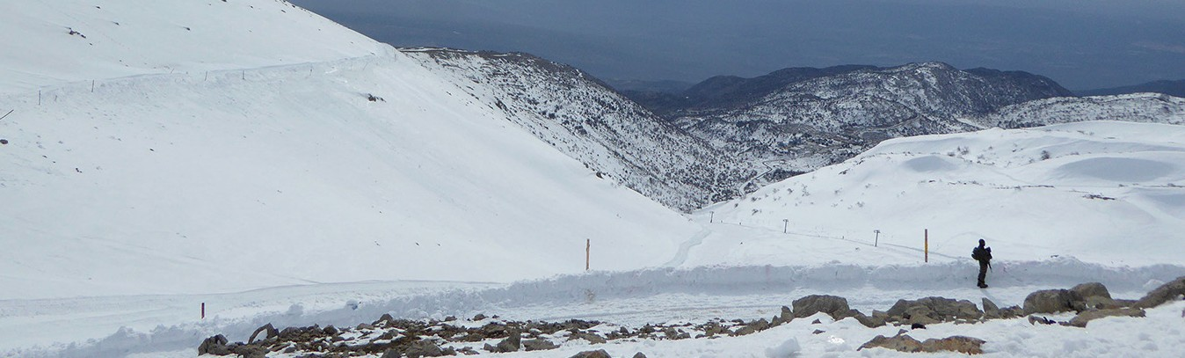
Patrol north

CFI and Outreach Project David’s Shield stand ready to serve in solidarity with the efforts of the brave defenders of Israel. We encourage them at every opportunity that they are not only fulfilling their mission as IDF soldiers and Border Police in an admirable way, but also fulfilling the very words of God spoken through Isaiah …once again he will settle them in their own land. Aliens will join them and unite with the house of Jacob. Nations will take them and bring them to their own place. (Isaiah 14:1,2. NIV).
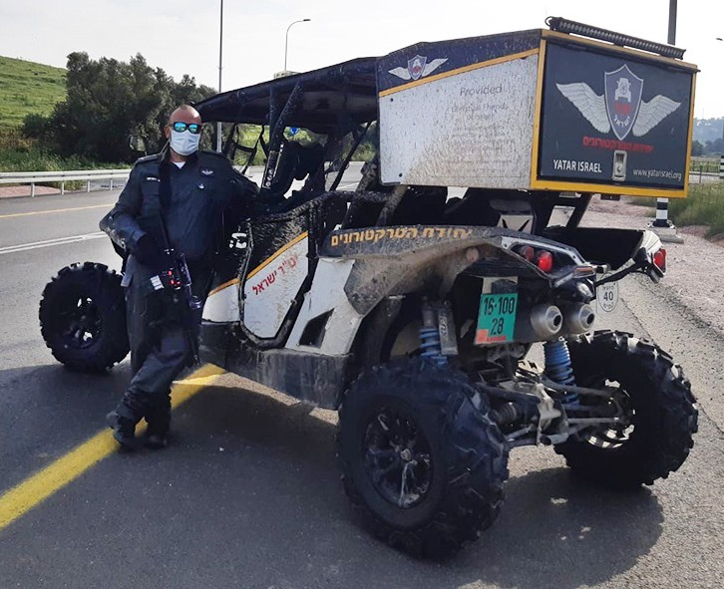
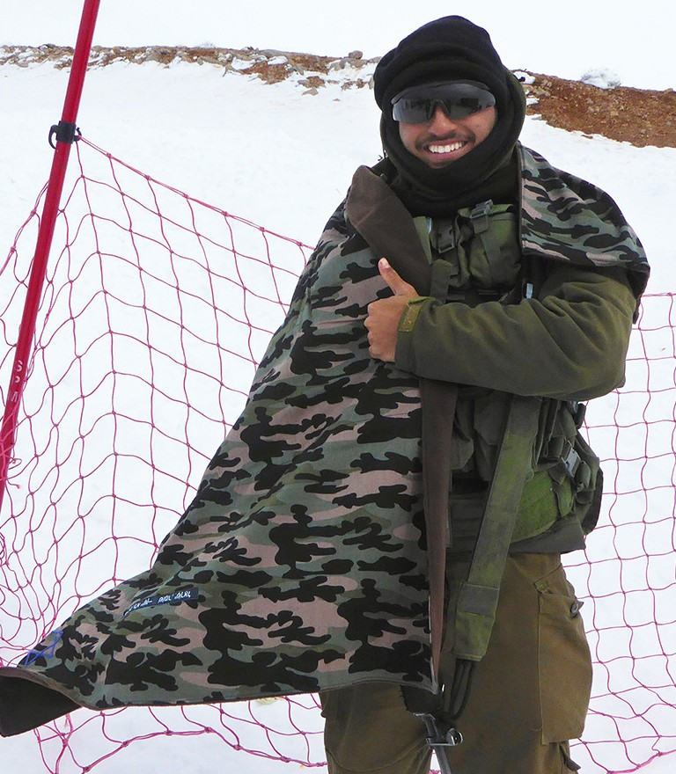
Patrol C19 DS giving

Recent contributions to the efforts of Lone Soldier Center activities, permitted appropriate visits with defenders in remote positions, and continued support of Units with items of comfort continue to afford CFI Jerusalem and the purpose of the David’s Shield outreach to be fulfilled. We are grateful for recent letters and words of encouragement from you in the nations that are being shared with the soldiers who carry the burden of an “our watch”. Thank you for your continued support and prayers for the brave defenders of Israel.

Jim McKenzie Project Coordinator

Project First Fruits

Instruct them to do good, to be rich in good works, to be generous, willing to share [with others]. 1 Timothy 6:18

The First Fruits Project managed to remain active and vibrant during this time of international and national upheaval due to the COVID-19 outbreak and the global adjustment and response to it. Since our last report, (and some activity not included in our last report) we have maintained a broad and generous operation in our service to the Israeli faith community. We are intentional about being included with those spoken of in Nehemiah 11:2 “and the people blessed all the men who volunteered to live in Jerusalem,” and not only living here, but being an asset to the well-being of citizens.

We visited Immanuel Church, based in Haifa which has a building set aside for Christian Soldiers serving in the IDF. Their focus is on Aramean soldiers that may face ostracizing for serving in the “Zionist” military within their majority Muslim communities and might need a less contentious option on Shabbat or when on leave. We assisted them in reinforcing their porous roof during the winter season so they can maintain a sterile living unit for these brave men and women.
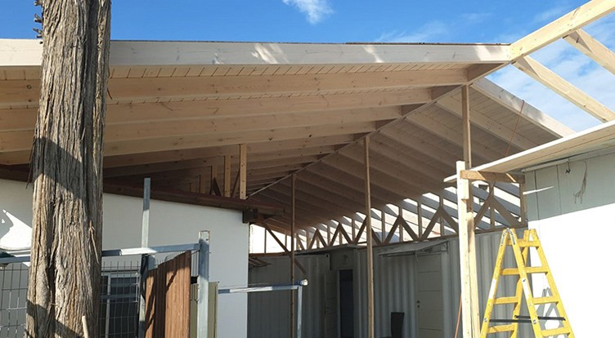
Christian Soldiers construction

There is also a ministry in Tel Aviv called Abundant Life that specializes in street outreach, which we were able to assist with clothing from our Distribution Center. We were delighted to resume relationship with them there as our Founder Ray Sanders did much for this ministry during its origins, years ago.

Locally, our other Founder, Sharon, was gracious enough to allow us to gift the Jerusalem Seminary with computer equipment necessary to help them with their international assignment of supporting those abroad who are translating bibles from the biblical Hebrew into the tongues of the earth. We expect generational impact from this partnership!

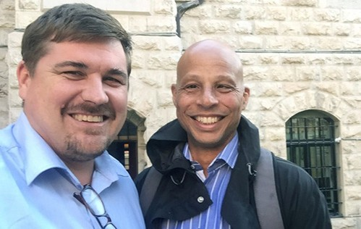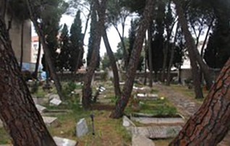
Brian from Jerusalem Seminary Alliance Cemetery

We were also happy to partner with the Alliance Cemetery in maintenance needed with the trees and ground at the only Christian cemetery within the Jerusalem city limits. Many of the righteous Gentiles are interned here and we share their love for Israel and believe it matters that the grounds where they are honoured are manicured properly.

We certainly don’t expect the same logistical challenges next quarter as the last, but in any case, First Fruits will be up to the task because you are faithful, as is He!

… or he who encourages, in the act of encouragement; he who gives, with generosity; he who leads, with diligence; he who shows mercy [in caring for others], with cheerfulness.
Romans 12:8

Kim Brunson Project Coordinator

Project Streams Of Blessings

LOVE IN TIMES OF CORONAVIRUS

I will bless the Lord at all times (Psalm 34:1)

Many times our hearts go through fireproof seasons, not to determine whether if we love or not but to define the level of faithfulness and commitment needed towards what we so strive and long for, no matter what. The ways of the Lord are a mystery, and we are not called to understand but to faithfully love and serve Him regardless the situations. To trust unconditionally.

Faith and faithfulness are two words that complement each other as they have the same prefix root:

Unmovable certitude.

And this is what some of our beneficiaries made us experience during the quarantine season that is still going forward. Before the lock down started, we had constant communication and interaction with each one of them. After we had to close the doors of our Head Quarters in Jerusalem, we could not have contact personally except for some phone calls to check how they were doing. Things got tougher and some of them started struggling deeply, as we know their cases and the circumstances they face on daily basis.

They cried out from a distance, some in areas outside of Jerusalem, to ask for help, as children within a family who don’t exactly know what the situation is in the house, or if there is food or not to eat for the day. With no doubting they just approached the table trusting that the caretakers would bring provision.
For over 35 years, Christian Friends of Israel has served the people of Israel taking many leaps of faith and witnessing the supernatural multiplication and outpouring of the Lord into the ministry for us to keep on comforting, helping and mainly loving when it’s needed the most.

For two months the whole entire world has been paralyzed, but the Faithful heart of the Father continues providing for His children, and these are some ways we could continue blessing as He filled out our nets:

- We designated a large amount of food voucher donations to help five families in extreme need.
- From afar we wired a donation to OHR SIMCHA, an Israeli nonprofit organization that cares and restores children suffering from abandonment and domestic violence. We provided medical supplies like: masks, gloves, thermometers and other utensils. As they also are instructed in Judaism principles, we also donated fifteen Tefillin for their bar mitzvah ceremony.
- We continue donating funds to cover education fees for children as the kindergarten centers re-opened.
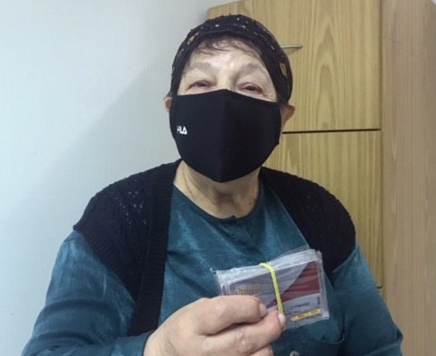
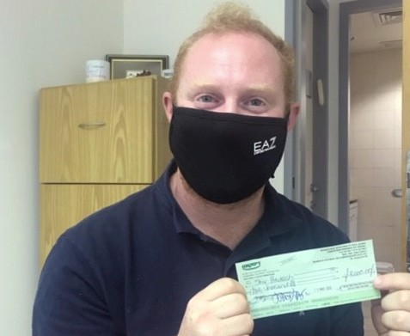

Life continues and we cannot depend on the circumstances around us to interrupt our unity here in Israel. We need to dare to make things happen, believing and staying strong with the conviction that the authenticity of the word of God and His promises through the Bible will always prevail.

“And I am convinced that nothing can ever separate us from the love of God. Neither death nor life, neither angels nor demons, neither our fears for today nor our worries about tomorrow – not even the powers of hell can separate us from the love of God.” Rom 8:38

Blessings and thank you.

Karen Tohon Project Coordinator

Project Under His Wings

Dear Friend of Israel,

“When the enemy comes in like a flood, the Spirit of the LORD will lift up a standard against him”
(Isaiah 59:19).

As the number of Corona infections has been decreasing, the Israeli government has eased the lock- down, allowing people to go back to offices to work and students to return to school to study, provided a face mask and social distancing and hygiene regulations are maintained. I was able to reach out to some terror victims via a phone call during working from home in the past months, to encourage and strengthen them with the words of God to those who were stressed out during lockdown. For precaution Project visits are still prohibited by the government at this stage until further notice.

Despite the crisis of Corona, the Palestinians terrorists have not stopped their evil plans and actions to carry out terror attacks against the Israelis, the Lord raised a standard against them (Isaiah 59:19).
Security services say the plan of three Palestinians to blow up Teddy Stadium of Jerusalem fell through, so they instead tried to carry out attacks on IDF soldiers in Judea and Samaria. The three terrorists were neutralized and no soldiers were injured in the attack. Praise God. Car ramming terror attacks (one combined with stabbing attack) were also carried out during Corona period, resulting injuries to an IDF soldier and a border guard. Pipe bombs were found in the van of the attacker of a border guard.

Sadly an IDF soldier named Amit Ben Yigal was killed on 12 May, by a Palestinian who threw down a huge rock on his head from the roof of a house in the middle of the night during his mission to arrest members of a terror cell in Ya’bad, a village in northern Samaria. Furthermore, his grave was vandalized.

- Pray for revelation of Yeshua be given to Muslims as they are still in the Month of Ramadan fasting.
- Pray that the intelligence gathering of Israel will be even more effective and more evil plans of terror attacks will be thwarted before being carried out.
- Praying that the IDF solders and border guards will be vigilant, not be distracted and remain alert while on duty.
- Pray for the comfort from God for the family of the slain IDF soldier Amit Ben Yigal.
- Praying that Israelis will continue to follow government regulations after exit of lockdown so there will not be second wave of Corona outbreak.
- Please pray for the increase of financial support of Projects UHW & CUA.

Thank you so much for being a faithful co-labor in UHW & CUA ministries in the Lord. (2 Corinthians 8:23). May God continue to pour out His blessing on you as you bless His people in Israel.

With love and blessings from Jerusalem.

Project Communities Under Attack

Dear Friend of Israel,

“Now He who supplies seed to the sower and bread for food will also supply and increase your store of seed and will enlarge the harvest of your righteousness” (2 Corinthians 9:10).

When I was visiting my country (Taiwan) the COVID-19 outbreak originated from China started, and I heard my government officials said “fighting epidemic is like fighting a war.” It is true. Thankfully like my government, the Israeli government also has taken COVID-19 very seriously and has been ahead of many other leaders in the world in pro-actively dealing the Corona crisis, so the situation in Israel is less serious than many countries.

News said that the Hamas regime in the Gaza Strip is making significant efforts to prevent a full-scale outbreak of the coronavirus, while also threatening to hold Israel “responsible” if the virus does begin to spread. The threats imply rocket fire on Israeli cities if Hamas officials begin losing control of the situation. How absurd! On the other hand, global NGOs also have been exploiting the Coronavirus for Anti-Israel Campaigns. Nothing new actually, as 15 years after the Gaza disengagement, Hamas and the NGOs continue to blame Israel for “humanitarian crisis” of Gaza (Psalm 69:4).

During the Corona lockdown, Projects CUA and UHW received several phone calls from terror and rocket victims, asking for financial help, as the economies of many Israelis have been seriously affected by this pandemic as mentioned in previous CUA & UHW updates.
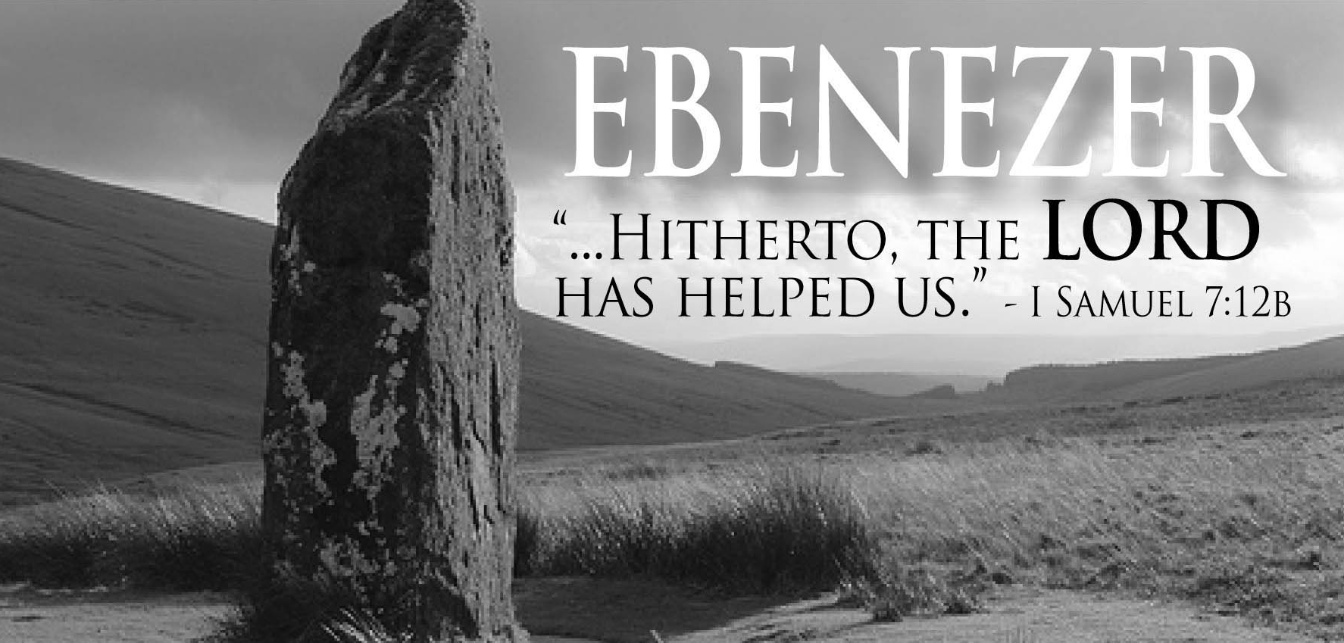

Please lift up the financial needs of Projects CUA & UHW in prayer. The funds of these two projects are at low points, as both projects have reached out and helped great multitudes of individual victims as well as corporate communities during these past years. Please intercede with us that God will provide the needed finance of these two projects, and that He touches people’s hearts to give so the two projects will be able to minister as well as provide help for the financial needs of the terror victims and rocket victims, in the near future when the ban of project visits are lifted (2 Corinthians 9:10), thank you.

Thank you so much for being a great supporter to projects CUA & UHW. I pray all may go well with you and that you may be in good health body, soul and spirit despite COVID related global turmoil

