Bnei Brak - ברק
בני
May 2022 /Jewish Year 5782

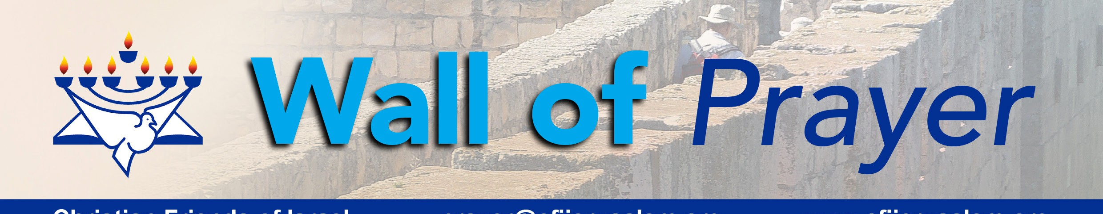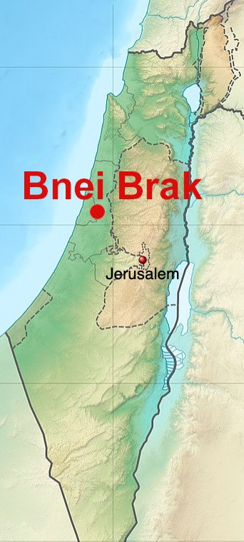“A friend loves at all times, and a brother is born for adversity” Proverbs 17:17 TLV.
Christian Friends of Israel
prayer@cfijerusalem.org
www.cfijerusalem.org

Bnei Brak, also spelled Bene Beraq, is a burgeoning Israeli city in the central Mediterranean coastal plain, sometimes considered a northeast suburb of Tel Aviv. It was named for the Biblical town of Bene-Berak, mentioned in Joshua 19:45 as one of the ancient cities allocated to the tribe of Dan. In 1924, Bnei Brak was founded about 4 kilometers (2.5 miles) from the site of the Biblical Bene-Berak. It was established as an agricultural village by several orthodox families who immigrated during the Fourth Aliyah. The lack of land caused many of the founders to turn to other professions, enabling the village to become industrialized. By 1950, the village had grown into a city.

In 2019, Bnei Brak was home to 204,639 people. It is currently ranked as Israel’s most densely populated city, with 28,000 people per square kilometer. Unfortunately, this municipality became a coronavirus hotspot in January 2020 because families lived in close quarters with no room for isolation of infected individuals. As a result of the massive outbreak, the entire city was quarantined, causing quite an uproar among the residents.

Bnei Brak is a citadel of Haredi Judaism, a group within Orthodox Judaism characterized by strict adherence to Jewish law and traditions. Considered an ultra-orthodox city, it has only one neighborhood of approximately 30,000, which is not primarily Haredi. There are numerous yeshivas, institutes of religious learning, and more than 200 synagogues contained within Bnei Brak. It was previously home to one of the original gender- segregated bus lines that served Haredi populations for whom public male/female separation was customary. In 2011, such buses were ruled illegal by the Israeli courts. According to the Jerusalem Post, Bnei Brak is one of Israel’s most economically disadvantaged cities. A large sector of the population places a higher value on religious studies than participating in the workforce.
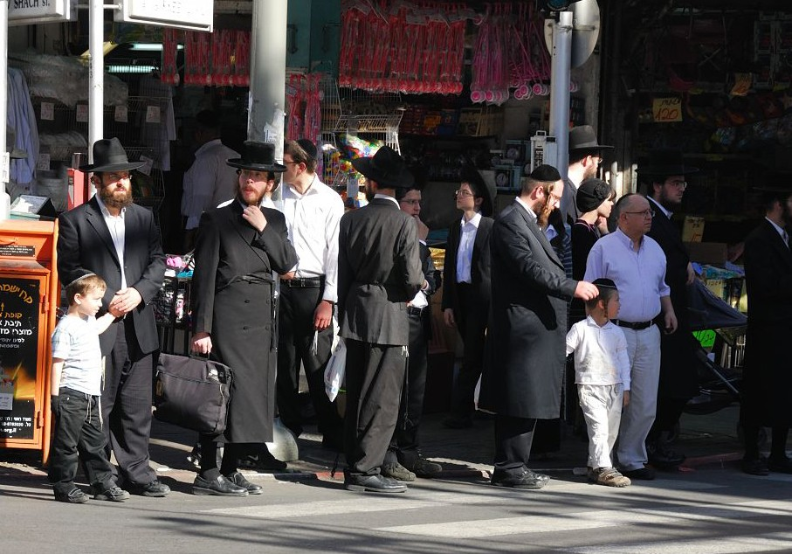
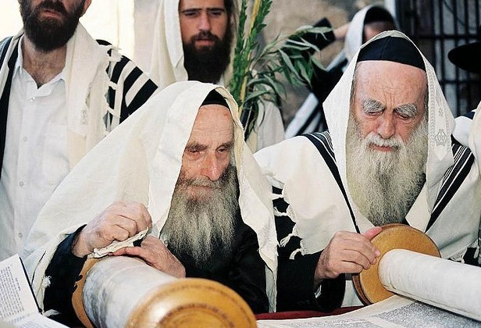
Haredim in Bnei Brak (CC BY-SA 3.0, Wikipedia) Tora reading (CC BY-SA 3.0, by Eliel Joseph Schafler, Wikipedia)

A recent tragedy struck Bnei Brak that was a catalyst for bringing Israelis from diverse religious backgrounds together. On March 29, 2022, a Palestinian terrorist unleashed a shooting attack in Bnei Brak, which killed five people. A Christian-Arab police officer, Amir Khoury, responded to the emergency and died while thwarting the assault of many more citizens. Israel honored him for rushing to the scene of a deadly terror attack and ending

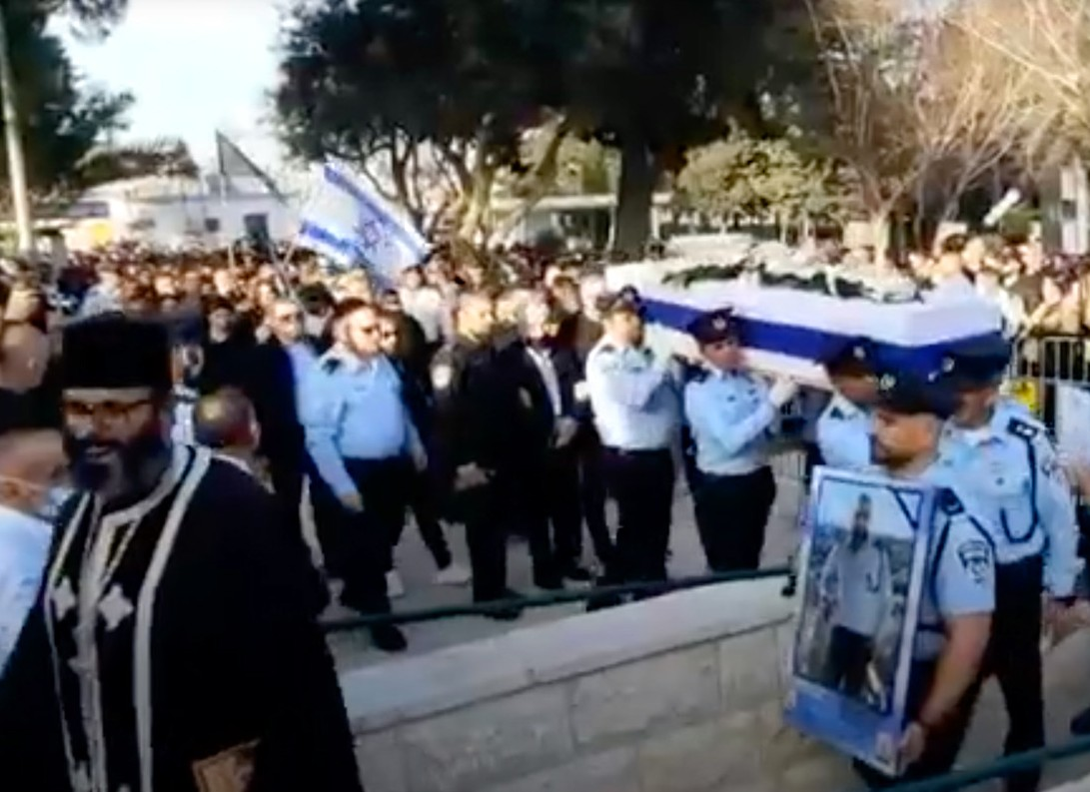
Funeral of Arab-Israeli Policeman Amir Khoury (YouTube)
the killing spree while paying with his life. The Times of Israel headlines read, “Cop Amir Khoury, who halted Bnei Brak terror, mourned as ‘hero of Israel’ at funeral.” Although it was not customary, Hanan Rubin, an Orthodox resident, organized bus services for religious Jews to attend the Christian funeral in Nazareth; there were about 200 Haredi residents of Bnei Brak who came to honor him. Rubin said, “For many sectors of the religious public, it was very difficult to attend a Christian ceremony… And here, today, we witnessed a substantial religious and Orthodox presence at Amir’s final farewell.” Another ultra-Orthodox resident, Yaakov, was interviewed on Channel 13 enroute to Khoury’s funeral. Speaking of Khoury, he said, “He gave his life for others. He’s from another people, but we are brothers. He fought for us.” The Times of Israel

Amir Khoury truly fulfilled Proverbs 17:17, which says, “A friend loves at all times, and a brother is born for adversity.” 1 John 3:16 challenges us to give of ourselves for others, by saying. “The way that we have come to know love is through his [Yeshua] having laid down his life for us and we ought to lay down our lives for the brothers!”

Let’s Pray for Bnei Brak
- Worship God for His sovereignty in our lives. His ways and thoughts are much higher than ours. Perhaps the terrorist intended to take many more lives through the attack in Bnei Brak, but God allowed brave First Sergeant Khoury to be there to halt the shooting. Like Joseph, we can say, “God produced something good from it, in order to save the lives of many people” (Genesis 50:20, CEB). “Furthermore, we know that God causes everything to work together for the good of those who love God and are called in accordance with his purpose” (Romans 8:28, CJB).
- Thank the Lord for Hanan Rubin’s wise timing and bravery in organizing transportation for Bnei Brak residents to honor the life of Sergeant Koury at his Christian funeral. “There is an occasion for everything, and a time for every activity under heaven… a time to kill and a time to heal; a time to tear down and a time to build; a time to weep and a time to laugh; a time to mourn and a time to dance; a time to throw stones and a time to gather stones; a time to embrace and a time to avoid embracing” (Ecclesiastes 3:1-5, HCSB).
- Intercede for those charged with protecting Israel – the police department and Israel Defense Forces. We must also pray for those protecting nations like the Ukraine and others. “But you, Israel, My servant, Jacob, whom I have chosen, descendant of Abraham, My friend …I have chosen you and not rejected you. Do not fear, for I am with you; do not be afraid, for I am your God. I will strengthen you; I will help you; I will hold on to you with My righteous right hand” (Isaiah 41:8-10, HCSB).
- Pray for comfort for those everywhere who have witnessed trauma and are grieving. “...God of all encour- agement and comfort, who encourages us in all our trials, so that we can encourage others in whatever trials they may be undergoing with the encouragement we ourselves have received from God” (2 Corinthians 1:3-4, CJB).
- Ask God to draw Israel to the beautiful words of the Torah, which point to the coming Messiah. May the Lord fulfill His Promises in Ezekiel 11:19-20, which say, “Then I will give them one heart. I will put a new Spirit within them. I will remove the heart of stone from their flesh and give them a heart of flesh. They will be My people, and I will be their God.”
To Our Dear Prayer Warriors:
What a joy it is to be back in the Land of Israel! God is enlarging our “territory” and areas of responsibility. As we each follow the direction of the Ruah Ha Kodesh (Holy Spirit), may we walk only in the domain that the Lord assigned for us. Shalom!

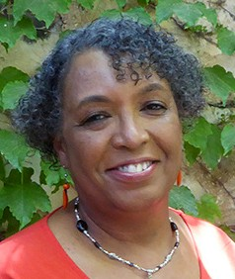
In His Service,

Linda D. McMurray
Wall of Prayer Supervisor

