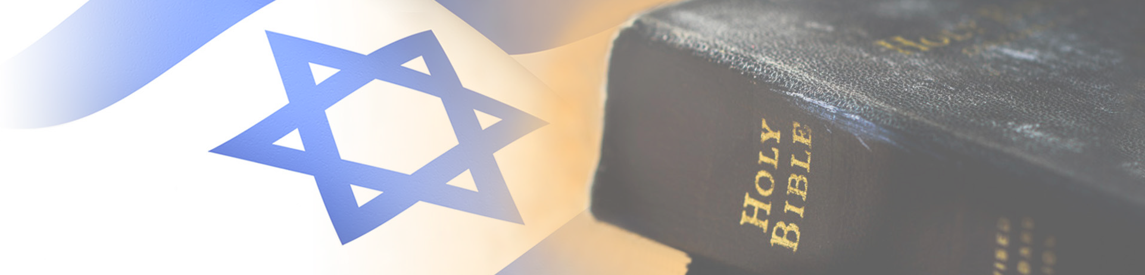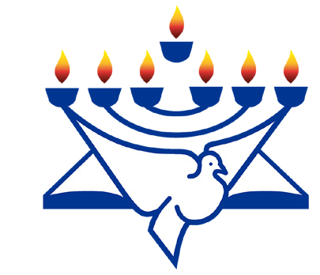
CFI News Insights
Christian Friends of Israel
feedback@cfijerusalem.org
www.cfijerusalem.org

October 10, 2021 /Jewish Year 5782

Fall Feasts Observed in Israel
Part 2
“On exactly the fifteenth day of the seventh month when you have gathered in the crops of the land, you shall celebrate the feast of the LORD for seven days, with a Sabbath rest on the first day and a Sabbath rest on the eighth day. Now on the first day you shall take for yourselves the foliage of beautiful trees, branches of palm trees, and boughs of thick (leafy) trees, and willows of the brook [and make booths of them]; and you shall rejoice before the LORD your God for seven days. You shall celebrate it as a feast to the LORD for seven days in the year. It shall be a permanent statute throughout your generations; you shall celebrate it in the seventh month. You shall live in booths (temporary shelters) for seven days; all native-born in Israel shall live in booths” Leviticus 23:39-42 (AMP).
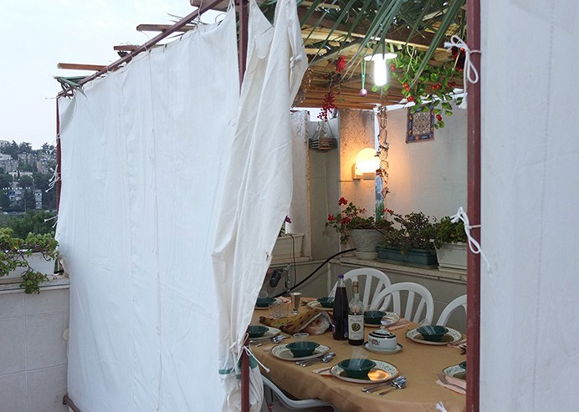
Canvas-sided sukkah in Jerusalem topped with palm branches and bamboo matt (by Gilabrand, CC BY-SA 3.0, Wikipedia)

This time on Insights, we will look at Sukkot (or Tabernacles) and the main days that are bookends of this week of celebration. The Hebrew construct of the word Sukkot consists of the concepts of wholeness and attentiveness, which is supposed to reflect the unity of the history and legacy of Jewish peoples on the whole. Each day of Sukkot simultaneously point to Old Testament icons (Abraham, Isaac, Jacob, Joseph, Moses, Aaron and David) and prominent species in the land (wheat, barley, grapes, figs, pomegranates, olives and dates) that manifest the abundance promised to the Hebrew children upon taking possession of Canaan.

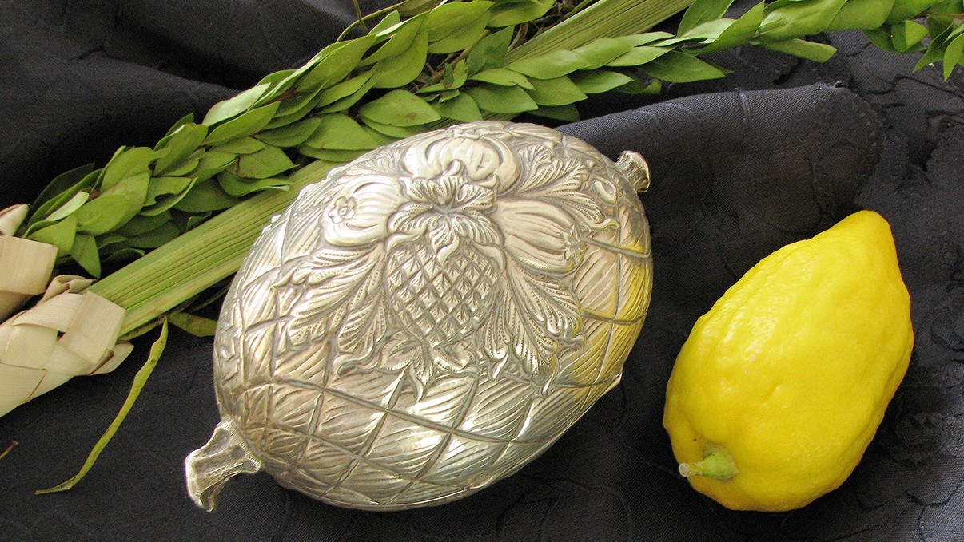
Sukkot’s 4 Holy Species from left to right: Lulav (palm frond), Hadass (myrtle), Aravah (willow branch), Etrog (citron) carrier, Etrog (citron) outside its carrier.
(by Gilabrand, CC BY-SA 3.0, Wikipedia)
Sukkahs when constructed normally consist of palm branches, willows, citrons and myrtle branches. In order, these are to embody solid backbone, humility, hearts of compassion and penetrating eyes, which were and are to remain within Jewish consciousness in each year this feast is remembered. Specifically, palm branches have been connected with victory, from the periods of the Maccabean and Bar Kochba revolts and echoed also in military conflicts that occurred during Israel’s modern era.
This Sukkot, some within the community drew some unwanted attention from authorities by constructing a sukkah that was deemed unstable and thereby hazardous to sojourners who had to travel nearby. Conflict between those who put the edifice up and police did reach some physical confrontation.

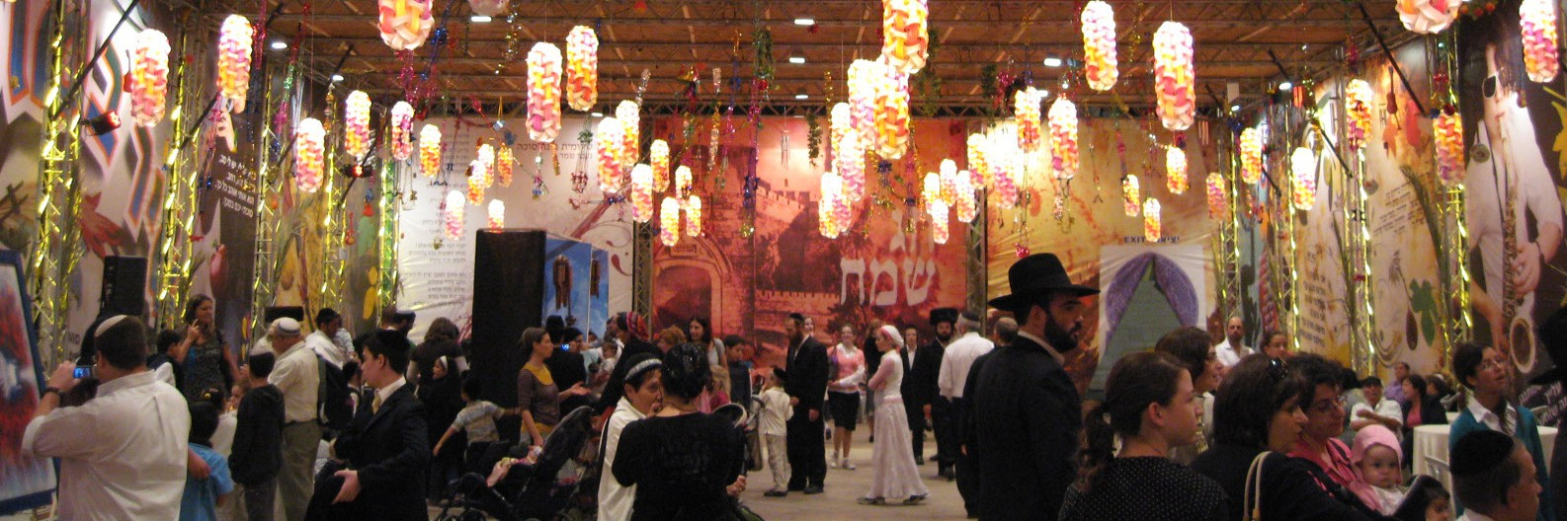
Sukkah built in Safra Square, Jerusalem. (by Jshir1, CC BY-SA 3.0, Wikipedia)

Looking at the Sukkah through the eyes of the Father, it is easy to see that he wants us to remember the temporal and transitory nature of our lives on earth. The Sukkah paints a vivid picture for us, and in living and eating there for 8 days we are reminded of the fragility of life and our dependency upon God. We move out of our safe houses into the somewhat shaky structure, only to find that trusting in God is above all the safest place to be. It is interesting to note that Sukkot comes at the time of the changing of the seasons. We feel some relief from the heat and see the tail end of the long hot summer and catch breaths of the cooler air and season to come. On several past years in the land, the heavy rains have actually begun during Sukkot, providing a perfect picture of running into the shelter, The Lord Our Rock and Redeemer, whilst the palm branch roof leaks in buckets and we long for the comforts of home.
In a world of shaking values and circumstances let us consider, in God alone is our refuge.

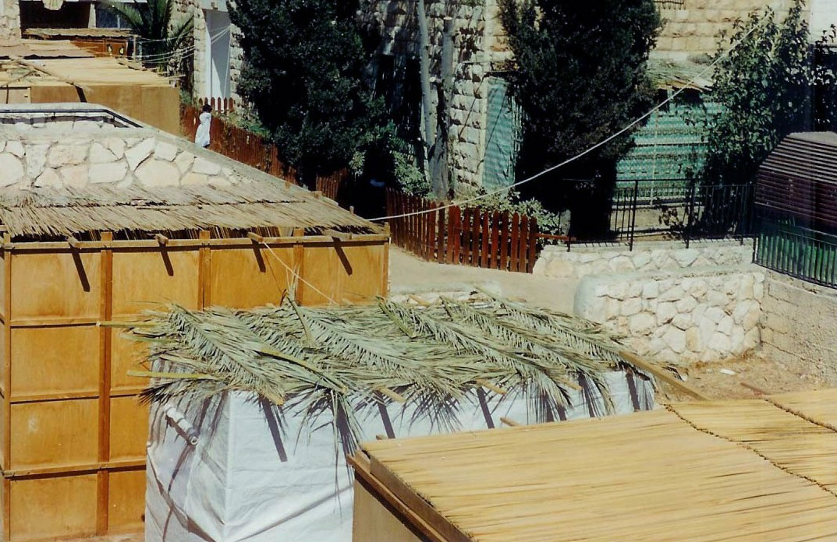
“My soul, wait only upon God; for my expectation is from him. He only is my rock and my salvation: he is my defense; I shall not be moved. In God is my salvation and my glory: the rock of my strength, and my refuge, is in God. Trust in him at all times; you people, pour out your heart before him: God is a refuge for us. Sela” Psalm 62:5-8.

“In the multitude of my thoughts within me thy comforts delight my soul” Psalm 94:19.

“He that dwells in the secret place of the most High shall abide under the shadow of the Almighty. I will say of the Lord, He is my refuge and my fortress: my God; in him will I trust” Psalm 91:1-2.

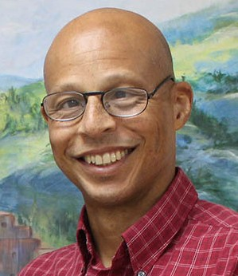
Reporting from Jerusalem,
Kim S. Brunson

Sukkah roofs. (by Yoninah, CC BY 2.5, Wikipedia)

