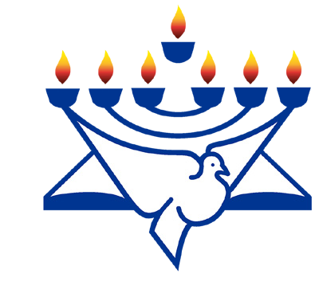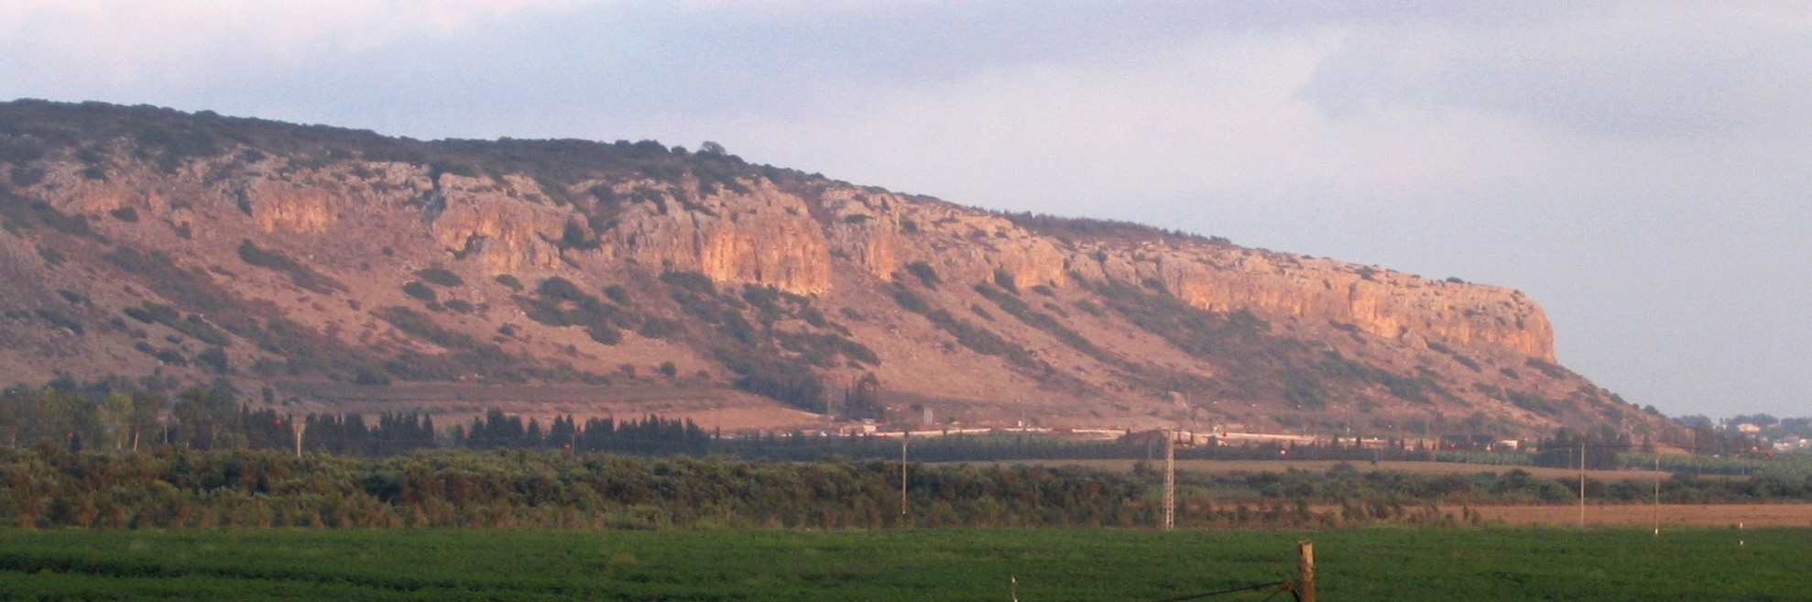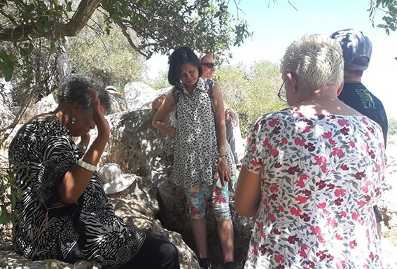
in

Prayer Letter
Watchman’s

Christian Friends of Israel prayer@cfijerusalem.org www.cfijerusalem.org
December 2021 /Jewish Year 5782
Appointments on Mount Carmel
“A person may plan his path, but Adonai directs his steps” (Proverbs 16:9 CJB).

The southwest face of mount Carmel during the sunset. (CC BY 4.0, by Chadner, Wikipedia)

Beautiful Mount Carmel was the third and final “high place” our team visited during our August prayer journey. Rather than a single mountain, Har HaCarmel (in Hebrew) is a range of coastal mountains approximately
6.5 to 8 kilometers (4.0 to 5.0 miles) wide, which stretch 39 kilometers (24 miles) from the Mediterranean Sea towards the southeast. Although it is not exceptionally high, with a summit of only 546 meters (1,791 feet) above sea level, Mount Carmel has always been a symbol of beauty. The changes in scenery from the flat coastal plain up to the summit give it a striking feature. Because of its location near the sea, this mountain range has large amounts of precipitation and high humidity that nourish its lush Mediterranean groves and natural forests. Mount Carmel provides breathtaking views of the Mediterranean and the Jezreel Valley; it is also a place of well-known Biblical history (Jewish Virtual Library, Wikipedia).

Our plan was to video the reading of the story of Elijah and the prophets of Baal on Mount Carmel while we were on-site. We worshipped while traveling to this location and asked the Lord to guide us to any divine appointments He might have scheduled. Upon arrival, we discovered that the usual entrance through the Carmelite Monastery was closed; other visitors returned to their cars and left the parking lot. However, after having traveled a long distance, we would not allow this obstacle to deter us. Suddenly a man and his son emerged from a trail among the trees and directed us upward. I noticed a couple heading toward that footpath; after exchanging greetings, I told them we would see
them shortly. We gathered our gear and also climbed up the trail. This path led to a very confined and une- ven place with numerous trees, but we found a small space where one or two people could stand and view the magnificent Jezreel Valley. Many scholars be- lieve that the final Battle of Armageddon will occur somewhere in that beautiful, vast valley.

We sat down with the couple and began conversing. The husband was born in Israel, and his wife had made aliyah from South America many years ago. They asked us where we were from and our reason for being in Israel. We explained that as Christians, we had a love for God and His Chosen People. During

the conversation, we informed them that our purpose for being on Mount Carmel was to pray for the land of Israel and its people. They gladly permitted us to pray blessings over them. They were accustomed to liturgical prayers, but the unscripted prayers that God gave us on their behalf touched them because we were total strangers from other countries. We prayed in English, but when our team member, Enrique, prayed over the wife in Spanish, her first language, it deeply impacted her; she had tears in her eyes. As they were leaving, the husband commented, “This was not an accident; the Lord had you meet us here today.”
We believe that God left an indelible impression on them and will visit them in dreams and visions, just as we prayed. We prepared to video, but as soon as that couple left, another couple came and sat down, making it impossible to film. The man saw that we were about to read scripture and said, “Oh, I know. You are going to read from the additional book.” Maggie, another team member, spoke to him in Hebrew, saying, “No, we will be reading from your Scriptures, the Tanakh, from I Kings 18:20-39.” The man found the verses on his phone and followed along for the entire reading, which ended with these resounding words, “The Lord, He is God! The Lord, He is God!”

After the second couple left, we sensed that we had completed the assignment the Lord had intended for us; we had done our part, and He would orchestrate the next steps in the lives of the people we had met. This assignment reminded me of Paul’s words in 1 Corinthians 3:6-7, “I planted the seed, and Apollos watered it, but it was God who made it grow. So neither the planter nor the waterer is anything, only God who makes things grow” (CJB). We pray that the seed of the Word of God will grow in the hearts of those who hear it. We later realized the Lord did not want the Mount Carmel visit included in the video; these were private appoint- ments set by the God of Heaven and Earth.

Let’s keep our appointment with God around His Throne!
- Worship the Lord for His Omniscience. God knows every detail of our lives – past, present and future, and He orchestrates our steps to accomplish His divine purposes. We bow in submission to His plans for this prayer time; as willing servants, may we say and do whatever He instructs. Our Father knows best. “For My thoughts are not your thoughts, nor are your ways My ways. It is a declaration of Adonai. For as the heavens are higher than earth, so are My ways higher than your ways, and My thoughts than your thoughts” (Isaiah 55:8-9, TLV).

- Praise God for His amazing love for Israel! Even though many of His Chosen People are resistant to His Word, He has promised to redeem them. “The Lord appeared to me (Israel) from ages past, saying, ‘I have loved you with an everlasting love’” (Jeremiah 31:3, AMP). “I will take away your stubborn heart and give you a new heart and a desire to be faithful” (Ezekiel 36:26, CEV).

- Intercede for Israelis who have tender hearts and yearn to know more about the God of Israel. Ask the Lord to give them intriguing dreams and visions that will draw them closer to Himself. “I will pour out my Spirit on all kinds of people. Your sons and daughters will prophesy, your old men will have dreams, and your young men will see visions” (Joel 2:28, ERV).

- Lift your voices in prayer for Believers in the Holy Land who face much opposition. Please intercede for their grace, strength, and encouragement. Amid pressures, may they exude the sweet aroma of Messiah to those around them. “But thanks be to God, who in the Messiah constantly leads us in a triumphal procession and through us spreads everywhere the fragrance of what it means to know him!” (2 Corinthians 2:14, CJB).

To Our Dear Prayer Warriors:
How precious it is to pray alongside you, my brothers and sisters in the Lord! We have joined in prayer by phone or computer – what sweet fellowship around the Throne of God. Thank you to those who emailed thoughts God gave them while interceding for Israel. From all over the world, your petitions arise as sweet incense to Him; He hears and will answer at the appropriate time.
In the days ahead, we look forward to more online prayer sessions in other time zones. If you would like to join us, please contact us at the email address shown below. God has been faithful to us this year, and we plan to continue honoring Him with faithful intercession for Israel through the Wall of Prayer. May the peace of God rest on you in the days to come.

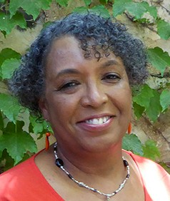
In His Love,

Linda D. McMurray
Wall of Prayer Supervisor

