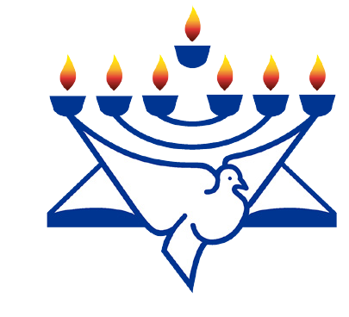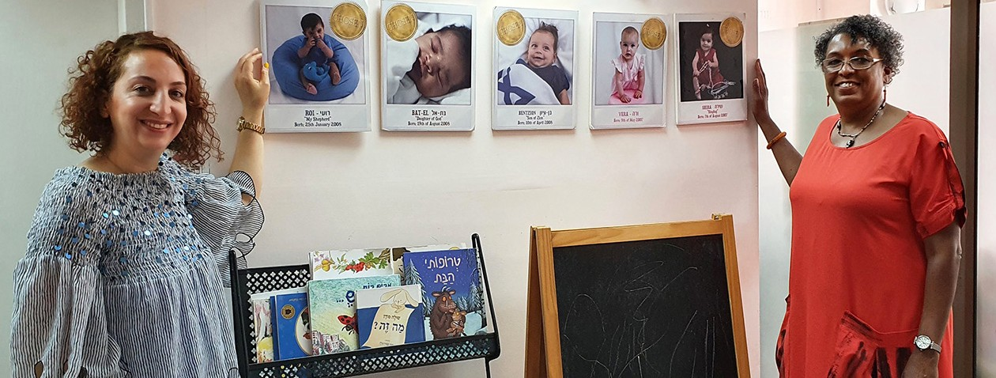
in

Prayer Letter
Watchman’s

Christian Friends of Israel prayer@cfijerusalem.org www.cfijerusalem.org
August 2021 /Jewish Year 5781
CHOOSE LIFE
“Today I am giving you the choice between a blessing and a curse – a blessing, if you obey the commands of the Lord your God that I am giving you today; but a curse, if you disobey these commands… I am now giving you the choice between life and death, between God’s blessing and God’s curse, and I call heaven and earth to witness the choice you make. Choose life.” (Deuteronomy 11:26-28, 30:19 GNT)

Visiting with grief counselor Annie at Be’ad Chaim (Pro-Life Center)

Moses spoke these poignant words to the children of Israel as they camped at the brink of Canaan. He gave advice and warnings to prepare them for the experiences that lay ahead. After 40 years of leading them from slavery and watching their parents die in the wilderness, Moses solemnly prepared the Israelites for his own departure from this life and their entrance into the Promised Land under Joshua’s leadership. How touching his parting words must have been as he told them that he would not be allowed to enter the long-awaited land because of his failure to honor God before them. It was from personal experience that he understood the consequences of disobedience. He earnestly urged them to obey the word of the Lord, to be courageous, and conquer the land by God’s power.

After Moses’ death, Joshua led the young Israelites into the Promised Land as he reiterated God’s word. “This Book of the Law shall not depart from your mouth, but you shall meditate on it day and night, so that you may be careful to do according to all that is written in it; for then you will make your way prosperous, and then you will achieve success” (Joshua 1:8 NASB). To “choose life” meant obedience to God’s instructions which would result in a successful and rewarding life. These eternal principles still apply today, not only for Israel, but for all of mankind.

The fact that the people of Israel still live today (despite repeated attempts throughout history to annihilate them) is proof of the immutability of God’s word. The 1948 establishment of the State of Israel can only be explained as divine providence where the Lord fulfilled His ancient promise from Jeremiah 31:3-4: “For long ago the Lord had said to Israel: I have loved you, O my people, with an everlasting love; with loving-kindness I have drawn you to me. I will rebuild your nation, O virgin of Israel...” (TLB). There is an Israeli song called Am Yisrael Chai (חי ישראל עם) which means The Nation of Israel Lives. To God be the glory!

After the long history of campaigns of genocide against Jewish people, it is disturbing to read current Israeli abortion statistics. In 2 Kings 16:3, God prohibited Israel from willingly giving their children over to death like

the nations around them who sacrificed their children to idols. God wanted them to be a culture of life and not of death. According to The Jerusalem Post, in 2019 approximately 17,580 females received approval from an Israel pregnancy termination committee to abort their children. Thankfully, this number of abortions represents a downward trend since 1988, according to new data from Israel’s Central Bureau of Statistics.

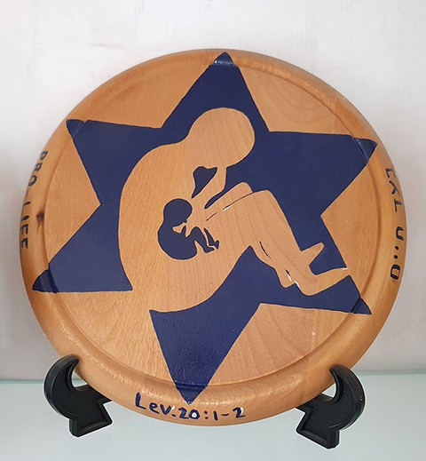
We are very grateful for men and women of faith working in Israeli Pro- Life centers who come alongside women in crisis pregnancies to give assistance, counsel, and continued encouragement. Some centers even have grief counselling for post-abortive women, as well as for those who have had stillbirths and miscarriages. Those who need grief counseling are a special sector of Israelis who I am asking you not to overlook, but to remember them in your prayers.

Please join us in praying that more Israelis will truly choose abundant life by obeying God’s word in their everyday decisions. As Christians praying for Israel, we read Yeshua’s words in John 10:10, “The thief comes only in order to steal, kill and destroy; I have come so that they may have life, life in its fullest measure. I am the good shepherd. The good shepherd lays down his life for the sheep (CJB).” We want the blessings of the Lord upon every Israeli as they choose life.

Let’s Pray for Abundant Life in Israel!
- Extol the Lord, our Creator, for His love and concern for the unborn. “Your eyes could see me as an embryo, but in your book all my days were already written; my days had been shaped before any of them existed. God, how I prize your thoughts! How many of them there are!” (Psalm 139:16-17 CJB).

- Praise God for those people who He has called to come alongside girls and women experiencing crisis pregnancies. Please intercede for the workers’ physical, emotional, and spiritual strength and wisdom as they uphold others. “Bear one another’s burdens – in this way you will be fulfilling the Torah’s true meaning, which the Messiah upholds” (Galatians 6:2 CJB). Please pray for resources to meet the needs of their clients. Ask the Lord of the Harvest to send more laborers to work in this field. “Then He said to His disciples, “The harvest is plentiful, but the workers are few. Therefore, pray to the Lord of the harvest that He may send out workers into His harvest field” (Matthew 9:37-38 TLV).

- Beseech the Lord on behalf of the women in Israel. May they have an insatiable hunger to know more about the word of God and experience the Bread of Life. “Yeshua answered, ‘I am the bread which is life! Whoever comes to me will never go hungry, and whoever trusts in me will never be thirsty’” (John 6:35 CJB).

- Intercede for the girls and women who are being pressured to have an abortion. Ask God to give them a courageous spirit like Jochebed, Moses’ mother, and a plan for saving their children. May those children who are spared from death grow up to become those who will serve God mightily, bringing life to their generation. “The woman conceived and gave birth to a son…when she could no longer hide him, she took a basket of papyrus reeds, coated it with tar and pitch, put the child inside, and laid it in the reeds by the bank of the Nile“ (Exodus 2:2-3 TLV).

Our Dear Prayer Partners,
It is a pleasure to meet with you again as we ‘travel on our knees’ praying over Israel. Each time we pray with you, we are strengthened, and Israel is helped. Recently someone told us that their prayer team calls out the names of each Jerusalem staff member as they intercede for the Holy Land. Thank you so much! We certainly feel your prayers sustaining us. It is a joy to see your pictures on our world map as we in turn, pray for you. If you would like to add your photo to the map of those who pray for Israel, please email it to the address below. May God bless you with life in its fullest measure.

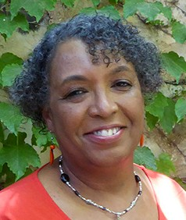
In His Love,

Linda D. McMurray
Wall of Prayer Supervisor

