CFI News Insights
Christian Friends of Israel
feedback@cfijerusalem.org
www.cfijerusalem.org

July 25, 2022 /Jewish Year 5782

Coalition Chapter Closes
Israeli Government in flux again?

“By me princes’ rule, and nobles, all who judge and govern rightly” Proverbs 8:16 (AMP).
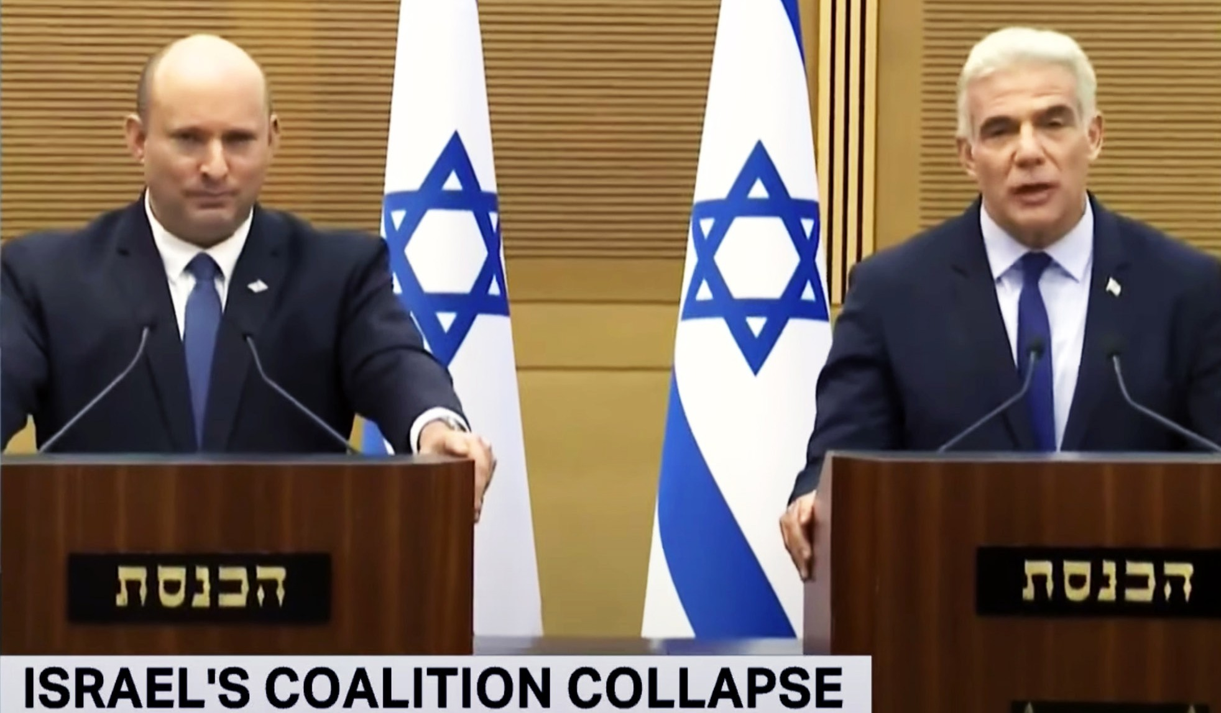
Bennett announces coalition’s demise, new elections: ‘We did our utmost to continue’ (YouTube)

When this coalition began, pundits indicated that it was contrived and convoluted and simply created to keep Binyamin Netanyahu from remaining in Prime Minister. After a year, it is possible that by elections that will take place in October or even prior that time, he may be able to re-assume the office once again. “Bibi” does not have many confidantes within the political establishment even within those in ideological harmony with his positions, but with legal cases against the former Prime Minister losing momentum, some negative perceptions of him in the public may have diminished enough for him to cobble together a Knesset ruling majority despite this. Many politicians that have served in this coalition have wagered their short-term political status on their ability to prevent Bibi from re-assuming rule. They may regret being as strident or inflexible regarding this. The outcome remains to be seen.

“The rulers do not know, nor do they understand; They walk on in the darkness [of complacent satisfaction]; All the foundations of the earth [the fundamental principles of the administration of justice] are shaken” Psalm 82:5 (AMP).

One unintended circumstance of having a government that is transitional is that it may embolden Israel’s enemies to attack, whether it be Hamas, Islamic Jihad or even Hezbollah. This would be a miscalculation. We

pray for the protection of Israel’s citizens and borders, but we also pray for the Palestinian and Lebanese populations who may or may not be on board with the radical Islamic terrorist agendas of the dominant political entities within their communities. Israel has made it a point to be prepared for any military, cyber-tech, or even propaganda attack from those driven by Islamic apocalyptic fervor (i.e., Iran). The Word of God indicates that when days came in which Israel was not able to defend itself, that the outcome for her enemies has even been worse (Exodus 14:13, Isaiah 37:36). Why do we suppose the next chapter in the history of this people and land would differ in our time? We will still pray for some type of political consensus, short of abandoning core Torah principles for the land of Israel. We suggest you pray the same for whatever nation you are fellowshipping with the Lord from.

Reporting from Jerusalem,
Kim S. Brunson

