CFI Projects Monthly Reports for
International
Representatives

Dear CFI International Representative Family,

Thank you for your continued support of the Outreach efforts of Christian Friends of Israel. We continue to strive to encourage those in need and to offer practical assistance during times of struggle. It’s during these times when relationships can be formed which please God and allow us to show Compassion to those who need it the most and have possibly never experienced it before.

During this time of global pandemic, we continue to offer assistance as we are able, and we know each passing day may allow for additional hardships, but we also know the God whom we serve. He is more than able to protect, and provide and heal. We are willing to represent Him to the people of Israel.

Please receive the CFI Outreach electronic updates as a reminder
of the impact each of you have in the lives of so many. We are grateful to represent those of you in the Nations - to those in the Land of Israel.

A friend loves at all times, And a brother is born for adversity.
Proverbs 17:17 (NKJV)

Project Bridal Salon

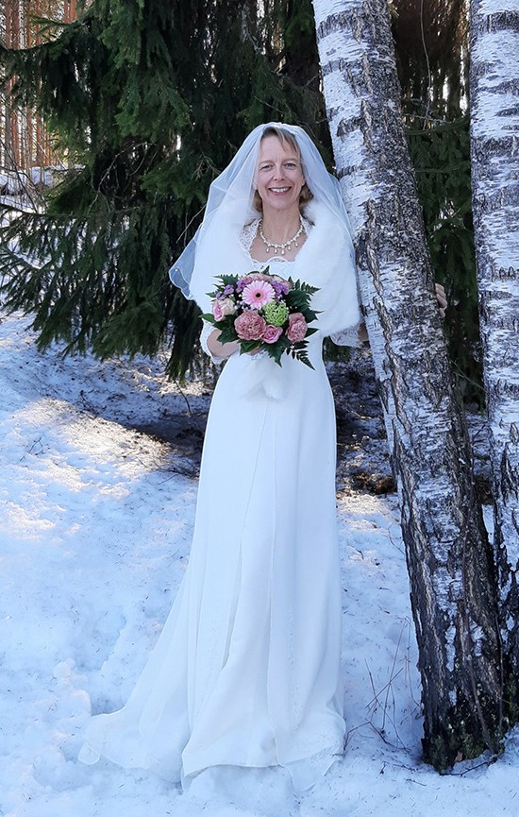
Shalom from Jerusalem!

Have you heard about anybody who has married three times, with the same man, without divorce in between? Israel is a special place, where the marriage and also the wedding ceremony is classified as a religious act.
Here you can be officially married only when both the groom and the bride have the same religion: A Jew can be married only with a Jew, a Muslim with a
Muslim and a Christian with a Christian. The religious status must be demonstrable before the officials of the government. That’s why many Israeli couples have two weddings: one in the Land and one aboard. If you bring a certificate of the marriage from aboard, it is acceptable.

My husband and I got married three times. Presently, we should have all the needed papers and our marriage will be finally recognized here in Israel. Our wedding gowns have been used by us a couple of times now.
The third wedding was a small family celebration that took place in Finland. But we wanted to look as
beautiful as the first time ☺. We are happy and thank- ful that we didn’t have to worry about that part at all.
CFI Bridal Salon provided for us completely. It was a great blessing.

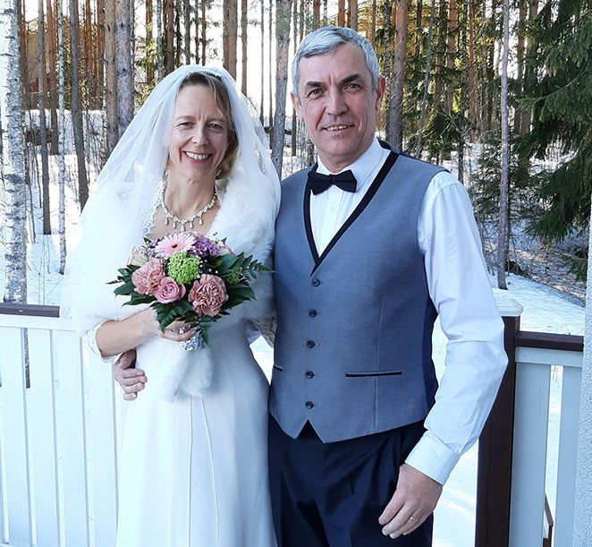
After the special holiday I am ready to serve again at my place here in Jerusalem. Please, pray that we could be a blessing for many couples this year. The covid restric- tions have been lifted and people can have normal weddings again in the Land. Please, pray that the Lord will bring new clients in and that they could experience something special at our place. May the presence of the Lord be in our Bridal Salon. May the work we do glorify the God of Israel.

“For God, who said, ‘Let light shine out of darkness’ has shone in our hearts to give the light of the knowledge of the glory of God in the face of Jesus Christ.”
2 Corinthians 4:6

Tiina Danilevski Project Supervisor

Project Wall of Prayer

ENLARGING OUR TERRITORY

“Enlarge the location of your tent, let the curtains of your dwellings be stretched wide, and don’t hold back. Lengthen your cords; strengthen your stakes. For you will spread out to the right hand and to the left” (Isaiah 54:2-3, ISV).

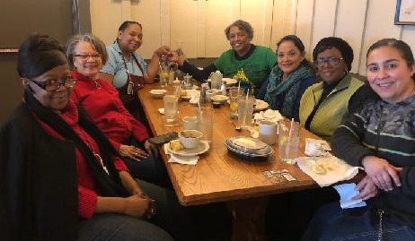
April was a month of intentional expansion for the Wall of Prayer. While in the United States, I deliberately looked for opportu- nities to connect more people to pray for Israel, the nations, and one another. I invited some Israel Watch team members who regularly join our online prayer sessions to meet each other in person. They came from different states, ethnicities, and churches. Two of the members brought a friend. We met in the corner of a restaurant and spent over an hour
in intercession after our lunch. Continually praying together forms bonds between people and gathering face-to-face can add a deeper dimension of unity than is accomplished online. Through this meeting, we prayed God’s will, formed new relationships, added to the group, and encouraged the intercessors to continue in earnest prayer.

Working remotely from the US allowed me the flexibility to pray with multiple intercessory teams. It was a pleasure to pray with our faithful CFI International Representatives. In Matthew 18:20, the Lord
promised to be among us when two or three people gather in His name. The CFI staff and international representatives experience His presence each time we meet. I joined Intercessors for Israel online; this is a prayer group based in Jerusalem led by Chuck Cohen. On several occasions, I interceded with other teams in the US as we prayed for Israel, Ukraine, Russia, and the nations of the world.

April was also a time to prepare for my return to Jerusalem. As citizens of the spiritual Kingdom of God, we take the Kingdom with
us wherever we go. In Luke 17:21, Yeshua told His disciples, “Behold, the kingdom of God is within you.” This scripture came alive as an in- tercessor from my city and I drove to the Consulate General of Israel in downtown Chicago to obtain my entry visa. We took advantage of being in that 41-story building to

focus our prayers on the Knesset, Israeli government leaders, and other employees. When we entered the lobby and spoke to the woman at the desk, she apologized for not responding to us immediately and explained that she was not feeling well. As a representative of the Kingdom of God, I quietly prayed a short prayer over her before going upstairs to get my visa. When I returned, she thanked me and said she felt much better. We both benefited from that visit: she was touched through prayer, and I received my visa. I am now back in Jerusalem!

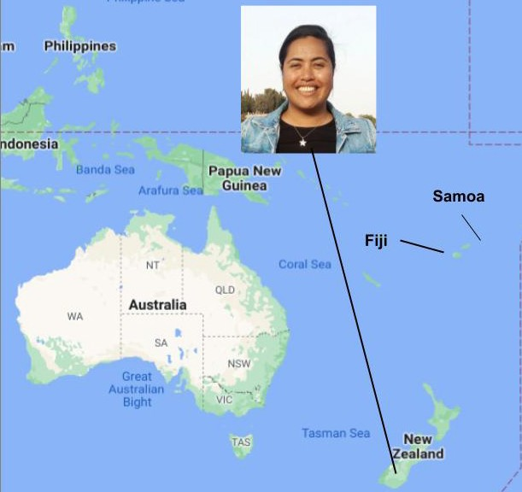
As a part of the plan to enlarge our prayer network, I met with an intercessor and former CFI volunteer, Lise Afele, from New Zealand. Differing time zones make it difficult for our global prayer team to pray online simultaneously, so we will organize online prayer sessions for specific regions of the world.
Lise will join the Wall of Prayer and help us link with intercessors in the South Pacific area, specifically the nations of New Zealand, Fiji, and Samoa. We plan to initiate our first South Pacific prayer meeting in May 2022! As we link countries in prayer for the nation of Israel, we enable global participation in intercession that reaches the throne of God. We are enlarging our territory. As God directs us and opens doors to new areas, we will link with other intercessory teams.

It is of paramount importance to align with Israel in these end times. In Matthew 25, Yeshua taught about the last days through a parable, comparing the nations to sheep and goats. Those that treated His People with mercy and compassion were the sheep who would inherit the Kingdom and eternal life. But those who mistreated or ignored His people were the goats who would be doomed to eternal punishment. The parable concludes by saying, “And the King will answer them, ‘I assure you: Whatever you did for one of the least of these brothers of Mine, you did for Me’... Then He will answer them, ‘I assure you: Whatever you did not do for one of the least of these, you did not do for Me either’ ” (Matthew 25:40, 45, HCSB). The way we treat God’s people is how He will treat us; our relationship with Israel directly affects our destiny.

We are grateful for those who have supported our work in Israel through prayer, financial gifts, and countless labors of love. May God bestow bountiful blessings upon you.; He promised to bless those who bless Abraham in Genesis 12:3, “I will bless those who bless you, I will curse those who treat you with contempt (HCSB).”

Linda McMurray Project Supervisor

Project Forsake Them Not

“The Lord loves the gates of Zion More than all the dwellings of Jacob. Glorious things are spoken of you, O city of God! Selah” (Psalm 87:2-3).

Jerusalem - here we go again, to enter the doors of your precious inhabitants. Those who went through darkest moments of history to arrive at the promised hope. They had been doomed to destruction but yet survived by many miracles.
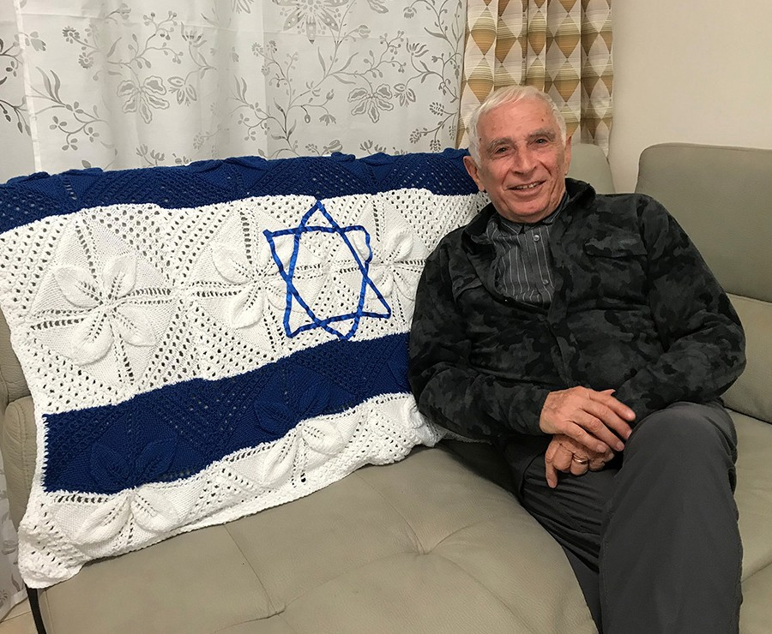
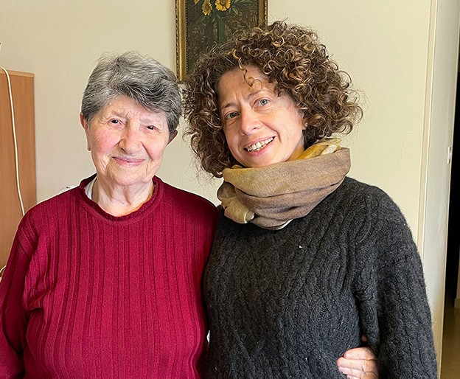

Let’s enter Abrams humble dwelling place, where he lives with his beloved Ludmila. When the war started Abram was three years old and therefore does not remember much of the difficult time his family had just to survive. What he knows is mainly from the stories that he heard from his older sister. There were three children in the family including a younger brother. Abram’s father had his own workshop, and Abram’s mother helped him as well as caring for all the children.
When the war started Abram’s father went straight to the frontline, but the family could not evacuate because the children got sick with dysentery. The Germans took control of Nemirov and then began targeting the Jews and a ghetto was formed. Abram’s mother was forced to work in the fields, construction or cleaning. Occasionally during the war Abram’s father was able to return home. Once he was captured by the Germans, but thankfully he was able to escape and find his way home. It was great to have their father back alive but it was dangerous for him to stay in the ghetto, so he joined a small partisan unit in the area. They organised many activities against the German occupation, and were able to save some lives of those in the ghetto when they heard about the Germans plans for a killing raid. He also found a safe place for his own family to hide during the mass killings.
One Ukrainian family hid them in their storage area, but because Abram’s younger brother cried some neighbours heard him and reported them to the police. When the police arrived the son of the host family started chasing their chickens to make them noisy and saying there was no baby, just noisy chickens!
There were many more stories of how they miraculously survived during these terrible times.

We discovered another miracle in Sonia’s habitation. Sonia was only 5 months old after the war started and her life was spared because of the compassion of the local beekeeper.
Just before the whole family was taken to the deadly Auschwitz from Holland, Sonia’s mother ordered some honey from the beekeeper and the rescue mission was arranged. One early morning the beekeeper

brought honey to the Ghetto and swapped it for Sonia, whom he hid between bee frames on his carriage and so was able to leave unnoticed.
All the years of the war Sonia lived in hiding in his house not even once going outside. She is the only survivor from her entire family.

These testimonies of the marvelous deeds of God and His victory in every saved life, encourages us today to hold on to the promised hope that defeats all the power of darkness.
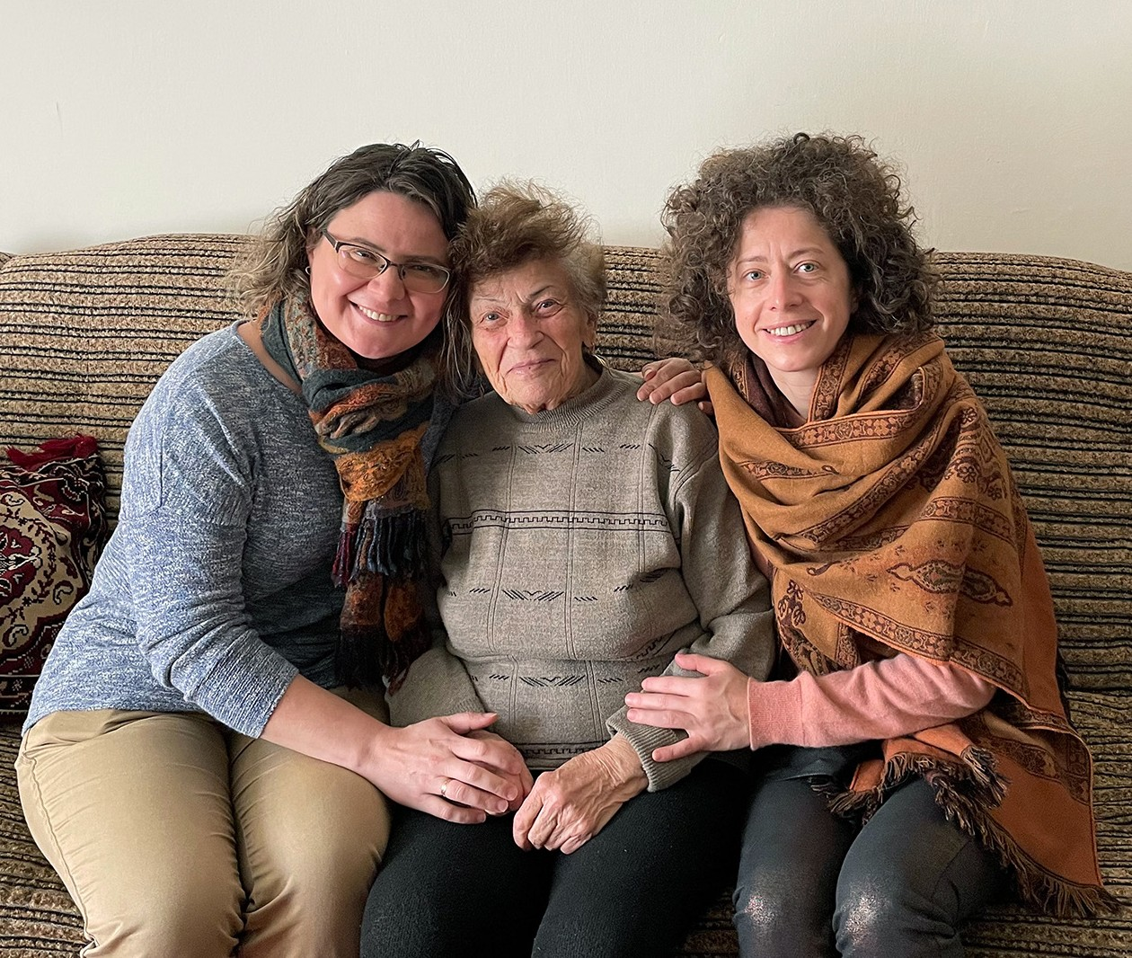
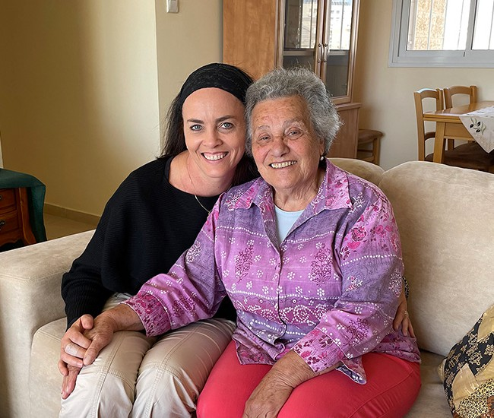

Thank you for joining us again on our visits! Thank you for your faithful financial and prayer sup- port. Thank you for making it possible for us to enter into the dwelling places of God’s chosen people, through entering His heart of compassion first. There are still the Glorious things to be spoken of!

“And He delivered them out of their distresses. And He led them forth by the right way, That they might go to a city for a dwelling place” (Psalm 107:6b-7).

Olga Kopilova Project Supervisor

Project Open Gates

Greetings from CFI “Start Up”- Store!
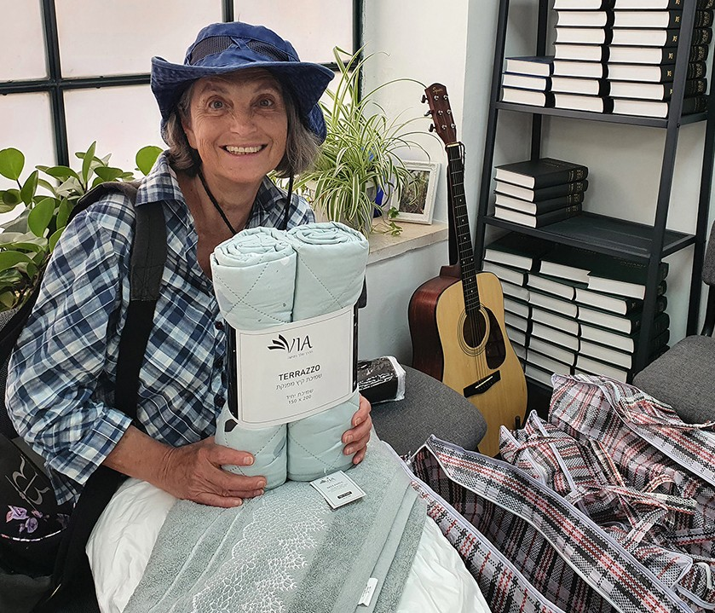

This month has been busy. We have been helping many new immigrants from the Ukraine. The majority of them had to leave everything behind to save their lives. They are staying for the first couple of weeks in different hotels here in the city center of Jerusalem. After that they need to find an apartment somewhere in the Land. They have heard about CFI and they come to us by themselves. We have given them so called “emergency bags” and many of them have already chosen their gifts from our Store. They received from Christian Friends some good and useful items for their new homes in Israel. All of these people are very grateful, and I am sure that they will remember us for a long time.

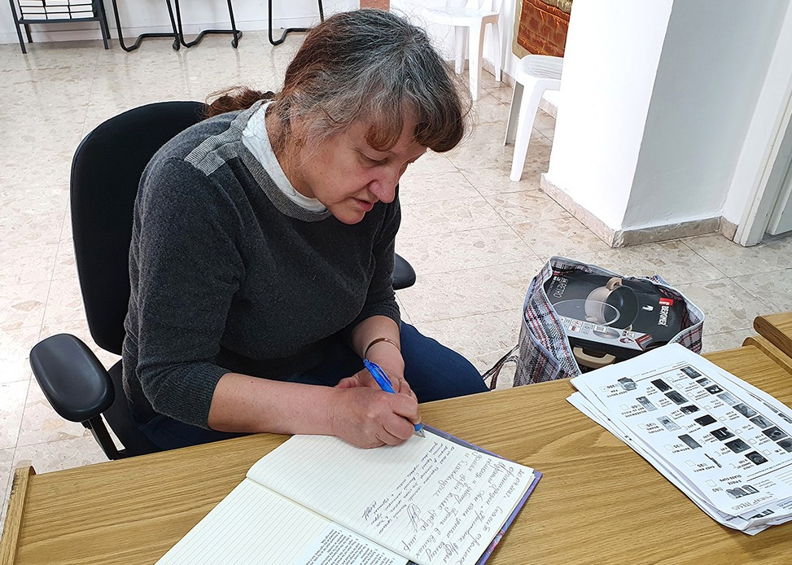
“Please, receive our gratefulness from the new immigrants from Kharkov, Ukraine, for the help you gave in the situation we are in. Your help and support is very important for us at the moment. We appreciate it so much. We thank you for your kind hearts and prayers.”
Zhanna and Katerina 25.04.2022

“A great thankfulness from all of our hearts of new immigrants from Ukraine. We were and are in a difficult situation, but we are supported by love and care.”
Yuliya

We can hear touching stories about their evacuation from the cities that were already “on fire”. Someone was saved from deadly rockets at the last minute. Some of our new friends are still in shock. Many women came to Israel by themselves or with their children. Men are not allowed to leave Ukraine. They must serve in the army. Today four young mothers came to get the emergency bags. One of them chose also the gift during the same visit, because she is moving to her new home in two days. One of them is pregnant with her third child. These ladies don’t know, when they will meet their husbands again… Thank

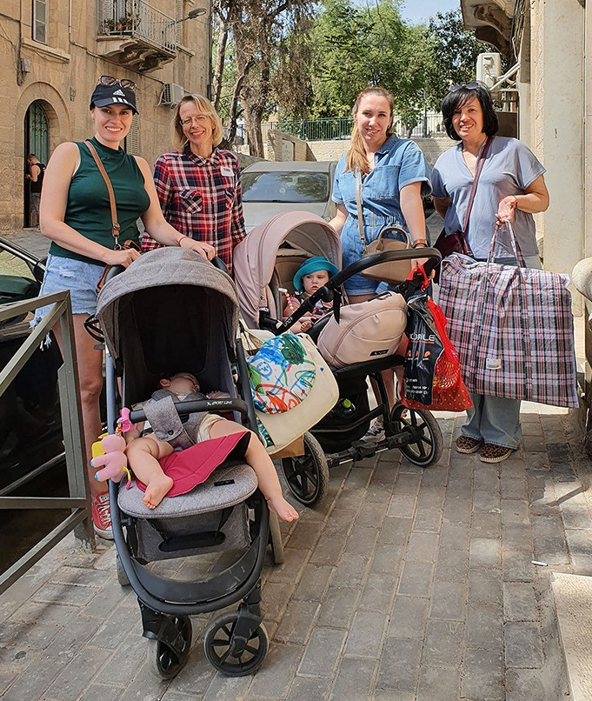
God that they still have contact with them by phone.

This is the time, when we can be a real blessing for hundreds of families and individuals, who are in huge need here in Israel because of the war in Ukraine. Please, pray that the Lord will show the way and comfort His people in a special way. May He use us as He wants in this season. Every one of us can do something. Your prayers can make
a change in people’s life and in our project, too. Thank you for being with us!

“Therefore, behold, the days are coming, says the Lord, when it shall no longer be said ‘As the Lord lives who brought up the people of Israel out of the land of Egypt,’ but ‘As the Lord lives who brought up the people of Israel out of the north country and out of all the countries where He had driven them.’ For I will bring them back to their own land which I gave to their fathers,” Jeremiah 16:14-15

“ … then they shall dwell in their own land.” Jeremiah 23:7-8
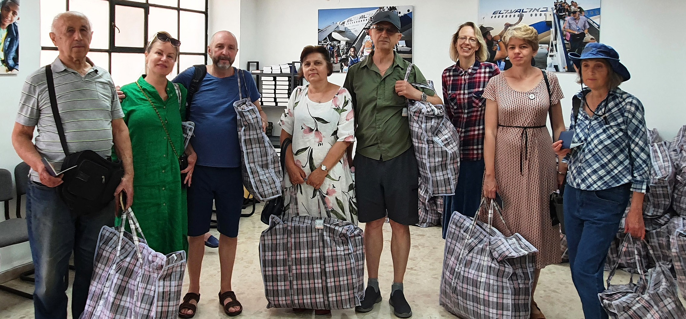

“Then they shall know that I am the Lord their God because I sent them into exile among the nations, and then gathered them into their own land. I will not leave none of them remaining among the nations anymore.” Ezekiel 39:28
Tiina Danilevski Project Supervisor

Project Hope For The Future

Israel’s cities are filled with the multifaceted colours and beauty of Ethiopian families, with babies, elderly and youth filling the streets. All are in wonder and awe of this land! Those that made Aliyah many years ago, without difficulties assimilating into the society here, while others are still burdened with the strug- gles and uncertainties of life and survival on a daily basis. We are aware in the cities that there is a different generation that has emerged: One that possesses resilience and the tenacity to stay rooted in order to contribute to Israeli society. They are becoming the image that they see as the face of Israel by exhibiting success and unity with others; all the while adhering proudly to their own customs.

“Go up and down the streets of Jerusalem. Look now and take note; search her squares. If you can find a single person, anyone who acts justly, anyone who seeks the truth, then I will forgive the city” Jeremiah 5:1.

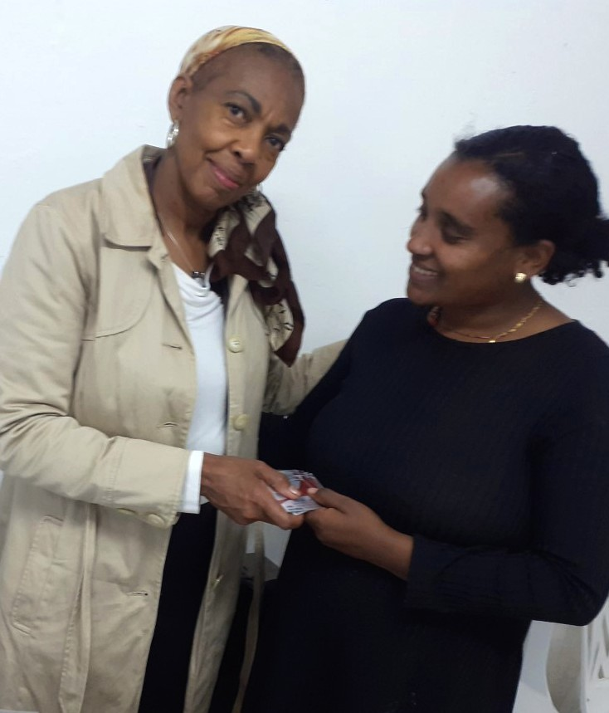
The present situation is a fulfilment of the absolute reliability of the promise made to Abraham, Isaac, and Jacob that Adonai would return the tribes back to Israel. The Ethiopian Aliyah is a never-ending story even though many are still waiting for permis- sion to enter Israel. The Ethiopians hold in high regard benevolent organizations that help keep their stories and identity with their heart felt desires to live in Jerusalem and throughout Israel.

It is an honour to work with the prominent individuals that have laid down their personal agendas to see that the Ethiopian community is taken care of, especially during crisis, the Jewish holidays and regarding day to day needs
- Promoting Justice and Mercy (Micah 6:8)
- Taking care of the poor (Deuteronomy 15:11)
- Feeding the hungry (Isaiah 58:10)

I am very thankful for the men and women that are the liaison within the Ethiopian community, otherwise many would suffer and go without the essential needs. For me personally, I want to do all I can do to help but it is hard when you are not fluent in Amharic or Hebrew. This month we were able to help twenty-eight families have a Pesach celebration in Beni Brak, Kiryat Gat and Ramat Gan. It is heart-warming to be
a part of the homes, even without sitting at each table! We want to remain vigilant for the single-parent
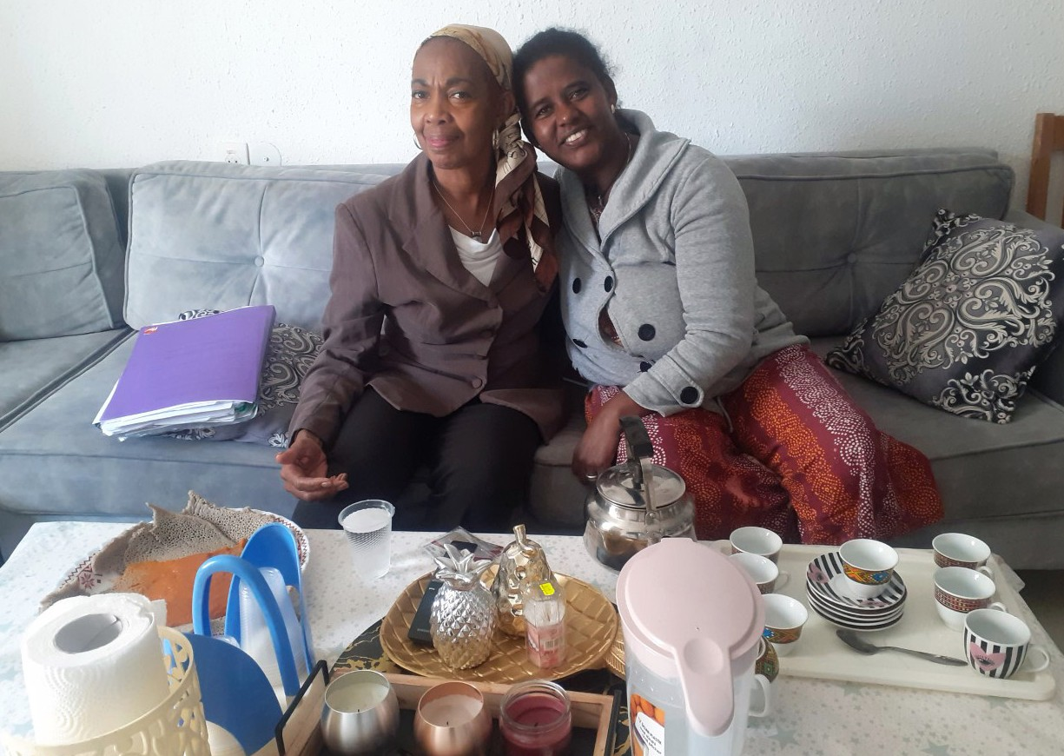
families, but also the men that have no family at all and currently no available social workers to assist, due to a shortage. Because of disabilities, many of the mothers are leaving their husbands! We don’t understand many things that plague this community, but prayer for the families is much needed in times like these. To take hold of the heart of Abba and
to live in unity is high on the list of petitions. Thank you for all your prayers, genuine love and donations which help extend our Kingdom expression to the Ethiopian community.

Marcia Brunson Project Coordinator

