CFI Projects Monthly Reports for
International
Representatives

Dear CFI International Representative Family,

Thank you for your continued support of the Outreach efforts of Christian Friends of Israel. We continue to strive to encourage those in need and to offer practical assistance during times of struggle. It’s during these times when relationships can be formed which please God and allow us to show Compassion to those who need it the most and have possibly never experienced it before.

During this time of global pandemic, we continue to offer assistance as we are able, and we know each passing day may allow for additional hardships, but we also know the God whom we serve. He is more than able to protect, and provide and heal. We are willing to represent Him to the people of Israel.

Please receive the CFI Outreach electronic updates as a reminder
of the impact each of you have in the lives of so many. We are grateful to represent those of you in the Nations - to those in the Land of Israel.

A friend loves at all times, And a brother is born for adversity.
Proverbs 17:17 (NKJV)

Project Wall of Prayer

Praying for Israel and the Nations

“First of all, then, I counsel that petitions, prayers, intercessions, and thanksgivings be made for all human beings, including kings and all in positions of prominence, so that we may lead quiet and peaceful lives, being godly and upright in everything. This is what God, our Deliverer, regards as good; this is what meets his approval. He wants all humanity to be delivered and come to full knowledge of the truth” (1 Timothy 2:1-4, CJB).

During my travels in the United States in January, the number of opportunities to pray with intercessory teams in-person and online multiplied exponentially! Modern technology makes it convenient for people around the world to come together. What a tremendous blessing!

After being away from Israel for a few weeks, it was a joy to reunite online with our Jerusalem staff prayer team to offer petitions for the nation of Israel and our staff. On another occasion, a prayer warrior located in a country thousands of miles away called unexpectedly; the Lord had prompted her to connect with us in intercession for the staffing needs of organizations in Israel. We followed the instructions of Luke 10:2, which says, “The harvest is abundant, but the workers are few. Therefore, pray to the Lord of the harvest to send out workers into His harvest.” We trust God to remove the obstacles and send the needed workers.

In this new year, we feel impressed to spend time listening to God to gain His strategy for navigating these tumultuous times. After hearing from Him, we can pray with wisdom. Our faithful prayer warriors, the CFI Reps prayer team and Prayer Team #4 from the nations, gathered online for our first prayer meetings of 2022; the theme was: Prayer Warriors - Watching and Listening.

One of this month’s memorable activities was joining an online prayer event focusing on the Hope for the Future project, CFI’s outreach to Ethiopian Jews. Julia Soakell of CFI United Kingdom hosted this anointed 2-hour meeting. Marcia Brunson, the Hope for the Future project coordinator, explained the scope of the outreach and the challenges Ethiopian Jews face when immigrating to Israel. She announced the opening of CFI’s new Hope Resource Center, a place designed to help close the education and career gap for Ethiopian Jews. The first computer literacy classes opened in December and sewing classes will begin in February. Following Marcia’s presentation, we were divided into break-out groups to pray for the needs of the Ethiopian community and the Hope Resource Center. James 5:16 says, “The prayer of a righteous person is powerful and effective.” We believe that God heard the fervent prayers of the United Kingdom team and will answer them.

The Wall of Prayer project strives to engage the nations in prayer for Israel; we also pray for the nations to fulfill God’s purpose for their existence. God desires that all nations worship Him; there is a universal call to worship Him. In Psalm 117:1-2, David writes, “Praise the Lord, all nations! Glorify Him, all peoples! For His faithful love to us is great; the Lord’s faithfulness endures forever. Hallelujah!”

The highlight event was participation in a Prayer for the Nations session in Indianapolis, Indiana, United States. This was not a virtual event but a live gathering led by Pamela Thomas of New Wineskin Ministries. The 2-hour intercessory meeting featured prayer for specific nations: Nigeria, Brazil, Nepal, Mexico, Liberia, Russia, China, Israel, the USA, Canada, Haiti, Scotland, Bulgaria, India, Ukraine, and Ethiopia. These countries were places where prayer team members had visited, lived, or knew someone in that nation. During this strategic prayer meeting, Pam shared information about a country and invited the participants to stand next to its flag to pray aloud for that nation. At one point, Senior Pastor Mark Brown revised a well-known song to sing his prayer sentiments over the nations. He led us in singing, “Open the eyes of their hearts, Lord. Open the eyes of their hearts. They need to see You. They need to see You.” This prayer meeting was powerful because fellow believers joined together in heartfelt intercession for nations.
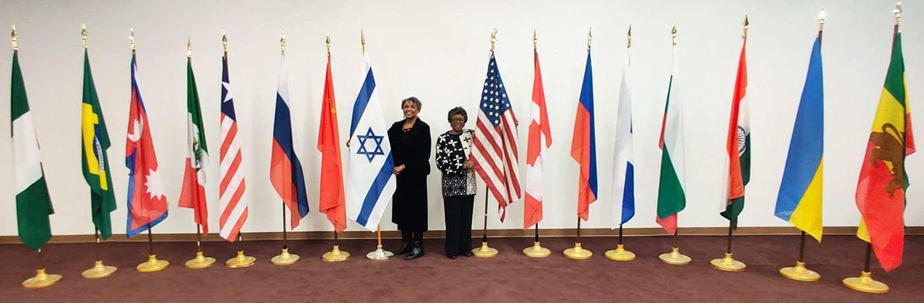

In summary, January was a month of intercession and time spent in the presence of the Lord. We, at CFI, are thankful for those who are also praying for Israel and the nations of the world. Your messages, gifts, and prayers boost our spirits and encourage us to keep listening, watching, and praying. May the Lord bless you and continue to make you a blessing, for blessing Israel.

Linda McMurray Project Supervisor

Project Forsake Them Not

“He uncovers deep things out of darkness, and brings the shadow of death to light” (Job 12:22).

December is the darkest month of the year, and it is when the Light is needed the most (John 1:5-9). When the Light comes, darkness must flee. In times of thick darkness when evil regimes spawn hatred among the people that God created for Himself, we desperately need His Light to cast out the shadows of death. So many people today are longing for that hope, and we should use every opportunity He provides to be His servants and to bring His light.
As we plan our visits, we pray the words from Psalms 43:3: “Oh, send out Your light and Your truth! Let them lead me.” We are ever so grateful that He always directs our paths and helps us fulfil what He called us to, moment by moment.

The Hanukkah season here in Israel was very special, as always. We were able to participate in several events with our precious friends. One was in Jerusalem, where we were guests and enjoyed the fellowship without responsibilities. As I watched these elderly Holocaust survivors, who came from all over the country, rejoicing with all their hearts, I envisioned little children who are so excited to see one another they can’t stop talking. It reminded me of a classroom with zero discipline! As I kept watching, I was struck with the deep realisation that this could be our last chance to create memories with and about them. Despite everything these people had been through in their lifetimes, they know how to appreciate life. As tears trickled down my cheeks, my heart was overwhelmed with gratitude. What a privilege!

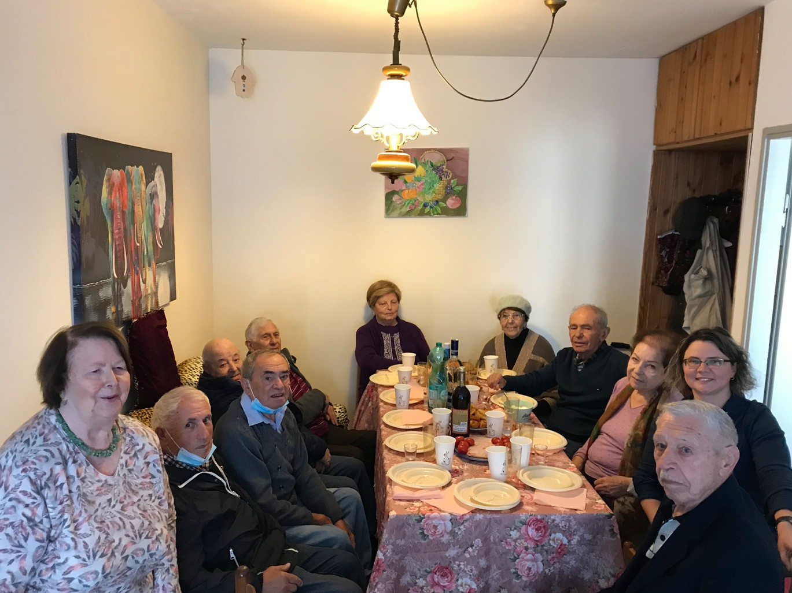
In past years it became a tradition to visit our friends in the northern town of Safed to celebrate Hanuk- kah together. Thankfully, this year was no exception. We gathered together as a small group, but everyone was visibly excited. In the last few years, most of these people were deprived of visits because of COVID-19 restrictions. Clearly they were hungry for fel- lowship and determined to speak. Three hours passed unnoticed, as it would in the company of good friends. It’s impossible to describe the release, happiness, joy and gratitude that overflowed from their hearts. We witnessed how the shadows of loneliness and
depression left as the Light brought hope and the joy of life returned to them. As we continue to pray for
our friends, we are asking for more of these precious moments.

The following day, our visit with Raya was also very special. Raya was a teacher. She loved people and was always active, even when she came to Israel. Everything changed three years ago when she was diagnosed with Alzheimers. When her husband passed away, it developed rapidly. Today Raya has a 24-hour caregiver. She loves reading children’s’ books and that only slowly, but she has almost stopped

talking. When she first saw us, she got so excited and overjoyed! Her face lit up as she smiled and even laughed. She suddenly became so talkative! Though we couldn’t really understand what she was saying, she definitely recognized us, hugging us and holding our hands. She read and reread the colourful cards we brought her, with encouraging words from the Psalms. She was calm and happy. Unfortunately, it’s not the place she had been lately, struggling with depression and bursts of anger. Raya’s caregiver
said she’d never seen her so happy and could hardly believe what she was seeing, even calling Raya’s daughter. I truly believe we witnessed what only the True Light could have done in a weary human heart, uncovering the deep residue of darkness.
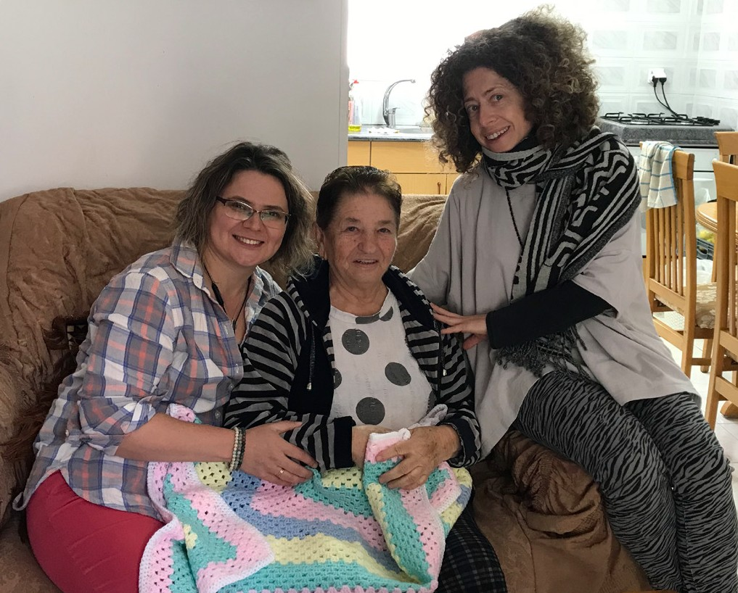
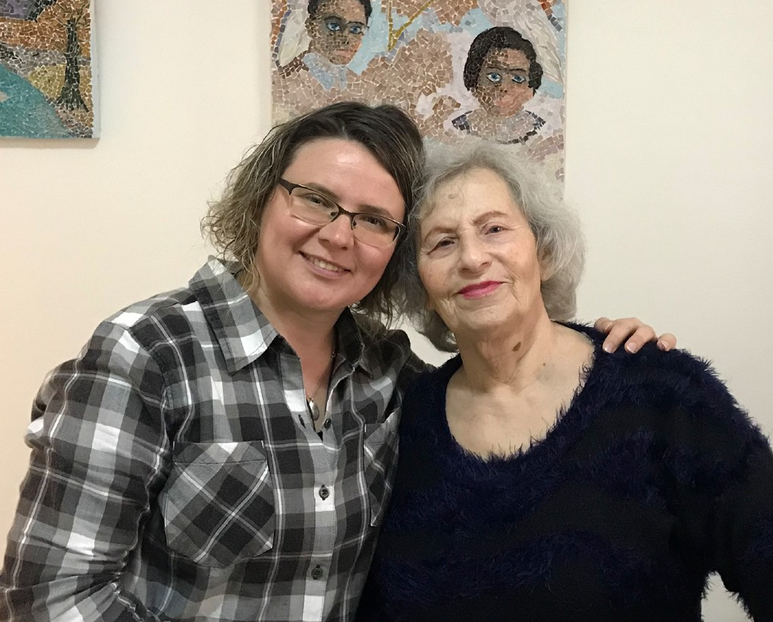

Sadly, every day we lose our dear friends and it fills our hearts with grief. Their days are getting shorter and shorter. Every visit, every smile and every hug is important and treasured as never before. Every reunion is precious.

It was our greatest privilege to visit 371 Holocaust Survivors during 2021, which was only possible because of God’s grace and your generous support. We are storing wonderful memories in our hearts, taking pictures together and sharing our experiences with you.

Thank you so very much for enabling us to reach out to so many Survivors through your faithfulness, love and prayers. One day we will see the final triumph of the Light over all darkness, but meanwhile let each of us present ourselves as living sacrifices to our beloved Saviour.

“The light of the righteous rejoices, but the lamp of the wicked will be put out” Proverbs 13:9.

Olga Kopilova Project Supervisor

Project Hope For The Future

“The Lord is close to the brokenhearted… and Saves those who are crushed in spirt” Psalm 34:18.

The first week of 2022 in Israel began how it ended with new boundaries and restrictions in place. We are still hopeful at CFI, consistently looking forward to opportunities for our project supervisors to get out and visit clients. We can still reach out to clients with desperate needs or emergencies with some moderation. This past weekend, a client requested a visit to Ramat Gan. Ortal is an Ethiopian single Mom raising alone a nine-year-old boy with spectrum autism. On a routine Shabbat morning, I took a drive to her home, knowing that she needed help counseling and guidance. It is extremely hard for this woman, who also suffers from episodes of epilepsy, to stay employed and current with her financial obligations.

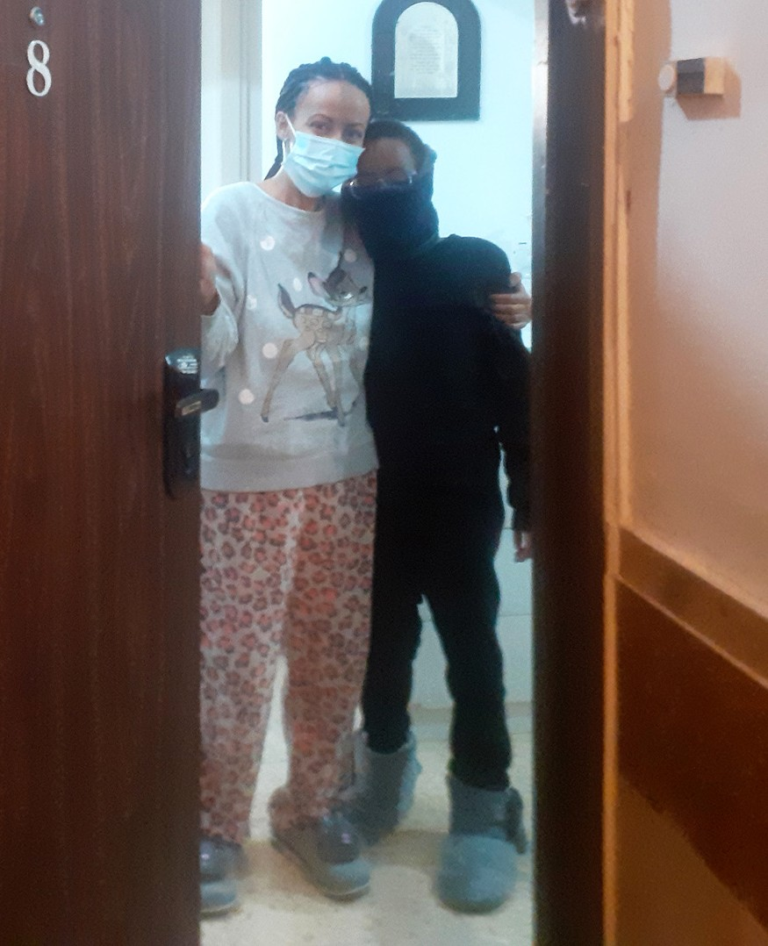
I hoped to sit with her, go over her information, and explore other options. Unfortunately, before I arrived, she telephoned me on the way about her current situation of having to be in quarantine due to Ely’s exposure at school. In place of the meeting, I asked for documents to be placed into a bag and hung out on her door. After disinfecting, I would review her information. Statistically, mothers like Ortal with multiple issues, need help. If possible, we provide a
hand-up more than a handout. Her son’s most significant needs are to have the necessary therapeutic service to develop and grow into a responsible man able to live independently and be as independent as possible. Your prayers are crucial for Otal! Pray for restoring her physical and psychological health so that she can be all she can be for her son. We will help her as much as possible. I will investigate legal coverage help in her pursuit of parental financial assistance from the Abba.

“And my soul shall be joyful in the Lord; It shall rejoice in His salvation” Psalm 35: 9.

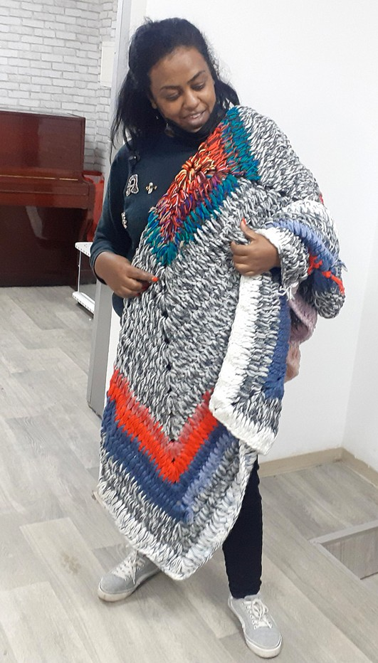
Before returning to Jerusalem, I attended an additional meeting with an Ethiopian Assistant Pastor in Tel Aviv. Pastor Ayni directs the youth group of her ministry along with her husband. As a leader, she contacted me when she received information about our Hope Resource Centre. Four of her congregants were interested even though they would have to travel from Tel Aviv. At the church site in Jerusalem, a couple of Ethiopians also expressed interest.

What was so inspiring about her vision in Tel Aviv with the Kaela “House of Generation Israel Worldwide,” was that the youth learn principles to care for other citizens. They have a Holocaust survivor outreach, and they care for the elderly and homeless. To bless the program, I took three boxes with beautiful, knitted blankets and lap shawls from Canada and the UK. It was such a blessing to see this generation shaped and trained to love from
the inside out! Praying the reports to come will bring you all joy for being a crucial part of Christian Friends of Israel! Thank you for all your prayers, unconditional love, and gifts!
Marcia Brunson Project Coordinator

Project Under His Wings

Dear Friends of Israel,

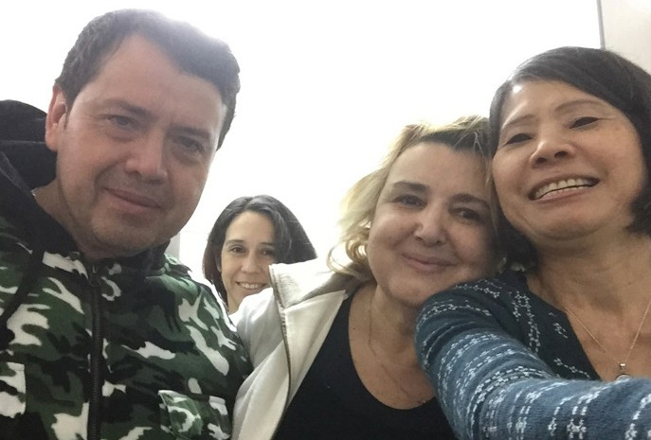
“To provide for those who grieve in Zion―to bestow on them… a garment of praise instead of a spirit of despair” (Isaiah 61:3).

Praise the Lord for restoring the captives of Israel to their ancestral homeland, among those is Yitzhak who made Aliyah from Brazil with his wife Rachel.

But life in Israel has been difficult and challenging for new immigrants, to say the least. And this affected their marriage; his wife put all the blame of making Aliyah on Yitzhak and decided to sepa- rate from him. Despite her decision to divorce him, she still lives in his tiny apartment as she has no family in Israel. Yitzhak, who is very kind to continue
to make provision for her and care for her, as she has been suffering health problems, also thinks he is responsible for the decision of having her make Aliyah with him.

In July 2020 while walking home after work at late evening, Yitzhak was attacked from behind by two Arabs in a street in down town Jerusalem. His head and arms were injured and bleeding badly, he was taken to hospital for treatment.

I felt led to go to his home to minister to him and Rachel, instead him wanting him to come to our office by himself. Praise God that Holy Spirit ministered deeply to them through scriptures, songs and words of encouragement during our visit and Rachel was a changed person at our departure – with garment of praise instead of a spirit of despair (Isaiah 61:3). Praise God for the move of Holy Spirit.

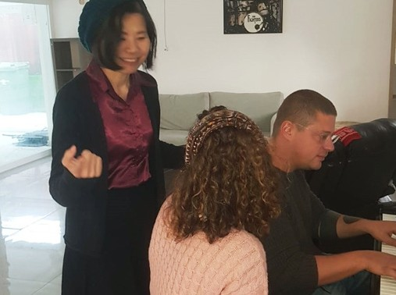
Project UHW visited another terror survivor named Shay who was severely traumatized by terrorism during his military service and was put into a mental hospital for 4 years not knowing that nothing wrong with him mentally except that he was traumatized. Praise God that someone who was also traumatized took him out of mental hospital.

Shay is a very gifted musician. During visits we played musical instruments together and had a discussion on the Bible as well as spiritual issues. Praise God that Shay is making progress and even has a girlfriend now.

Thank you so much for making UHW ministry for terror victims possible through your prayers and financial support. God bless you abundantly.
Maggie Huang Project Supervisor

Project Communities Under Attack

Shalom Dear Friends of Israel,

“You are the light of the world. A city on a hill cannot be hidden” (Matthew 5: 14).

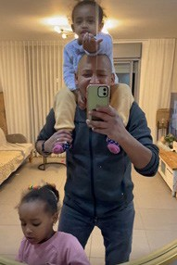
Recently Project CUA was contacted by Getzio, a traumatized former IDF soldier, who was severely traumatized by war, saying he was very ashamed to contact us asking for help but he had no food to feed his two young children. Getzio has not been able to work, and as a result they have accumulated a huge debt as well as being far behind paying their mortgage.

Praise God and thank you – our supporter, for your financial support that Project CUA was able to help meet this need of Getzio and his young family.

Project CUA reached out to another family living in Gaza peripheral who were affected by rocket attacks, and during the visit we were overjoyed to discover that this family belongs to the house of our faith, furthermore, they pastor the only Messianic congregation in that city bordering Gaza.

Praise the Lord that this congregation has grown steadily, with many young couples with their children joining the congregation. However, the religious people in that city were not happy over their growth (Matthew 5:14), and have been persecuting this congregation severely, in the attempt to bring them to an end. It was a severe trial for them – facing threat within and without: not only going through the physical danger of rocket attacks from Gaza, but also threat of spiritual persecution from within the land of Israel.

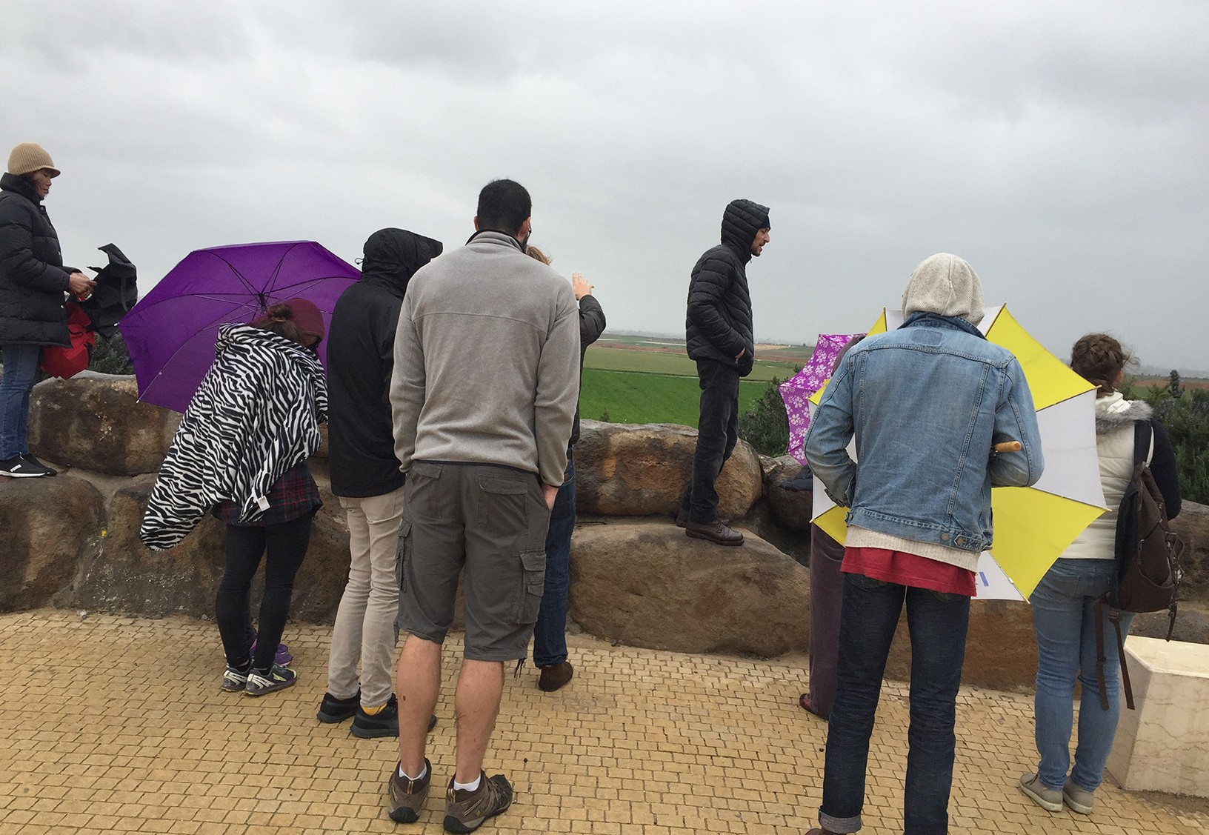
Seeing they need encourage, physical support and as well prayer support, during one visit we had a group of Bible school students who came alongside to help them to get rid of weeds and garbage from the surroundings
of their new building as well as to make intercession for them. This was a great encouragement to this Pastor as well as to their entire congregation, knowing that they are not alone. Please remember them in your prayer as the persecution is still ongoing.

Thank you for being co-worker of Project CUA. With love and blessings.

Maggie Huang Project Supervisor

