January 2022 /Jewish Year 5782

The Ancient City of Akko
“The army of the tribe of Asher did not expel the inhabitants of Acco… so the descendants of Asher lived among the Canaanites who continued to inhabit the land because they did not expel them” (Judges 1:31-32, ISV).

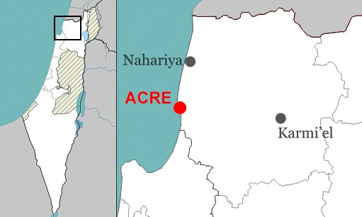Acre, known as Akko (Hebrew: עַּכֹו), is one of the oldest continuously inhabited cities in the world dating back to the time of the Pharaoh Thutmose III (1504-1450 BCE). This coastal city in northern Israel is situated on a peninsula 14 miles (23 kilometers) north of Haifa. As visitors stroll along Acre’s city walls, they can enjoy a magnificent view of the Mediterranean Sea. Akko depicts the tumultuous history of the Land of Israel because it was conquered by the Roman, Ottoman, Crusader, Mameluke, Byzantine, and British empires. Each of these conquering empires left an indelible influence on the city.

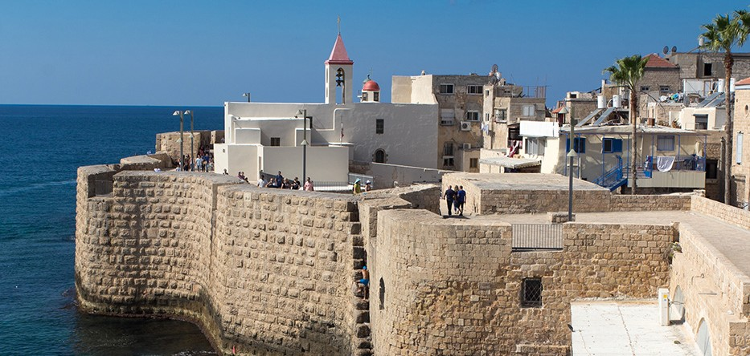
Findings from excavations in Akko provide evidence of a long and uninterrupted occupation of this settlement. Today it closely resembles the 18th and 19th-century walled cities of the Ottoman empire, replete with its ancient mosques and baths. The city also displays magnificent Crusader ruins above and below street level. This ancient site has undergone
large-scale excavation and preservation with extensive renovations. In 2001, the Old City of Akko was designated as a UNESCO World Heritage Site because of its outstanding universal value.

Akko is now home to approximately 40,000 people consisting of a coexistent mixed population of Jews, Muslims, Christians, Druze, and Baháʼís. It has one of the higher proportions of non-Jewish residents of any

Acre’s southern sea wall (CC BY-SA 4.0, Wikipedia)

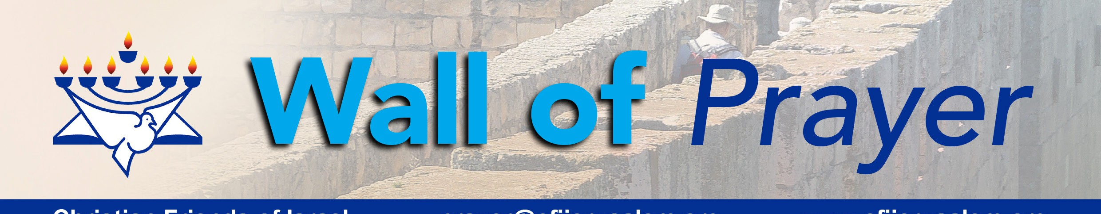of Israel’s cities. Unfortunately, during the May 2021 Gaza conflict, Akko’s normally peaceful coexistence between Jews and Arabs was challenged. The mounting tensions during the 11 days of rocket attacks in Israel sparked violent riots and arson at the Akko police station and other places in the city. In the aftermath of the violence, some neighbors and business owners from different backgrounds joined together to support one another. A small group of Believers from various cities met in front of the burned Akko police station. These pastors and leaders prayed, repented, and spiritually cleansed the area. We praise God for the response of those who chose to follow a biblical principle that says, “If possible, and to the extent that it depends on you, live in peace with all people” (Romans 12:18 CJB).
Christian Friends of Israel
prayer@cfijerusalem.org
www.cfijerusalem.org

In July, our CFI prayer team traveled to a congregation in Akko as part of a prayer group consisting of Jewish, Christian, and Arabic believers from diverse nations. We worshipped and prayed for Israel and for the spiritual

leaders who were present. Our fellowship and care for each other were centered around a mutual love for our Messiah according to John 13:35, which says, “By this, all will know that you are My disciples if you have love for one another” (TLV).
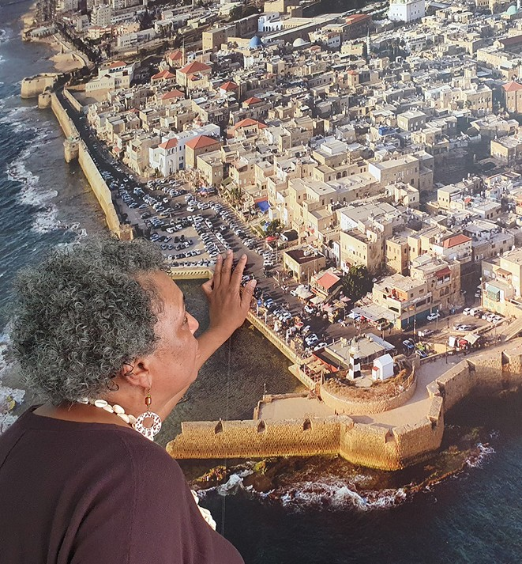
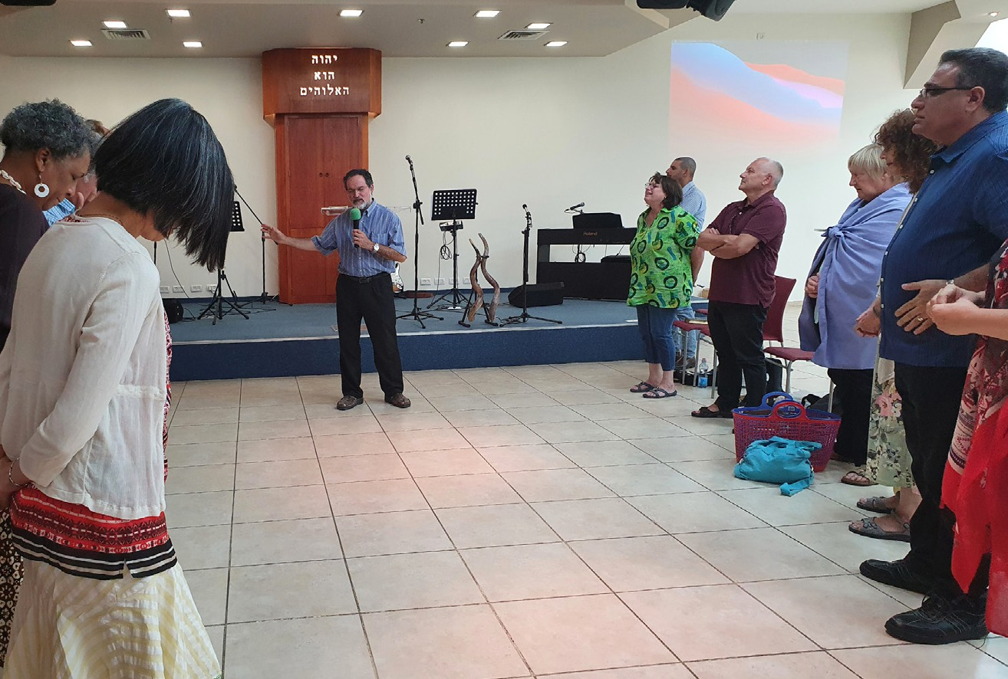

Gathering in the Throne Room
- Let us Honor God for the power of His infallible Word! He reminds us to sit at His feet, listen to His voice, and follow His directions as we commune with Him. In this season, we cannot afford to be shaken or dis- tracted by what is happening around us. “God says, ‘Be still and know that I am God. I will be praised in all the nations. I will be praised throughout the earth ” (Psalms 46:10 ISV).

- Bless the Lord for His great mercy and love for humankind. God has always intended that His blessings, promises, and rulership would be for people from every tribe, tongue, and nation who honor Him. “Let not the foreigner who has joined himself to the Lord say, ‘The Lord will surely separate me from his people’; and let not the eunuch say, ‘Behold, I am a dry tree.’ For thus says the Lord: ‘To the eunuchs who keep my Sabbaths, who choose the things that please me and hold fast my covenant, I will give in my house and within my walls a monument and a name better than sons and daughters; I will give them an everlasting name that shall not be cut off’ “ (Isaiah 56:3-5, ESV).

- Please intercede for people who are steeped in ancient hatred and animosity toward one another, which has been passed down through generations. God promised an outpouring of His Spirit; please petition Him to soften hard-hearted people to see others from His perspective. “I will pour out my Spirit on all kinds of people“ (Joel 2:28). “I will give them unity of heart. I will put a new spirit among you. I will remove from their bodies the hearts of stone and give them hearts of flesh” (Ezekiel 11:19-20).

- Please pray for Israeli Believers who are on the frontline of many spiritual battles in the Holy Land. Some pastors and ministry leaders are targets of unfounded lawsuits and false media campaigns designed to discredit their ministries, drain their budgets, and dissuade the community from engaging with them. Pray for protection, financial provision, and stamina for these ministries and their families. “May God, the source of encouragement and patience, give you the same attitude among yourselves as the Messiah Yeshua had, so that with one accord and with one voice you may glorify the God and Father of our Lord Yeshua the Messiah” (Romans 15:5-6, CJB).
Happy New Year, Fellow Prayer Warriors!
God has appointed us to serve in this hour of great challenge. We must remember that the Greater One who lives in us has given us everything we need to be victorious! It is our responsibility to access what He has provided. May this be our time of sitting at His feet and digging deeper into His Word. May our prayer times together in this New Year be even more impacting and powerful!

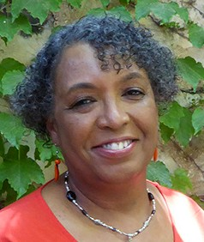
In His Service,

Linda D. McMurray
Wall of Prayer Supervisor

